September 6th, 2026 – Week #1
Milton Campus – Pastor Branden Mestach
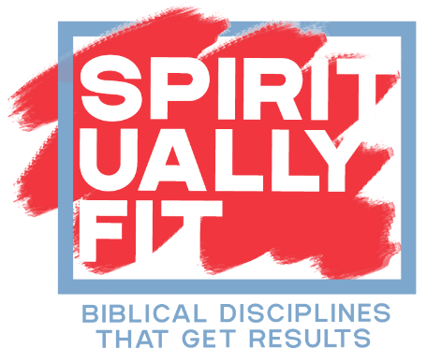 | WEEK ONE:  READ SCRIPTURE  Psalm 119:105  Matthew 4:4  James 1:21-25

- God’s Word _________ What We Need
- It __________ the next step on our path.
“Your Word is a lamp to my feet and a light to my path.” Psalm 119:105(ESV)

- It ___________ the state of our heart.
“For if anyone is a hearer of the Word and not a doer, he is like a man who looks intently at his natural face in a mirror. For he looks at himself and goes away and at once forgets what he was like.” James 1:23-24(ESV)

- It ____________ and nourishes our very soul.
“But He answered, ‘It is written, ‘Man shall not live by bread alone, but by every word that comes from the mouth of God.’’” Matthew 4:4(ESV)

Notetakers are History Makers: ________________________________________________________________________________________________________________________________________________________________________________________________________
__________________________________________________

- God’s Word _______________ an Active Response
- We ____________ it with a humble heart.
“Therefore put away all filthiness and rampant wickedness and receive with meekness the implanted Word, which is able to save your souls.” James 1:21(ESV)

- We ___________ truth into action.
“But be doers of the Word, and not hearers only, deceiving yourselves.” James 1:22(ESV)

- We ________________ freedom by obeying it.
“But the one who looks into the perfect law, the law of liberty, and perseveres, being no hearer who forgets but a doer who acts, he will be blessed in his doing.” James 1:25(ESV)

Notetakers are History Makers:
__________________________________________________________________________________________________________________________________________________________________________________________________________________________________________________________

- YOUR SPIRITUAL WORKOUT
 | - GET STARTED  Take the first step  Challenge: Take 10 minutes a day this week to read a chapter of God’s Word.  Ask God before reading: "Reveal one truth to me today, and what is one concrete action I can take because of it?"
   | - COMMIT TO IT  Make it a habit  Challenge: Move from merely reading to acting. Join a mid-week group for deeper dive into Scripture. Get an accountability partner to go with you or read together.  - INCREASE INTENSITY  Go deeper  Challenge: Memorize Psalm 119:105 or Matthew 4:4 this week. Use it as a daily reminder to let God's Word shape your choices when temptation or trial comes.

Bottom Line:
Scripture isn't passive advice;
it’s daily fuel to be lived out.

To begin a relationship with Jesus…
Text: “Jesus” to 570-273-0088

Next Sunday:
Spiritually Fit – Biblical Disciplines that Get Results

Week 2: Rest and Recovery
Genesis 2, Exodus 20:8-11, Matthew 11:28-29

Milton Campus: Pastor Branden Mestach
Sunbury Campus: Pastor Billy Robel



Giving & Attendance Update
Giving last Sunday: 101.4%
Giving year to date: 89.9% of goal
Attendance Last Weekend: 1,954
Salvations to date: 49 | Baptisms to date: 55

Upcoming Happenings:

September 9 – 6:30p Midweek Groups Showcase

September 12 – 8:00a Men’s Breakfast (Youth Center)

September 13 – November 22 - Marriage Matters: Intentionally Growing Healthy Relationships
(During First Service)

September 18th – 6:30p Classics Fall Kickoff Dinner

“Reach the One” Campaign Update
484 Total Participants
$4,000,000 – Giving Goal by Nov. 2027
$2,456,686.64 - Donations Anticipated by Nov. 2027
$2,116,148.75 - Received Donations – 53% of $4M Goal

Want to pledge, donate, or learn more?
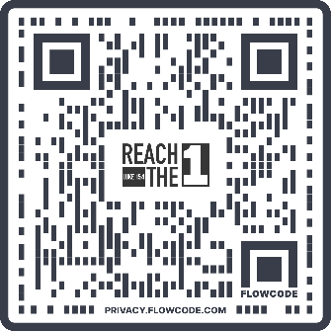
Scan:

Looking for your next step at CWC?
Welcome Party: 1st Sunday of Every Month
- If you are new or if you’ve been around a bit and are looking to build friendships with others, our Welcome Party is for you! Get to know others who are newer at CWC as well as our welcome team and our pastors in a relational environment. There will be light refreshments and the opportunity to hear about our small groups, baptism, and your next step of Growth Track. If you’re asking the question, “How can I make friends here?” then this is for you! No registration is required, you can just show up. Look for the signs on the first Sunday of the month.

Growth Track: 3-week classes/Sunday morning in-person and Wednesday evening online
- Growth Track exists to help you learn about the vision of CWC, the gifts God has given you, and how you can use them in specific opportunities to serve His church. The classes will guide you to not only become a vital part of our ministries, but more importantly, how to use what you learn to continue growing in your faith to share with others. We are excited to now have online-facilitated evening classes in addition to the existing in-person Sunday class opportunities. You can see what classes are available by going to cwclife.churchcenter.com/registrations and select the Next Steps filter.

Membership Class: Once a quarter on Sundays after 2nd service
- Membership class is the last step of fully assimilating at CWC. Learn about our denomination, The Wesleyan Church and the bigger movement we are a part of across the world. This 3-hour class with the lead pastor provides you a place to ask important questions about our beliefs as a church and allows you to become eligible for our local board of administration. You also become eligible for denominational events like our district and general conferences. To sign up for our next class, let us know at the Hub or email: loretta.paulhamus@cwc.life

