August 9th, 2026 – Week #10
Milton Campus – Pastor Branden Mestach
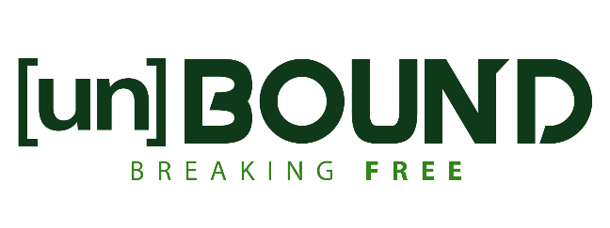

Unbound From Hopelessness
Hebrews 10:19-25

- Unbound _________
- We have the unfiltered freedom to _______.
“Therefore, brothers, since we have confidence to enter the holy places by the blood of Jesus, by the new and living way that He opened for us through the curtain, that is, through His flesh…” Hebrews 10:19-20 (ESV)

- We have the unfiltered freedom to ask for _______________.
“…and since we have a great priest over the house of God, let us draw near with a true heart in full assurance of faith, with our hearts sprinkled clean from an evil conscience and our bodies washed with pure water.” Hebrews 10:21-22 (ESV)

Mirror Moment: When you talk to God, you speak from a position of direct, open access purchased by the blood of Jesus.

Notetakers are History Makers: ________________________________________________________________________________________________________________________________________________________________________________________________

- Unbound _______
- We have hope for a stable _____________.
“Let us hold fast the confession of our hope without wavering…” Hebrews 10:23a (ESV)

- We have hope in a _____________ God.
“…for He Who promised is faithful.” Hebrews 10:23b (ESV)

Mirror Moment: Our hope is not tethered to local conditions—it’s tethered to the hope we profess.

Notetakers are History Makers:
________________________________________________________________________________________________________________________________________________________________________________________________________________________________________________
________________________________________________

- Unbound Action
- We are called to provoke love.
“And let us consider how to stir up one another to love and good works…” Hebrews 10:24 (ESV)

- We are called to provoke community.
“…not neglecting to meet together, as is the habit of some, but encouraging one another…” Hebrews 10:25a (ESV)

- We are called to provoke preparedness.
“…and all the more as you see the Day drawing near.” Hebrews 10:25b (ESV)

Mirror Moment: God did not unbind you so that you could sit comfortably in a sanctuary.

Bottom Line:
Unbound access leads to unbound action.

To begin a relationship with Jesus…
Text: “Jesus” to 570-273-0088

Whether you are walking around a school property, downtown businesses, or walking near city hall, I want you to remember what Hebrews 10 taught us today:
- You walk with Unbound Access. You are not praying as outsiders. You carry the presence of God with you.
- You declare Unbound Hope. Speak life, peace, and protection over every administrator, business owner, and first responder.
- You spark Unbound Action. Let your prayers be followed by acts of love and encouragement throughout this week.

Next Sunday: UnBound: Breaking Free

Week 11: Unbound From Faithlessness

Hebrews 11

Milton Campus: Pastor Branden Mestach
Sunbury Campus: Pastor Billy Robel


Giving & Attendance Update
Giving last Sunday: 68.5%
Giving year to date: 89.7% of goal
Attendance Last Weekend: 1,711
Salvations to date: 47 | Baptisms to date: 53

Upcoming Happenings:

August 17 – April 2027 – Christian Bowling League
Looking for regular bowlers and subs. For more details or to sign up, stop at the Hub!

September 13 – November 22 - Marriage Matters: Intentionally Growing Healthy Relationships
(During First Service)

“Reach the One” Campaign Update
479 Total Participants
$4,000,000 – Giving Goal by Nov. 2027
$2,439,015.52 - Donations Anticipated by Nov. 2027
$2,078,635.70 - Received Donations – 52% of $4M Goal

Want to pledge, donate, or learn more?

Scan:

Looking for your next step at CWC?
Welcome Party: 1st Sunday of Every Month (Next one: August 2nd)
- If you are new or if you’ve been around a bit and are looking to build friendships with others, our Welcome Party is for you! Get to know others who are newer at CWC as well as our welcome team and our pastors in a relational environment. There will be light refreshments and the opportunity to hear about our small groups, baptism, and your next step of Growth Track. If you’re asking the question, “How can I make friends here?” then this is for you! No registration is required, you can just show up. Look for the signs on the first Sunday of the month.

Growth Track: 3-week classes/Sunday morning in-person and Wednesday evening online
- Growth Track exists to help you learn about the vision of CWC, the gifts God has given you, and how you can use them in specific opportunities to serve His church. The classes will guide you to not only become a vital part of our ministries, but more importantly, how to use what you learn to continue growing in your faith to share with others. We are excited to now have online-facilitated evening classes in addition to the existing in-person Sunday class opportunities. You can see what classes are available by going to cwclife.churchcenter.com/registrations and select the Next Steps filter.

Membership Class: Once a quarter on Sundays after 2nd service
- Membership class is the last step of fully assimilating at CWC. Learn about our denomination, The Wesleyan Church and the bigger movement we are a part of across the world. This 3-hour class with the lead pastor provides you a place to ask important questions about our beliefs as a church and allows you to become eligible for our local board of administration. You also become eligible for denominational events like our district and general conferences. To sign up for our next class, let us know at the Hub or email: loretta.paulhamus@cwc.life

