August 2, 2026 – Week #9
Milton Campus – Pastor Erik Ireland
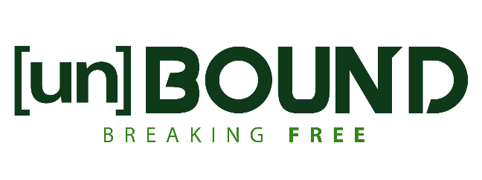

Unbound From the Crimson Stain
Hebrews 9:23-28

Notes:__________________________________________________________________________________________________________________________________________________________________________________________________________________________________________________________________________________________________________________________________________________________________________________________________________________________________________________________________________________________
________________________________________________________________________________________________________________________________________________
________________________________________________

To begin a relationship with Jesus…
Text: “Jesus” to 570-273-0088

Next Sunday: UnBound: Breaking Free

Week 10: Unbound From Hopelessness

Hebrews 10

Milton Campus: Pastor Branden Mestach
Sunbury Campus: Pastor Billy Robel
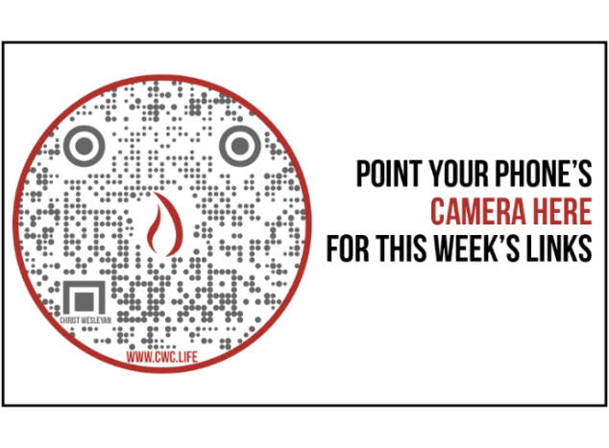

Giving & Attendance Update
Giving last Sunday: 67.7%
Giving year to date: 91.0% of goal
Attendance Last Weekend: 1,798
Salvations to date: 23 | Baptisms to date: 53

Upcoming Happenings:
Saturday, August 8th – Reach the Hole in One Golf Tournament (Benefit our Reach the One Capital Campaign)
Scan the QR Code below for more information:


Sunday, August 9th – Get Out Sunday! One service at 10:15am with community prayer groups to follow!

Sunday, August 9th - Fireworks Rain date. Gather at 7:00pm with fireworks around 9:30pm.

“Reach the One” Campaign Update
474 Total Participants
$4,000,000 – Giving Goal by Nov. 2027
$2,435,960.59 - Donations Anticipated by Nov. 2027
$2,068,528.58 - Received Donations – 51% of $4M Goal
Want to pledge, donate, or learn more?
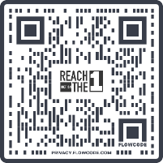
Scan:

Looking for your next step at CWC?
Welcome Party: 1st Sunday of Every Month (Next one: August 2nd)
- If you are new or if you’ve been around a bit and are looking to build friendships with others, our Welcome Party is for you! Get to know others who are newer at CWC as well as our welcome team and our pastors in a relational environment. There will be light refreshments and the opportunity to hear about our small groups, baptism, and your next step of Growth Track. If you’re asking the question, “How can I make friends here?” then this is for you! No registration is required, you can just show up. Look for the signs on the first Sunday of the month.

Growth Track: 3-week classes/Sunday morning in-person and Wednesday evening online
- Growth Track exists to help you learn about the vision of CWC, the gifts God has given you, and how you can use them in specific opportunities to serve His church. The classes will guide you to not only become a vital part of our ministries, but more importantly, how to use what you learn to continue growing in your faith to share with others. We are excited to now have online-facilitated evening classes in addition to the existing in-person Sunday class opportunities. You can see what classes are available by going to cwclife.churchcenter.com/registrations and select the Next Steps filter.

Membership Class: Once a quarter on Sundays after 2nd service
- Membership class is the last step of fully assimilating at CWC. Learn about our denomination, The Wesleyan Church and the bigger movement we are a part of across the world. This 3-hour class with the lead pastor provides you a place to ask important questions about our beliefs as a church and allows you to become eligible for our local board of administration. You also become eligible for denominational events like our district and general conferences. To sign up for our next class, let us know at the Hub or email: loretta.paulhamus@cwc.life

