July 26, 2026 – Week #8
Milton Campus – Pastor Branden Mestach


Unbound From the Outdated
Hebrews 8:1-13

- ______ We Need to Be Unbound
- When we are bound, we mistake the shadow for the ________________.
“Now the point in what we are saying is this: we have such a high priest, One who is seated at the right hand of the throne of the Majesty in heaven, a minister in the holy places, in the true tent that the Lord set up, not man... They serve a copy and shadow of the heavenly things.” Hebrews 8:1-2, 5a (ESV)

- When we are bound, we burn out trying to maintain a ___________________ identity.
“For every high priest is appointed to offer gifts and sacrifices; thus it is necessary for this priest also to have something to offer... But as it is, Christ has obtained a ministry that is as much more excellent than the old as the covenant He mediates is better, since it is enacted on better promises.” Hebrews 8:3, 6 (ESV)

Notetakers are History Makers: ________________________________________________________________________________________________________________________________________________________________________________________________

- _________ the Breakdown Happened
- The old way was faulty and became ___________.
“For if that first covenant had been faultless, there would have been no occasion to look for a second. For He finds fault with them when He says: ‘Behold, the days are coming, declares the Lord, when I will establish a new covenant with the house of Israel and with the house of Judah…’” Hebrews 8:8 (ESV)

- The old way became reliant on __________ confidence.
“…not like the covenant that I made with their fathers on the day when I took them by the hand to bring them out of the land of Egypt. For they did not continue in My covenant, and so I showed no concern for them, declares the Lord.’” Hebrews 8:9 (ESV)

Notetakers are History Makers:
________________________________________________________________________________________________________________________________________________________________________________________________________________________________________________
________________________________________________

- How God Offers to Unbind Us
- Through Internal Transformation
“For this is the covenant that I will make with the house of Israel after those days, declares the Lord: I will put My laws into their minds, and write them on their hearts, and I will be their God, and they shall be My people.” Hebrews 8:10 (ESV)

- By Direct Intimacy
“And they shall not teach, each one his neighbor and each one his brother, saying, ‘Know the Lord,’ for they shall all know Me, from the least of them to the greatest.” Hebrews 8:11 (ESV)

- With Complete Forgiveness
“‘For I will be merciful toward their iniquities, and I will remember their sins no more.’ In speaking of a new covenant, He makes the first one obsolete. And what is becoming obsolete and growing old is ready to vanish away.” Hebrews 8:12-13 (ESV)

Notetakers are History Makers:
________________________________________________________________________________________________________________________________________________________________________________________________________________________________________________
________________________________________________

Bottom Line:
Unbound lives don't manage past shame—
they walk in present mercy.

To begin a relationship with Jesus…
Text: “Jesus” to 570-273-0088

Next Sunday: UnBound: Breaking Free

Week 9: Unbound From the Crimson Stain

Hebrews 9:23-28

Milton Campus: Pastor Erik Ireland
Sunbury Campus: Pastor Billy Robel
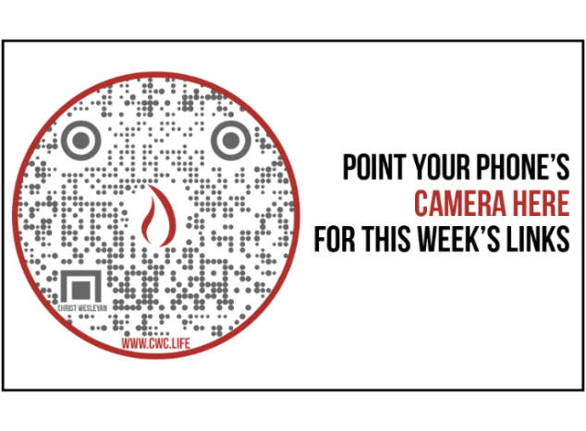

Giving & Attendance Update
Giving last Sunday: 73.9%
Giving year to date: 92.5% of goal
Attendance Last Weekend: 1,791
Salvations to date: 18 | Baptisms to date: 20

Upcoming Happenings:
Saturday, August 8th – Reach the Hole in One Golf Tournament (Benefit our Reach the One Capital Campaign)
Scan the QR Code below for more information:
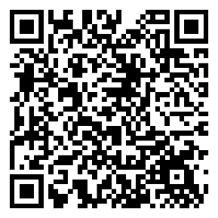

Sunday, August 9th – Get Out Sunday! One service at 10:15am with community prayer groups to follow!

Sunday, August 9th - Fireworks Rain date. Gather at 7:00pm with fireworks around 9:30pm.

“Reach the One” Campaign Update
474 Total Participants
$4,000,000 – Giving Goal by Nov. 2027
$2,433,553.44 - Donations Anticipated by Nov. 2027
$2,061,747.56 - Received Donations – 51% of $4M Goal

Want to pledge, donate, or learn more?

Scan:

Looking for your next step at CWC?
Welcome Party: 1st Sunday of Every Month (Next one: August 2nd)
- If you are new or if you’ve been around a bit and are looking to build friendships with others, our Welcome Party is for you! Get to know others who are newer at CWC as well as our welcome team and our pastors in a relational environment. There will be light refreshments and the opportunity to hear about our small groups, baptism, and your next step of Growth Track. If you’re asking the question, “How can I make friends here?” then this is for you! No registration is required, you can just show up. Look for the signs on the first Sunday of the month.

Growth Track: 3-week classes/Sunday morning in-person and Wednesday evening online
- Growth Track exists to help you learn about the vision of CWC, the gifts God has given you, and how you can use them in specific opportunities to serve His church. The classes will guide you to not only become a vital part of our ministries, but more importantly, how to use what you learn to continue growing in your faith to share with others. We are excited to now have online-facilitated evening classes in addition to the existing in-person Sunday class opportunities. You can see what classes are available by going to cwclife.churchcenter.com/registrations and select the Next Steps filter.

Membership Class: Once a quarter on Sundays after 2nd service
- Membership class is the last step of fully assimilating at CWC. Learn about our denomination, The Wesleyan Church and the bigger movement we are a part of across the world. This 3-hour class with the lead pastor provides you a place to ask important questions about our beliefs as a church and allows you to become eligible for our local board of administration. You also become eligible for denominational events like our district and general conferences. To sign up for our next class, let us know at the Hub or email: loretta.paulhamus@cwc.life

