April 19th, 2026 – Week #2
Milton Campus – Pastor Ken Paulhamus
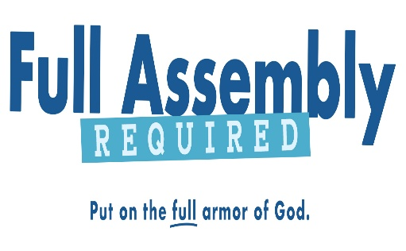

How To Stand Firm

Ephesians 6:10-13

A. _____ is to stand firm and ____ is it important to do so?
- Each of us are _______ to stand firm
“Therefore, my dear brothers (and sisters), stand firm. Let nothing move you.” 1 Corinthians 15:58 (NIV)

- It is important to stand firm in the Lord, because the enemy will ________ you.
“Be self-controlled and alert. Your enemy, the devil, prowls around like a roaring lion, looking for someone to devour. Resist him, standing firm in the faith because you know that your brothers throughout the world are undergoing the same kind of suffering.” 1 Peter 5:8-9 (NIV)

Notes:
________________________________________________________________________________________________________________________________________________________________________________________________________________________________________________________________________________________________

- What does____________ reveal about standing firm?

- Don’t be afraid, obey God, stand firm and _________ what God does.
“Moses answered the people, ‘Do not be afraid. Stand firm and you will see the deliverance the Lord will bring you today. The Egyptians you see today you will never see again. The Lord will fight for you; you only need to be still.’” Exodus 14:13-14 (NIV)

2. God does the __________ for me.
“You will not have to fight this battle. Take up your positions; stand firm and see the deliverance the Lord will give you, Judah and Jerusalem. Do not be afraid; do not be discouraged. Go out to face them tomorrow, and the Lord will be with you.’” 2 Chron. 20:15-17 (NIV)

Notes:
________________________________________________________________________________________________________________________________________________________________________________________________________________________________________________
________________________________________________

- How am I to stand firm?
- Do not be afraid but be courageous and strong in the Lord.

- Put on the full armor of God.

- Stand your ground – may mean to stand still

- Observe what happens as the Lord fights for you.

Notes:
________________________________________________________________________________________________________________________________________________________________________________________________________________________________________________

Bottom Line:
The part we play is to obey by putting on the armor God provides and then stand firm; God’s part is to fight and win the battle.

To begin a relationship with Jesus…
Text: “Jesus” to 570-273-0088

Next Sunday: Full Assembly Required

Week 3: How to Put on the Belt of Truth
Ephesians 6:14a

Milton Campus: Pastor Branden Mestach
Sunbury Campus: Pastor Billy Robel


Giving & Attendance Update
Giving last Sunday: 108.8%
Giving year to date: 106.7% of goal (since April 1)
Attendance Last Weekend: 1,874
Salvations to date: 3 |Baptisms to date: 45 (since April 1)

Upcoming Happenings:
Sunday, May 3rd - Welcome Party, The Cube in The Well, after 2nd service
Sunday, May 3rd – Local Church Conference, The Well, 6pm

“Reach the One” Campaign Update
161 Pledges
460 Total Participants
$4,000,000 – Giving Goal by Nov. 2027
$2,357,445.98 - Donations Expected by Nov. 2027
$1,810,920.12 - Received Donations – 45.3% of $4M Goal

Want to pledge, donate, or learn more?

Scan:

Looking for your next step at CWC?
Welcome Party: 1st Sunday of Every Month
- If you are new or if you’ve been around a bit and are looking to build friendships with others, our Welcome Party is for you! Get to know others who are newer at CWC as well as our welcome team and our pastors in a relational environment. There will be light refreshments and the opportunity to hear about our small groups, baptism, and your next step of Growth Track. If you’re asking the question, “How can I make friends here?” then this is for you! No registration is required, you can just show up. Look for the signs on the first Sunday of the month.

Growth Track: 3-week class on Sunday Mornings
- Growth Track exists to help you learn about the vision of CWC, the gifts God has given you, and how you can use them in specific opportunities to serve at CWC. You’ll learn amongst others of how to become a vital part of the ministries of the church so that we can share the light of Christ with our communities. If you miss a class, don’t worry! Growth Track runs every other month, on Sunday mornings, and we even have an online option you can participate in (though we recommend in-person if you can). You can see what classes are available by going to cwclife.churchcenter.com/registrations.

Membership Class: Once a quarter on Sundays after 2nd service
- Membership class is the last step of fully assimilating at CWC. Learn about our denomination, The Wesleyan Church and the bigger movement we are a part of across the world. This 3-hour class with the lead pastor provides you a place to ask important questions about our beliefs as a church and allows you to become eligible for our local board of administration. You also become eligible for denominational events like our district and general conferences. To sign up for our next class, let us know at the Hub or email: loretta.paulhamus@cwc.life

