April 12th, 2026 – Week #1
Milton Campus – Pastor Branden Mestach
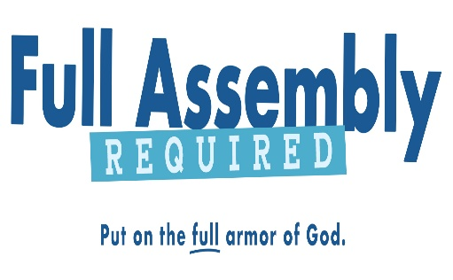
How to Recognize the Scheme of the Enemy

Ephesians 6:10-12

- We Realize the ___________
- The Realization of _________ Placement
“Finally, be strong in the Lord and in His mighty power.” Ephesians 6:10 (NIV)

- The Realization of _________________.
“Put on the full armor of God…” Ephesians 6:11a (NIV)

- The Realization of __________________.
“…so that you can take your stand against the devil’s schemes.” Ephesians 6:11b (NIV)

Notetakers are History Makers:
________________________________________________________________________________________________________________________________________________________________________________________________________________________________________________________________________________________________

- We Recognize the Correct ___________
- Who our battle is _____ with…
“For our struggle is not against flesh and blood…” Ephesians 6:12a (NIV)

- Who our battle ___ with…
“…but against the rulers, against the authorities, against the powers of this dark world…” Ephesians 6:12b (NIV)

- Where the battle takes ________…
“…and against the spiritual forces of evil in the heavenly realms.” Ephesians 6:12c (NIV)

Notetakers are History Makers:
________________________________________________________________________________________________________________________________________________________________________________________________________________________________________________
________________________________________________

- The Battle for the American Heart
- Worldly weapons are useless in this battle.
“The weapons we fight with are not the weapons of the world. On the contrary, they have divine power to demolish strongholds." 2 Corinthians 10:4 (NIV)

- Worldly entanglement leads to spiritual ineffectiveness.
“No one serving as a soldier gets entangled in civilian affairs, but rather tries to please his commanding officer.” 2 Timothy 2:4 (NIV)

- Worldly patterns lead to worldly reactions.
“Do not conform to the pattern of this world, but be transformed by the renewing of your mind.” Romans 12:2 (NIV)

Notetakers are History Makers:
________________________________________________________________________________________________________________________________________________________________________________________________________________________________________________

Bottom Line:
When the world is screaming, the fully armored Christian is calm.

To begin a relationship with Jesus…
Text: “Jesus” to 570-273-0088

Next Sunday: Full Assembly Required

Week 2: How to Stand Disciplined
Ephesians 6:13

Milton Campus: Pastor Ken Paulhamus
Sunbury Campus: Pastor Billy Robel


Giving & Attendance Update
Giving last Sunday: 104%
Giving year to date: 104% of goal
Attendance Last Weekend: 2,815
Salvations to date: 3 | Baptisms to date: 45

Upcoming Happenings:
Sunday, May 3rd - Welcome Party, The Cube in The Well, after 2nd service
Sunday, May 3rd – Local Church Conference, The Well, 6pm

“Reach the One” Campaign Update
459 Total Participants
$4,000,000 – Giving Goal by Nov. 2027
$2,353,682.22 - Donations Expected by Nov. 2027
$1,793,259.81 - Received Donations – 44.8% of $4M Goal

Want to pledge, donate, or learn more?

Scan:

Looking for your next step at CWC?
Welcome Party: 1st Sunday of Every Month
- If you are new or if you’ve been around a bit and are looking to build friendships with others, our Welcome Party is for you! Get to know others who are newer at CWC as well as our welcome team and our pastors in a relational environment. There will be light refreshments and the opportunity to hear about our small groups, baptism, and your next step of Growth Track. If you’re asking the question, “How can I make friends here?” then this is for you! No registration is required, you can just show up. Look for the signs on the first Sunday of the month.

Growth Track: 3-week class on Sunday Mornings
- Growth Track exists to help you learn about the vision of CWC, the gifts God has given you, and how you can use them in specific opportunities to serve at CWC. You’ll learn amongst others of how to become a vital part of the ministries of the church so that we can share the light of Christ with our communities. If you miss a class, don’t worry! Growth Track runs every other month, on Sunday mornings, and we even have an online option you can participate in (though we recommend in-person if you can). You can see what classes are available by going to cwclife.churchcenter.com/registrations.

Membership Class: Once a quarter on Sundays after 2nd service
- Membership class is the last step of fully assimilating at CWC. Learn about our denomination, The Wesleyan Church and the bigger movement we are a part of across the world. This 3-hour class with the lead pastor provides you a place to ask important questions about our beliefs as a church and allows you to become eligible for our local board of administration. You also become eligible for denominational events like our district and general conferences. To sign up for our next class, let us know at the Hub or email: loretta.paulhamus@cwc.life

