March 22nd, 2026 – Week #4
Milton Campus – Pastor Erik Ireland
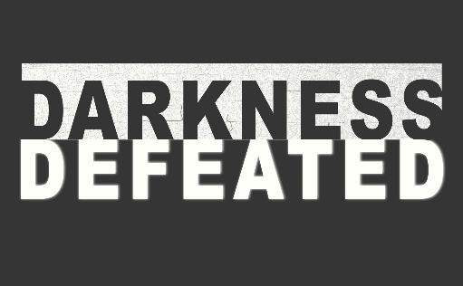

Darkness Defeated in Gethsemane

Matthew 26:39

Notes:__________________________________________________________________________________________________________________________________________________________________________________________________________________________________________________________________________________________________________________________________________________________________________________________________________________________________________________________________________________________
________________________________________________________________________________________________________________________________________________
________________________________________________

To begin a relationship with Jesus…
Text: “Jesus” to 570-273-0088

Next Sunday: Darkness Defeated

Week 5:
How Darkness Lost on the Cross
Matthew 27:39-41, Colossians 2:13-15

Milton Campus: Pastor Branden Mestach
Sunbury Campus: Shawnee Robel
March 22nd, 2026 – Week #4
Milton Campus – Pastor Erik Ireland

Darkness Defeated in Gethsemane

Matthew 26:39

Notes:__________________________________________________________________________________________________________________________________________________________________________________________________________________________________________________________________________________________________________________________________________________________________________________________________________________________________________________________________________________________
________________________________________________________________________________________________________________________________________________
________________________________________________

To begin a relationship with Jesus…
Text: “Jesus” to 570-273-0088

Next Sunday: Darkness Defeated

Week 5:
How Darkness Lost on the Cross
Matthew 27:39-41, Colossians 2:13-15

Milton Campus: Pastor Branden Mestach
Sunbury Campus: Shawnee Robel
March 22nd, 2026 – Week #4
Milton Campus – Pastor Erik Ireland

Darkness Defeated in Gethsemane

Matthew 26:39

Notes:__________________________________________________________________________________________________________________________________________________________________________________________________________________________________________________________________________________________________________________________________________________________________________________________________________________________________________________________________________________________
________________________________________________________________________________________________________________________________________________
________________________________________________

To begin a relationship with Jesus…
Text: “Jesus” to 570-273-0088

Next Sunday: Darkness Defeated

Week 5:
How Darkness Lost on the Cross
Matthew 27:39-41, Colossians 2:13-15

Milton Campus: Pastor Branden Mestach
Sunbury Campus: Shawnee Robel



Giving & Attendance Update
Giving last Sunday: 80%
Giving year to date: 86% of goal
Attendance Last Weekend: 1,844
Salvations to date: 302 | Baptisms to date: 65

“Reach the One” Campaign Update
161 Pledges
457 Total Participants
$4,000,000 – Giving Goal by Nov. 2027
$2,348,534.62 - Donations Expected by Nov. 2027
$1,743,143.22 - Received Donations – 43.6% of $4M Goal

Want to pledge, donate, or learn more?

Scan:

Upcoming Happenings:
Tuesday, February 24th-April 4th – 40 Days of Prayer and Fasting!
Sunday, March 29th – Voting by members for leadership positions (Sunbury and Milton Campus)
Easter Sunday (NO SATURDAY NIGHT SERVICE)
Milton Campus: 6:30a (Sunrise Service), 9:00a and 10:45a
Sunbury Campus: 10:15a



Giving & Attendance Update
Giving last Sunday: 80%
Giving year to date: 86% of goal
Attendance Last Weekend: 1,844
Salvations to date: 302 | Baptisms to date: 65

“Reach the One” Campaign Update
161 Pledges
457 Total Participants
$4,000,000 – Giving Goal by Nov. 2027
$2,348,534.62 - Donations Expected by Nov. 2027
$1,743,143.22 - Received Donations – 43.6% of $4M Goal

Want to pledge, donate, or learn more?
Scan:

Upcoming Happenings:
Tuesday, February 24th-April 4th – 40 Days of Prayer and Fasting!
Sunday, March 29th – Voting by members for leadership positions (Sunbury and Milton Campus)
Easter Sunday (NO SATURDAY NIGHT SERVICE)
Milton Campus: 6:30a (Sunrise Service), 9:00a and 10:45a
Sunbury Campus: 10:15a

Giving & Attendance Update
Giving last Sunday: 80%
Giving year to date: 86% of goal
Attendance Last Weekend: 1,844
Salvations to date: 302 | Baptisms to date: 65

“Reach the One” Campaign Update
161 Pledges
457 Total Participants
$4,000,000 – Giving Goal by Nov. 2027
$2,348,534.62 - Donations Expected by Nov. 2027
$1,743,143.22 - Received Donations – 43.6% of $4M Goal

Want to pledge, donate, or learn more?
Scan:

Upcoming Happenings:
Tuesday, February 24th-April 4th – 40 Days of Prayer and Fasting!
Sunday, March 29th – Voting by members for leadership positions (Sunbury and Milton Campus)
Easter Sunday (NO SATURDAY NIGHT SERVICE)
Milton Campus: 6:30a (Sunrise Service), 9:00a and 10:45a
Sunbury Campus: 10:15a

