March 15th, 2026 – Week #3
Milton Campus – Pastor Branden Mestach
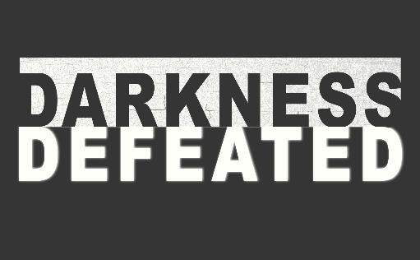
Darkness Defeated in the Wilderness

Matthew 4:1-11

- A ___________________ of Jesus
- A __________ Test
“Then Jesus was led by the Spirit into the wilderness…” Matthew 4:1a (NIV)

- An ___________________ Test
“…to be tempted by the devil.” Matthew 4:1b (NIV)

- A _______ Test
“After fasting forty days and forty nights, He was hungry.” Matthew 4:2 (NIV)

Notetakers are History Makers:
________________________________________________________________________________________________________________________________________________________________________________________________________________________________________________________________________________________________

- A Look Into the “_________ Narrative”
- A Test of _____________ (Deuteronomy 8:3)
“The tempter came to Him and said, ‘If you are the Son of God, tell these stones to become bread.’ Jesus answered, ‘It is written: ‘Man shall not live on bread alone, but on every word that comes from the mouth of God.’” Matthew 4:3-4 (NIV)

- A Test of ________ (Deuteronomy 6:16)
“Then the devil took Him to the Holy City and had Him stand on the highest point of the temple. ‘If You are the Son of God,’ he said, ‘throw Yourself down. For it is written: ‘He will command His angels concerning you, and they will lift you up in their hands, so that you will not strike your foot against a stone.’ Jesus answered him, ‘It is also written: ‘Do not put the Lord your God to the test.’” Matthew 4:5-7 (NIV)

- A Test of the _________ (Deuteronomy 6:13)
“Again, the devil took Him to a very high mountain and showed Him all the kingdoms of the world and their splendor. ‘All this I will give You,’ he said, ‘if You will bow down and worship me.’ Jesus said to him, Away from Me Satan! For it is written: ‘Worship the Lord your God, and serve Him only.’” Matthew 4:8-10 (NIV)

Notetakers are History Makers:
________________________________________________________________________________________________________________________________________________________________________________________________________________________________________________
________________________________________________

- A Wilderness of Competing Voices
- Consumerism vs. Contentment
“He humbled you, causing you to hunger and then feeding you with manna, which neither you nor your ancestors had known, to teach you that man does not live on bread alone but on every word that comes from the mouth of the Lord.” Deuteronomy 8:3 (NIV)

Question: Are you defined by your comforts,
or by a higher purpose?
Advice: Contentment defeats the darkness of greed.

- Certainty vs. Faith
“Do not put the Lord your God to the test as you did at Massah.” Deuteronomy 6:16 (NIV)

Question: Are you needing certain stunts from God,
or a faithful relationship with Him?
Advice: Faith defeats the darkness of manipulation.

- Earthly vs. Kingdomly
“Fear the Lord your God, serve Him only and take your oaths in His name. Do not follow other gods, the gods of the peoples around you;” Deuteronomy 6:13-14 (NIV)

Question: Are you controlled by idols, or allegiant to God?
Advice: Allegiance defeats the darkness of blackmail.

Notetakers are History Makers:
________________________________________________________________________________________________________________________________________________________________________________________________________________________________________________

Bottom Line:
We don't defeat the darkness by seizing its power; we defeat it by refusing its shortcuts.

To begin a relationship with Jesus…
Text: “Jesus” to 570-273-0088

Next Sunday: Darkness Defeated

Week 4:
Darkness Defeated in Gethsemane
Matthew 26:39

Milton Campus: Pastor Erik Ireland
Sunbury Campus: Pastor Billy Robel

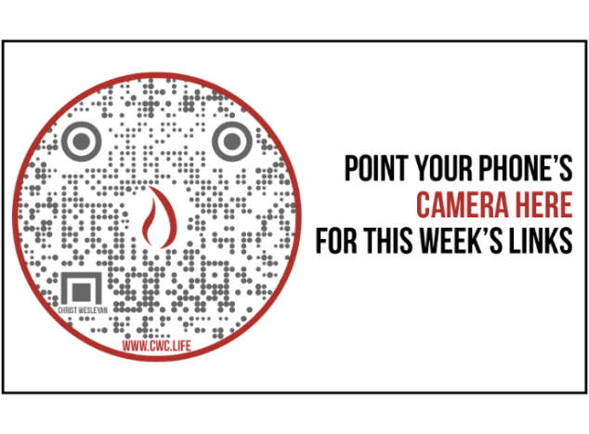

Giving & Attendance Update
Giving last Sunday: 119.5%
Giving year to date: 86.1% of goal
Attendance Last Weekend: 1,889
Salvations to date: 302 | Baptisms to date: 65

Upcoming Happenings:
Tuesday, February 24th-April 4th – 40 Days of Prayer and Fasting!

Sunday, March 29th – Voting by members for leadership positions (Sunbury and Milton Campus)

Easter Sunday (NO SATURDAY NIGHT SERVICE)
Milton Campus: 6:30a (Sunrise Service), 9:00a and 10:45a
Sunbury Campus: 10:15a

“Reach the One” Campaign Update
452 Total Participants
$4,000,000 – Giving Goal by Nov. 2027
$2,346,651.52 - Donations Expected by Nov. 2027
$1,731,558.76 - Received Donations – 43% of $4M Goal

Want to pledge, donate, or learn more?

Scan:

Looking for your next step at CWC?
Welcome Party: 1st Sunday of Every Month (Except for Easter Sunday)
- If you are new or if you’ve been around a bit and are looking to build friendships with others, our Welcome Party is for you! Get to know others who are newer at CWC as well as our welcome team and our pastors in a relational environment. There will be light refreshments and the opportunity to hear about our small groups, baptism, and your next step of Growth Track. If you’re asking the question, “How can I make friends here?” then this is for you! No registration is required, you can just show up. Look for the signs on the first Sunday of the month.

Growth Track: 3-week class on Sunday Mornings
- Growth Track exists to help you learn about the vision of CWC, the gifts God has given you, and how you can use them in specific opportunities to serve at CWC. You’ll learn amongst others of how to become a vital part of the ministries of the church so that we can share the light of Christ with our communities. If you miss a class, don’t worry! Growth Track runs every other month, on Sunday mornings, and we even have an online option you can participate in (though we recommend in-person if you can). You can see what classes are available by going to cwclife.churchcenter.com/registrations.

Membership Class: Once a quarter on Sundays after 2nd service
- Membership class is the last step of fully assimilating at CWC. Learn about our denomination, The Wesleyan Church and the bigger movement we are a part of across the world. This 3-hour class with the lead pastor provides you a place to ask important questions about our beliefs as a church and allows you to become eligible for our local board of administration. You also become eligible for denominational events like our district and general conferences. To sign up for our next class, let us know at the Hub or email: loretta.paulhamus@cwc.life

