February 22nd, 2026 – Week #4
Milton Campus – Pastor Branden Mestach

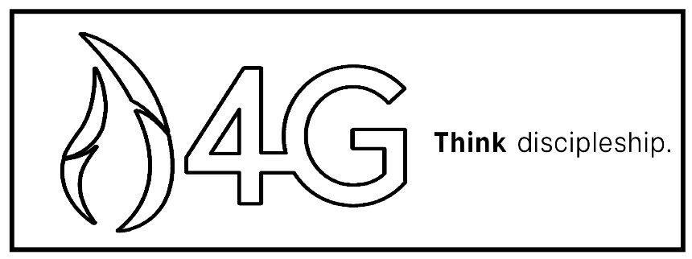
Go

Matthew 26:21-25
John 15:16
Matthew 28:18-20

Our _________ Statement
Sharing the Light of Jesus Christ with our world.

Our _______ Statement
To be one thriving, multi-site church, equipping fully engaged disciples who boldly share the Light of Jesus Christ near and far beyond the four walls of our church.

Our Plan for _____________ That Vision:

100% of Christ Wesleyan as 4G Disciples. We:

- _______ – together in a weekend service.

- ______ – together outside of a weekend service.

- ______ – of our time, talents, and resources.

- _____ – be a disciple who makes other disciples.
- Go – It Starts in the ________.
- Is God the ________ of your life?
“And while they were eating, He said, ‘Truly I tell you, one of you will betray Me.’ They were very sad and began to say to Him one after another, ‘Surely you don’t mean me, Lord?’” Matthew 26:21-22 (NIV)

- Is God the ________ of your life?
“Then Judas, the one who would betray Him, said, ‘Surely you don’t mean me, Rabbi?’ Jesus answered, ‘You have said so.’” Matthew 26:25 (NIV)

Notetakers are History Makers:
________________________________________________________________________________________________________________________________________________________________________________________________________________________________________________________________________________________________

- Go – It’s an _________________.
- We have been ______________ and commissioned.
“You did not choose Me, but I chose you…” John 15:16a (NIV)

- Our qualifications do not come from our ability, but from _____ appointment.
“…and appointed you so that you might go and bear fruit—fruit that will last—and so that whatever you ask in My name the Father will give you.” John 15:16b-c (NIV)

Notetakers are History Makers:
________________________________________________________________________________________________________________________________________________________________________________________________________________________________________________
________________________________________________
- Go – It’s a Mandated Posture
- When we Go, we go with authority.
“Then Jesus came to them and said, ‘All authority in Heaven and on Earth has been given to Me. Therefore, go and make disciples of all nations…” Matthew 28:18-19a (NIV)

- When we Go, we teach obedience.
“…baptizing them in the name of the Father and of the Son and of the Holy Spirit and teaching them to obey everything I have commanded you.” Matthew 28:19b-20a (NIV)

- When we Go, we are not alone.
“And surely I am with you always, to the very end of the age.” Matthew 28:20b (NIV)

Notetakers are History Makers:
________________________________________________________________________________________________________________________________________________________________________________________________________________________________________________________________________________________________

Bottom Line:
Disciple-Makers don’t just follow a Rabbi
to learn, they obey a Lord to go.

Or

We gather, grow, and give—so that we are equipped to go.

To begin a relationship with Jesus…
Text: “Jesus” to 570-273-0088

Next Sunday: New Series!
Darkness Defeated

Week 1:
Darkness Defeated in the Garden
Genesis 3:14-15
Genesis 3:21-24

Milton Campus: Pastor Branden Mestach
Sunbury Campus: Pastor Billy Robel



Giving & Attendance Update
Giving last Sunday: 68.6%
Giving year to date: 85.8% of goal
Attendance Last Weekend: 1,854
Salvations to date: 97 | Baptisms to date: 65

Upcoming Happenings:
Tuesday, February 24th-April 5th – 40 Days of Prayer and Fasting!

Friday, March 6th – Classics Movie Night! 7:00p – Youth Center

“Reach the One” Campaign Update
447 Total Participants
$4,000,000 – Giving Goal by Nov. 2027
$2,260,816.62 - Donations Expected by Nov. 2027
$1,599,176.12 - Received Donations – 40% of $4M Goal

Want to pledge, donate, or learn more?

Scan:

Looking for your next step at CWC?
Welcome Party: 1st Sunday of Every Month (Except for Easter Sunday)
- If you are new or if you’ve been around a bit and are looking to build friendships with others, our Welcome Party is for you! Get to know others who are newer at CWC as well as our welcome team and our pastors in a relational environment. There will be light refreshments and the opportunity to hear about our small groups, baptism, and your next step of Growth Track. If you’re asking the question, “How can I make friends here?” then this is for you! No registration is required, you can just show up. Look for the signs on the first Sunday of the month.

Growth Track: 3-week class on Sunday Mornings
- Growth Track exists to help you learn about the vision of CWC, the gifts God has given you, and how you can use them in specific opportunities to serve at CWC. You’ll learn amongst others of how to become a vital part of the ministries of the church so that we can share the light of Christ with our communities. If you miss a class, don’t worry! Growth Track runs every other month, on Sunday mornings, and we even have an online option you can participate in (though we recommend in-person if you can). You can see what classes are available by going to cwclife.churchcenter.com/registrations.

Membership Class: Once a quarter on Sundays after 2nd service
- Membership class is the last step of fully assimilating at CWC. Learn about our denomination, The Wesleyan Church and the bigger movement we are a part of across the world. This 3-hour class with the lead pastor provides you a place to ask important questions about our beliefs as a church and allows you to become eligible for our local board of administration. You also become eligible for denominational events like our district and general conferences. To sign up for our next class, let us know at the Hub or email: loretta.paulhamus@cwc.life

