January 25th, 2026 – Week #9
Milton Campus – Pastor Arlie Davis
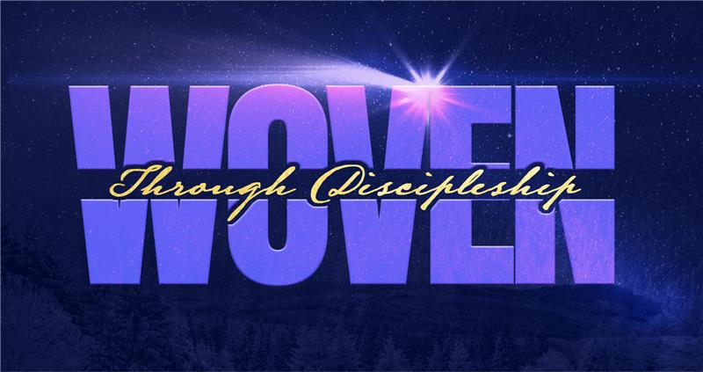

“It’s Time to
Grow Up”

“You have been believers so long now that you ought to be teaching others. Instead, you need someone to teach you again the basic things about God’s Word. You are like babies who need milk and cannot eat solid food.” Hebrews 5:12 NLT

What is spiritual ______?
“Like newborn babies crave pure spiritual milk, so that by it you may grow up in your salvation.” 1 Peter 2:2
- Milk is the ________...Reading your Bible, prayer, fellowship, service, stewardship.
- Milk is for ___________.
- Milk is always _____.
- Milk is ____________.
- Milk is ______...clean heart, clean conscience, and a willingness to obey and follow Jesus!

What are the ___________ to spiritual maturity?
- You don’t ______... “you no longer try to understand.” NIV “...since you are spiritually dull and don’t seem to listen.” NLT “...since you have picked up this bad habit of not listening.” MSG Hebrews 5:11b

You hear...but you don’t listen. Listening is a learned skill and takes mental effort.
“Do not merely listen to the Word, and so deceive yourselves. Do what it says. Anyone who listens to the Word but does not do what it says is like someone who looks at his face in a mirror and, after looking at himself, goes away and immediately forgets what he looks like. But whoever looks intently into the perfect law that gives freedom, and continues in it-not forgetting what they have heard, but doing it-they will be blessed in what they do.” James 1:22-25 NIV
- You don’t know _______...“you need someone to teach you again the basic things about God’s Word.”NLT “...you need someone to teach you the elementary truths of God’s Word all over again.” NIV Hebrews 5:12a
- You don’t do what is _____...“doesn’t know how to do what is right.” NLT “...is not acquainted with the teaching about righteousness.” NIV Hebrews 5:13b
- You don’t ________...“...who through training...” NLT “...constant use...” NIV Hebrews 5:14b
- You don’t ________ right and wrong... “...recognize the difference between right and wrong.” NLT “...have trained themselves to distinguish good from evil.” NIV Hebrews 5:14c
“Aren’t you living like people of the world?” NLT
1 Corinthians 3:3b (Sinful desires, jealousy, quarreling)
*See B. 5. a

What is spiritual meat?
- Meat is living to please ____ rather than living to please yourself.
“So, we make it our goal to please Him, whether we are at home in the body or away from it.” 2 Corinthians 5:9 NIV
- Meat is practicing __________ on a daily basis.
“If you love me, keep my commandments.” John 14:15 NIV
- Meat is developing __________ in things that draw you closer to God.
“So, my dear brothers and sisters, be strong and immovable. Always work enthusiastically for the Lord, for you know that nothing you do for the Lord is ever useless.” 1 Corinthians 15:58 NLT
- Meat is ________ by the Spirit.
“Since we live by the Spirit, let us keep in step with the Spirit.” Galatians 5:25 NIV
- Meat is _________ as you go along, what pleases God!
“and find out what please the Lord.” Ephesians 5:10 NIV

So, how do we get there?
- ________ that God has given everything you need to be fruitful and effective and begin thanking Him for it!
“His divine power has given us everything we need for a godly life through our knowledge of Him who called us by His own glory and goodness...they will keep you from being ineffective and unproductive in your knowledge of our Lord Jesus Christ.” 2 Peter 1:3,8b NIV
- See yourself as a ____________ person in Christ!
“...let God transform you into a new person...” Romans 12:2b NLT
- Know that every ________ can become an action!
“Guard your heart above all else, for it determines the course of your life.” Proverbs 4:23 NLT
“A person’s character, circumstances, and destiny are shaped by their thoughts.” -Jame Allen
- Give a conscious ______ to change the way you think!
“...by changing the way you think.” Romans 12:2c NLT
- Ask yourself these questions and _____ your thinking:
“Examine yourselves to see whether you are in the faith; test yourselves.” 2 Corinthians 13:5a NIV
Do my thoughts align with Scripture?
Do my thoughts draw me closer to God?
Do my thoughts make me look more like Jesus?
Do my thoughts maintain my integrity?

“And so, dear brothers and sisters, I plead with you to give your bodies to God because of all He has done for you. Let them be a living and holy sacrifice-the kind He will find acceptable. This is truly the way to worship Him. Don’t copy the behavior and customs of this world, but let God transform you into a new person by changing the way you think. Then you will learn to know God’s will for you, which is good and pleasing and perfect.” Romans 12:1-2 NLT

Here is a prayer I suggest for today:
Dear Lord,
I want to surrender each and every area of my life. (Pause to reflect) My desire is to release those things that have held me back from growing in my spiritual life...unforgiveness, bitterness, anger, jealousy, greed, envy, unhealthy relationships, lust, addictions, or anything that could stand in the way of my walk with Christ. I confess my need to fully follow you and need your power to see this accomplished in me. I want to walk in freedom...to grow in my faith...to see God answer prayer...to win others to Christ...and to be all He has called me to be! I am thanking you for the answer to this because in 1 Thessalonians 5:24, you say, “The one who calls you is faithful, and He will do it.”
In Jesus Name,
Amen

*B. 5. a.
“Immature thinking involves a lack of emotional, social, and intellectual development, characterized by impulsivity, self-centeredness, and an inability to see beyond immediate feelings or needs, often resembling a child's worldview with black-and-white thinking, blame shifting, and difficulty with empathy or long-term consequences. It’s about acting based on raw emotion rather than reasoned consideration, failing to take responsibility, and struggling with complex perspectives.”

“Spiritual immaturity means a person hasn’t fully grown in their faith, characterized by easily swayed by new ideas, lacking the discernment (like a spiritual baby), being inconsistent in practices (prayer, Bible study), acting self-centered, resisting correction, and struggling with emotional control or worldly desires, rather than developing Christ-like character, wisdom, and stable, mature faith. It’s a state of spiritual infancy often seen in new believers, where consistent spiritual growth is lacking, leading to instability and susceptibility to error.”
One of the significant causes of spiritual immaturity can be directly linked to our emotional maturity.
“Emotional immaturity may have its roots in childhood issues like trauma or neglect and can hinder spiritual growth.
Emotional intelligence (EI or EQ) is the skill of understanding and managing your own emotions, plus recognizing and influencing the emotions of others to navigate social situations, building relationships, relieve stress, and solve problems effectively. It involves self-awareness (knowing your feelings), self-regulation (managing your feelings), empathy (understanding others), and social skills (handling relationships).”
To begin a relationship with Jesus…
Text: “Jesus” to 570-273-0088

Next Sunday:
Vision - Gather
Acts 2:42-47

Milton Campus: Pastor Branden Mestach
Sunbury Campus: Pastor Billy Robel


Giving & Attendance Update
Giving last Sunday: 59.5%
Giving year to date: 86.4% of goal
Attendance Last Weekend: 1,761
Salvations to date: 95 | Baptisms to date: 54

“Reach the One” Campaign Update
161 – Pledges with 440 Total Participants
$2,250,171.91 - Donations Anticipated by Nov. 2027
$1,566,664.03 - Received Donations – 39% of $4M Goal

Want to pledge, donate, or learn more?

Scan:

Upcoming Happenings:

- Classics Dinner - February 6th; Silver Moon banquet hall at 6pm. Sign up by February 1st

- Enchanted Evening- February 21st, Sat @ 2pm

- Women’s DIY Event- February 21st

Looking for your next step at CWC?
Welcome Party – 1st Sunday of Every Month
- If you are new or if you’ve been around a bit and are looking to build friendships with others, our Welcome Party is for you! Get to know others who are newer at CWC as well as our welcome team and our pastors in a relational environment. There will be light refreshments and the opportunity to hear about our small groups, baptism, and your next step of Growth Track. If you’re asking the question, “How can I make friends here,” then this is for you! No registration is required, you can just show up. Look for the signs on the first Sunday of the month.

Growth Track – 3-week class on Sunday Mornings or Wednesday Nights
- Growth Track exists to help you learn about the vision of CWC, the gifts God has given you, and how you can use them in specific opportunities to serve at CWC. You’ll learn amongst others of how to become a vital part of the ministries of the church so that we can share the light of Christ with our communities. If you miss a class, don’t worry! Growth Track runs every other month and we even have an online option you can participate in (though we recommend in-person if you can). You can see what classes are available by going to bit.ly/cwcgrowthtrack.

Membership Class – Once a quarter on Sundays after 2nd service
- Membership class is the last step of fully assimilating at CWC. Learn about our denomination, The Wesleyan Church and the bigger movement we are a part of across the world. This 3-hour class with the lead pastor provides you a place to ask important questions about our beliefs as a church and allows you to become eligible for our local board of administration. You also become eligible for denominational events like our district and general conferences. To sign up for our next class, let us know at the Hub or email: loretta.paulhamus@cwc.life

