January 18th, 2026 – Week #8
Milton Campus – Pastor Eddie Witkowski
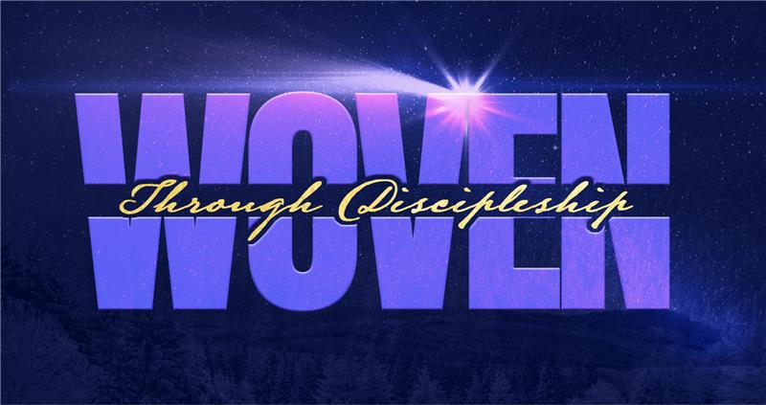

Bring my Coat

Acts 9 - 16

\
- Barnabas

- Barnabas looks for someone to _______.

- Barnabas seeks out someone to _______.

- Barnabas disciples someone in his own ________.

- Barnabas is not willing to _______, even in the face of ___________.

- Paul

- Paul invites Timothy to _______________.

- Paul invests _________ and ___________.

- Paul is an ___________ man.

- You

- Where in your life can you seek someone out, like Barnabas did for Paul?

- Where in your life, can you make the simple invite that Paul gave Timothy? Come with me.

- Who inside of your family, do you need to set your fear of rejection aside, and intentionally begin to disciple?

- Midweek Options

- How to Read & Understand the Bible with Allison Eager

- Hearing God with Pastor Erik Ireland

- Reading the Bible Together with Pastor Darrell Lamos

- Real-Life Discipleship with Pastor Kyle Roberts

- The Art of Parenting with Mike & Kendra Wright

Bottom Line:
You don’t need to be perfect… you just need to be intentional. The rest is in God hands.

To begin a relationship with Jesus…
Text: “Jesus” to 570-273-0088

Next Sunday:
Woven - Through Discipleship:
Paul—Acts 9:15-22

Milton Campus: Pastor Arlie Davis
Sunbury Campus: Dr. Charles Kim



Giving & Attendance Update
Giving last Sunday: 101.5%
Giving year to date: 87.1% of goal
Attendance Last Weekend: 1,989
Salvations to date: 93 | Baptisms to date: 54

“Reach the One” Campaign Update
161 – Pledges with 440 Total Participants
$2,248,653 - Donations Anticipated by Nov. 2027
$1,562,747.54 - Received Donations – 39% of $4M Goal

Want to pledge, donate, or learn more?

Scan:

Upcoming Happenings:

- CWC Kidz Behind the Scenes Tour - January 18th
after both services in Milton

- Classics Dinner - February 6th; Silver Moon banquet hall at 6pm. Sign up by February 1st

- Enchanted Evening- February 21st, Sat @ 2pm

- Women’s DIY Event- February 21st

Notetakers are history makers:

Looking for your next step at CWC?
Welcome Party – 1st Sunday of Every Month
- If you are new or if you’ve been around a bit and are looking to build friendships with others, our Welcome Party is for you! Get to know others who are newer at CWC as well as our welcome team and our pastors in a relational environment. There will be light refreshments and the opportunity to hear about our small groups, baptism, and your next step of Growth Track. If you’re asking the question, “How can I make friends here,” then this is for you! No registration is required, you can just show up. Look for the signs on the first Sunday of the month.

Growth Track – 3-week class on Sunday Mornings or Wednesday Nights
- Growth Track exists to help you learn about the vision of CWC, the gifts God has given you, and how you can use them in specific opportunities to serve at CWC. You’ll learn amongst others of how to become a vital part of the ministries of the church so that we can share the light of Christ with our communities. If you miss a class, don’t worry! Growth Track runs every other month and we even have an online option you can participate in (though we recommend in-person if you can). You can see what classes are available by going to bit.ly/cwcgrowthtrack.

Membership Class – Once a quarter on Sundays after 2nd service
- Membership class is the last step of fully assimilating at CWC. Learn about our denomination, The Wesleyan Church and the bigger movement we are a part of across the world. This 3-hour class with the lead pastor provides you a place to ask important questions about our beliefs as a church and allows you to become eligible for our local board of administration. You also become eligible for denominational events like our district and general conferences. To sign up for our next class, let us know at the Hub or email: loretta.paulhamus@cwc.life

