January 11th, 2026 – Week #7
Milton Campus – Pastor Branden Mestach
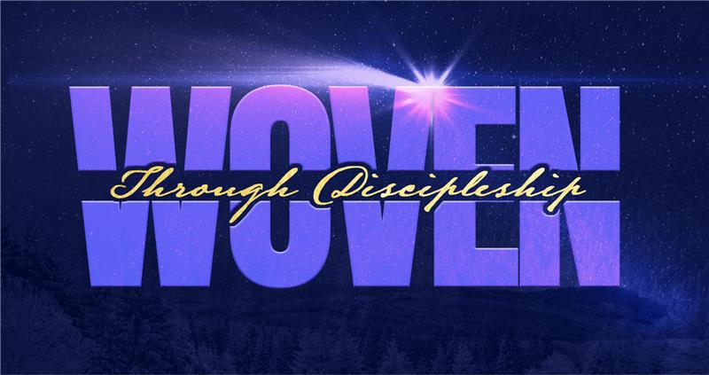
Making of a Disciple:
Paul

Acts 9:15-22

\
A. The Main _________
- Saul spent days hearing ________ accounts.
“Saul spent several days with the disciples in Damascus.” Acts 9:19b (NIV)

- Saul _______________ used his new calling.
“At once he began to preach in the synagogues that Jesus is the Son of God.” Acts 9:20 (NIV)

- Saul…wait, _____?
“All those who heard him were astonished and asked, ‘Isn’t he the man who raised havoc in Jerusalem among those who call on this name? And hasn’t he come here to take them as prisoners to the chief priests?’” Acts 9:21 (NIV)

- The Flashback: The ______________
- Saul’s ______________ with Jesus changed a man from villain to disciple.
“Meanwhile, Saul was still breathing out murderous threats against the Lord’s disciples. He went to the high priest and asked him for letters to the synagogues in Damascus, so that if he found any there who belonged to the Way, whether men or women, he might take them as prisoners to Jerusalem. As he neared Damascus on his journey, suddenly a light from heaven flashed around him. He fell to the ground and heard a voice say to him, ‘Saul, Saul, why do you persecute Me?’ ‘Who are You, Lord?’ Saul asked. ‘I am Jesus, Whom you are persecuting,’ He replied. ‘Now get up and go into the city, and you will be told what you must do.’” Acts 9:1-6 (NIV)

- Saul’s faithful friend simply ____________.
“But the Lord said to Ananias, ‘Go! This man is My chosen instrument to proclaim My name to the Gentiles and their kings and to the people of Israel. I will show him how much he must suffer for My name.’” Acts 9:15-16 (NIV)

- Saul’s physical and spiritual healings were the result of ________________.
“Then Ananias went to the house and entered it. Placing his hands on Saul, he said, ‘Brother Saul, the Lord—Jesus, Who appeared to you on the road as you were coming here—has sent me so that you may see again and be filled with the Holy Spirit.’ Immediately, something like scales fell from Saul’s eyes, and he could see again. He got up and was baptized and after taking some food, he regained his strength.” Acts 9:17-19a (NIV)

- Saul’s growth despite _____ was surprising.
“Yet Saul grew more and more powerful and baffled the Jews living in Damascus by proving that Jesus is the Messiah.” Acts 9:22 (NIV)

- The Making of a Modern Disciple
- Surrender – The Willing Instrument
“Teach me to do Your will, for You are my God; may Your good Spirit lead me on level ground.” Psalm 143:10 (NIV)

“Lord, what do You want me to do?”

- Scales – The New Perspective
“I pray that the eyes of your heart may be enlightened in order that you may know the hope to which He has called you, the riches of His glorious inheritance in His holy people.” Ephesians 1:18 (NIV)

“Lord, are there any ways I need to be enlightened in my faith life?”

- Strength – The Divine Fuel
“Finally, be strong in the Lord and in His mighty power.” Ephesians 6:10 (NIV)

“Let’s consider how to provoke one another to love and good works, not forsaking our own assembling together, as the custom of some is, but exhorting one another, and so much the more as you see the Day approaching.” Hebrews 10:24-25 (WEB)

“Lord, how can I find (more) strength in the Word and fellowship?”

Bottom Line:
You aren't just a spectator of the Gospel;
you are a thread in the rescue mission.

To begin a relationship with Jesus…
Text: “Jesus” to 570-273-0088

Next Sunday:
Woven – Through Discipleship:
Celebration Sunday!

Milton Campus: Pastor Eddie Witkowski
Sunbury Campus: Pastor Drew Lahr



Giving & Attendance Update
Giving last Sunday: 84.2%
Giving year to date: 86.7% of goal
Attendance Last Weekend: 1,902
Salvations to date: 93 | Baptisms to date: 54

“Reach the One” Campaign Update
160 – Pledges with 439 Total Participants
$2,244,444.32 - Donations Anticipated by Nov. 2027
$1,554,857.72 - Received Donations – 39% of $4M Goal

Want to pledge, donate, or learn more?

Scan:

Upcoming Happenings:
Membership Class – TODAY after second service in room 102! Pizza and snacks provided.

Notetakers are history makers:

Looking for your next step at CWC?
Welcome Party – 1st Sunday of Every Month
- If you are new or if you’ve been around a bit and are looking to build friendships with others, our Welcome Party is for you! Get to know others who are newer at CWC as well as our welcome team and our pastors in a relational environment. There will be light refreshments and the opportunity to hear about our small groups, baptism, and your next step of Growth Track. If you’re asking the question, “How can I make friends here,” then this is for you! No registration is required, you can just show up. Look for the signs on the first Sunday of the month.

Growth Track – 3-week class on Sunday Mornings or Wednesday Nights
- Growth Track exists to help you learn about the vision of CWC, the gifts God has given you, and how you can use them in specific opportunities to serve at CWC. You’ll learn amongst others of how to become a vital part of the ministries of the church so that we can share the light of Christ with our communities. If you miss a class, don’t worry! Growth Track runs every other month and we even have an online option you can participate in (though we recommend in-person if you can). You can see what classes are available by going to bit.ly/cwcgrowthtrack.

Membership Class – Once a quarter on Sundays after 2nd service
- Membership class is the last step of fully assimilating at CWC. Learn about our denomination, The Wesleyan Church and the bigger movement we are a part of across the world. This 3-hour class with the lead pastor provides you a place to ask important questions about our beliefs as a church and allows you to become eligible for our local board of administration. You also become eligible for denominational events like our district and general conferences. To sign up for our next class, let us know at the Hub or email: loretta.paulhamus@cwc.life

