January 4th, 2026 – Week #6
Milton Campus – Pastor Branden Mestach
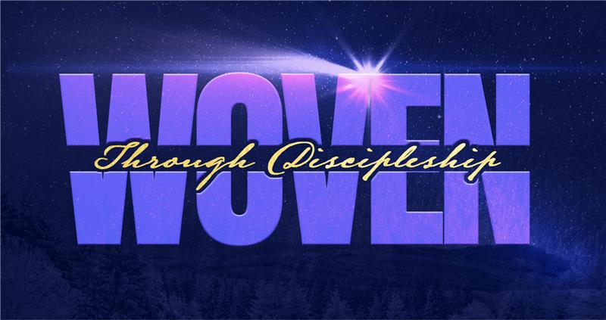
Making of a Disciple:
Peter

Acts 2:14-24

\
A. Peter and the _____________ Plan
- A Woven ____________
“The Lord turned and looked straight at Peter. Then Peter remembered the word the Lord had spoken to him: ‘Before the rooster crows today, you will disown Me three times.’ And he went outside and wept bitterly.” Luke 22:61-62 (NIV)

- A Woven __________________
“‘And I tell you that you are Peter, and on this rock I will build My church, and the gates of Hades will not overcome it.’” Matthew 16:18 (NIV)

- A Woven _________
“Then Peter stood up with the Eleven, raised his voice and addressed the crowd: ‘Fellow Jews and all of you who live in Jerusalem, let me explain this to you; listen carefully to what I say. These people are not drunk, as you suppose. It’s only nine in the morning.’” Acts 2:14-15 (NIV)

- Peter and the ___________ Weave
- A Prophetic ____________
“No, this is what was spoken by the prophet Joel: ‘In the last days, God says, I will pour out My Spirit on all people.’” Acts 2:16-17a (NIV)

- A Structural ____________
“‘Fellow Israelites, listen to this: Jesus of Nazareth was a man accredited by God to you by miracles, wonders and signs, which God did among you through Him, as you yourselves know. This man was handed over to you by God’s deliberate plan and foreknowledge; and you, with the help of wicked men, put Him to death by nailing Him to the cross.’” Acts 2:22-23 (NIV)

- An ________________ Thread
“‘But God raised Him from the dead, freeing Him from the agony of death, because it was impossible for death to keep its hold on Him.’” Acts 2:24 (NIV)

- Submitting to the Weaver
- Stop gritting and start bringing.
“My sacrifice, O God, is a broken spirit; a broken and contrite heart You, God, will not despise.” Psalm 51:17 (NIV)

- Submit to the tension
“For the Spirit God gave us does not make us timid, but gives us power, love and self-discipline.” 2 Timothy 1:7 (NIV)

- Interlock with the local church.
“Though one may be overpowered, two can defend themselves. A cord of three strands is not quickly broken.” Ecclesiastes 4:12 (NIV)

Bottom Line:
Surrender your frays to the Weaver;
He spins every broken strand into a
discipleship plan that death cannot hold.

To begin a relationship with Jesus…
Text: “Jesus” to 570-273-0088

Next Sunday:
Woven - Through Discipleship:
Paul—Acts 9:15-22

Milton Campus: Pastor Branden Mestach
Sunbury Campus: Pastor Billy Robel



Giving & Attendance Update
Giving last Sunday: 91.5%
Giving year to date: 86.8% of goal
Attendance Last Weekend: 1,631
Salvations to date: 91 | Baptisms to date: 54

“Reach the One” Campaign Update
160 – Pledges with 435 Total Participants
$2,235,524.62 - Donations Anticipated by Nov. 2027
$1,534,018.76 - Received Donations – 39% of $4M Goal

Want to pledge, donate, or learn more?

Scan:

Upcoming Happenings:
Men’s Breakfast – January 10th @ 8a-10a in Milton Campus Youth Center

Volunteer Red Carpet Ceremony – January 18th @ 3p-4:30p Milton Campus Auditorium
Notetakers are history makers:

Looking for your next step at CWC?
Welcome Party – 1st Sunday of Every Month
- If you are new or if you’ve been around a bit and are looking to build friendships with others, our Welcome Party is for you! Get to know others who are newer at CWC as well as our welcome team and our pastors in a relational environment. There will be light refreshments and the opportunity to hear about our small groups, baptism, and your next step of Growth Track. If you’re asking the question, “How can I make friends here,” then this is for you! No registration is required, you can just show up. Look for the signs on the first Sunday of the month.

Growth Track – 3-week class on Sunday Mornings or Wednesday Nights
- Growth Track exists to help you learn about the vision of CWC, the gifts God has given you, and how you can use them in specific opportunities to serve at CWC. You’ll learn amongst others of how to become a vital part of the ministries of the church so that we can share the light of Christ with our communities. If you miss a class, don’t worry! Growth Track runs every other month and we even have an online option you can participate in (though we recommend in-person if you can). You can see what classes are available by going to bit.ly/cwcgrowthtrack.

Membership Class – Once a quarter on Sundays after 2nd service
- Membership class is the last step of fully assimilating at CWC. Learn about our denomination, The Wesleyan Church and the bigger movement we are a part of across the world. This 3-hour class with the lead pastor provides you a place to ask important questions about our beliefs as a church and allows you to become eligible for our local board of administration. You also become eligible for denominational events like our district and general conferences. To sign up for our next class, let us know at the Hub or email: loretta.paulhamus@cwc.life

