December 7th, 2025 – Week #1
Milton Campus – Pastor Branden Mestach
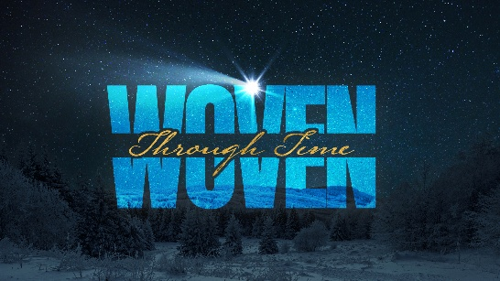
In the Beginning

Quest Book:
Chapter 1

John 1:1-18

A. The Word ________________
- The Word: The Eternally Existing _______
“In the beginning was the Word, and the Word was with God, and the Word was God. He was with God in the beginning.” John 1:1-2(NIV)

- The Word: The Weaver of ____________
“Through Him all things were made; without Him nothing was made that had been made.” John 1:3(NIV)

- The Word: The Unquenchable ________
“In Him was life, and that life was the light of all mankind. The light shines in the darkness, and the darkness has not overcome it.” John 1:4-5(NIV)

- The Word _____________
- The Witness ____________
“There was a man sent from God whose name was John. He came as a witness to testify concerning that light, so that through him all might believe. He himself was not the light; he came only as a witness to the light. The true light that gives light to everyone was coming into the world.” John 1:6-9(NIV)

- The Light Revealed and ____________
“He was in the world, and though the world was made through Him, the world did not recognize Him. He came to that which was His own, but His own did not receive Him.” John 1:10-11(NIV)

- The Culmination of the Cosmic ________
“The Word became flesh and made His dwelling among us. We have seen His glory, the glory of the One and only Son, Who came from the Father, full of grace and truth.” John 1:14(NIV)

- The Word Received
- The Condition and Result of Receiving
“Yet to all who did receive Him, to those who believed in His name, He gave the right to become children of God…” John 1:12(NIV)

- The Source of New Life
“…children born not of natural descent, nor of human decision or a husband’s will, but born of God.” John 1:13(NIV)

- The Believer’s Task: To Make God Known
“No one has ever seen God, but the One and only Son, Who is Himself God and is in closest relationship with the Father, has made Him known.” John 1:18(NIV)

“We are therefore Christ’s ambassadors, as though God were making His appeal through us. We implore you on Christ’s behalf: Be reconciled to God. God made Him Who had no sin to be sin for us, so that in Him we might become the righteousness of God. As God’s co-workers we urge you not to receive God’s grace in vain.” 2 Corinthians 5:20-6:1 (NIV)

Bottom Line:
Receive Christ.
Join the cosmic weave.

To begin a relationship with Jesus…
Text: “Jesus” to 570-273-0088

Next Sunday: Woven: Jesus Through Time.

Week 2: In the Lineage
Quest Book: Chapter 2

Milton Campus: Pastor Eric Ireland
Sunbury Campus: Pastor Billy Robel
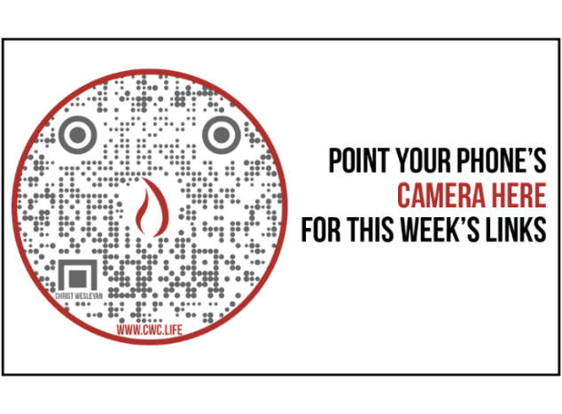

Giving & Attendance Update
Giving last Sunday: 50.3%
Giving year to date: 86% of goal
Attendance Last Weekend: 1,788
Salvations to date: 85 | Baptisms to date: 54

“Reach the One” Campaign Update
160 – Pledges with 427 Total Participants
$2,180,341.88 - Donations Anticipated by Nov. 2027
$1,401,106.69 - Received Donations – 35% of $4M Goal

Want to pledge, donate, or learn more?

Scan:

Upcoming Happenings:
December 12th and 13th- Christmas Encounter! 6:30p.

December 20th – Christmas Meal Distribution/Volunteer Day

December 24th - Christmas Eve Candlelight Service
Milton Campus: 3:00p, 4:30p, and 6:00p
Sunbury Campus: 3:00p and 6:00p
Notetakers are History Makers

Looking for your next step at CWC?
Welcome Party – 1st Sunday of Every Month
- If you are new or if you’ve been around a bit and are looking to build friendships with others, our Welcome Party is for you! Get to know others who are newer at CWC as well as our welcome team and our pastors in a relational environment. There will be light refreshments and the opportunity to hear about our small groups, baptism, and your next step of Growth Track. If you’re asking the question, “How can I make friends here,” then this is for you! No registration is required, you can just show up. Look for the signs on the first Sunday of the month.

Growth Track – 3-week class on Sunday Mornings or Wednesday Nights
- Growth Track exists to help you learn about the vision of CWC, the gifts God has given you, and how you can use them in specific opportunities to serve at CWC. You’ll learn amongst others of how to become a vital part of the ministries of the church so that we can share the light of Christ with our communities. If you miss a class, don’t worry! Growth Track runs every other month and we even have an online option you can participate in (though we recommend in-person if you can). You can see what classes are available by going to bit.ly/cwcgrowthtrack.

Membership Class – Once a quarter on Sundays after 2nd service
- Membership class is the last step of fully assimilating at CWC. Learn about our denomination, The Wesleyan Church and the bigger movement we are a part of across the world. This 3-hour class with the lead pastor provides you a place to ask important questions about our beliefs as a church and allows you to become eligible for our local board of administration. You also become eligible for denominational events like our district and general conferences. To sign up for our next class, let us know at the Hub or email: loretta.paulhamus@cwc.life

