November 16th, 2025 – Week #5
Milton Campus – Pastor Branden Mestach
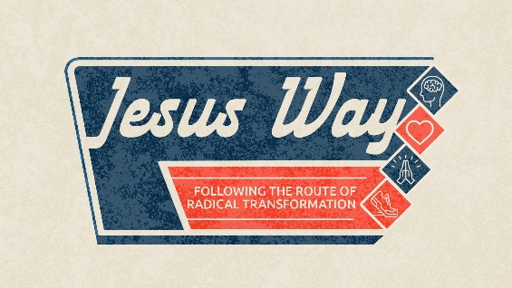
Dead End

Quest Book:
Chapter 31

Luke 15:11-32

“Now the tax collectors and sinners were all gathering around to hear Jesus. But the Pharisees and the teachers of the law muttered, ‘This Man welcomes sinners and eats with them.’ Then Jesus told them this parable…” Luke 15:1-3 (NIV)

A. The Choice of Repentance or _______
- ____________ a dead end.
“Not long after that, the younger son got together all he had, set off for a distant country and there squandered his wealth in wild living. After he had spent everything, there was a severe famine in that whole country, and he began to be in need.” Luke 15:13-14 (NIV)

- The ________ at the dead end.
“When he came to his senses, he said, ‘How many do my father’s hired servants have food to spare, and here I am starving to death! I will set out and go back to my father and say to him: Father, I have sinned against heaven and against you. I am no longer worthy to be called your son; make me like one of your hired servants.’ So he got up and went to his father.” Luke 15:17-20a (NIV)

- The ________ from the dead end.
“But while he was still a long way off, his father saw him and was filled with compassion for him; he ran to his son, threw his arms around him and kissed him. The son said to him, ‘Father, I have sinned against heaven and against you. I am no longer worthy to be called your son.’ But the father said to his servants…” Luke 15:20b-22a (NIV)
- The Choice of Repentance or ________
- ___________ a dead end.
“The older brother became angry and refused to go in. So his father went out and pleaded with him.” Luke 15:28 (NIV)

- The dead end of performance-based ______.
“But he answered his father, ‘Look! All these years I’ve been slaving for you and never disobeyed your orders. Yet you never gave me even a young goat so I could celebrate with my friends. But when this son of yours who has squandered your property with prostitutes comes home, you kill the fattened calf for him!’” Luke 15:29-30 (NIV)

- The ______ of the father at the dead end.
“‘My son,’ the father said, ‘you are always with me, and everything I have is yours. But we had to celebrate and be glad, because this brother of yours was dead and is alive again; he was lost and is found.’” Luke 15:31-32 (NIV)

- God’s Invitation at the Dead End.
- Are you lost in the pigpen of obvious sin?
“But God demonstrates His own love for us in this: While we were still sinners, Christ died for us.” Romans 5:8 (NIV)

- Are you lost in the pigpen of subtle pride?
“For all those who exalt themselves will be humbled, and those who humble themselves will be exalted.” Luke 18: 14b (NIV)

- Are you found in the celebration of the lost?
“I tell you that in the same way there will be more rejoicing in Heaven over one sinner who repents than over ninety-nine righteous persons who do not need to repent.” Luke 15:7 (NIV)

Bottom Line:
The Father runs to identity, not performance.

To begin a relationship with Jesus…
Text: “Jesus” to 570-273-0088

Next Sunday: Jesus’ Way
Following the Route of Radical Transformation

Week 6: (S)oil Change
Quest Book: Chapter 32

Milton Campus: Pastor Branden Mestach
Sunbury Campus: Pastor Billy Robel


Giving & Attendance Update
Giving last Sunday: 102.2%
Giving year to date: 87.9% of goal
Attendance Last Weekend: 1,813
Salvations to date: 85 | Baptisms to date: 54

“Reach the One” Campaign Update
160 – Pledges with 419 Total Participants
$2,171,177.69 - Donations Anticipated by Nov. 2027
$1,358,302.61 - Received Donations – 33.9% of $4M Goal

Want to pledge, donate, or learn more?

Scan:

Upcoming Happenings:
December 7th – Classics Holiday Dinner! 12:30p @ Silver Moon Banquet Hall.

December 12th and 13th- Christmas Encounter! 6:30p.

Notetakers are History Makers

Looking for your next step at CWC?
Welcome Party – 1st Sunday of Every Month
- If you are new or if you’ve been around a bit and are looking to build friendships with others, our Welcome Party is for you! Get to know others who are newer at CWC as well as our welcome team and our pastors in a relational environment. There will be light refreshments and the opportunity to hear about our small groups, baptism, and your next step of Growth Track. If you’re asking the question, “How can I make friends here,” then this is for you! No registration is required, you can just show up. Look for the signs on the first Sunday of the month.

Growth Track – 3-week class on Sunday Mornings or Wednesday Nights
- Growth Track exists to help you learn about the vision of CWC, the gifts God has given you, and how you can use them in specific opportunities to serve at CWC. You’ll learn amongst others of how to become a vital part of the ministries of the church so that we can share the light of Christ with our communities. If you miss a class, don’t worry! Growth Track runs every other month and we even have an online option you can participate in (though we recommend in-person if you can). You can see what classes are available by going to bit.ly/cwcgrowthtrack.

Membership Class – Once a quarter on Sundays after 2nd service
- Membership class is the last step of fully assimilating at CWC. Learn about our denomination, The Wesleyan Church and the bigger movement we are a part of across the world. This 3-hour class with the lead pastor provides you a place to ask important questions about our beliefs as a church and allows you to become eligible for our local board of administration. You also become eligible for denominational events like our district and general conferences. To sign up for our next class, let us know at the Hub or email: loretta.paulhamus@cwc.life

