November 9th, 2025 – Week #4
Milton Campus – Pastor Branden Mestach
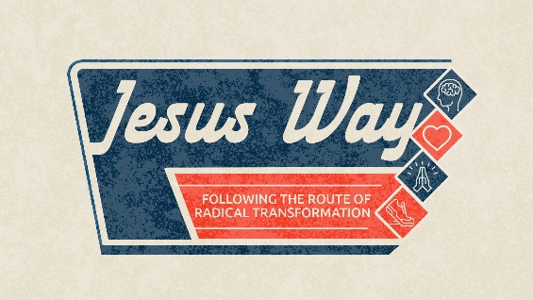
Fork in the Road

Quest Book:
Chapter 30

Matthew 6:19-34

A. A Lesson on _________________
- Know the two kinds of __________.
“Do not store up for yourselves treasures on earth, where moths and vermin destroy, and where thieves break in and steal. But store up for yourselves treasures in heaven, where moths and vermin do not destroy, and where thieves do not break in and steal.” Matthew 6:19-21 (NIV)
- Know the two kinds of _________.
“The eye is the lamp of the body. If your eyes are healthy, your whole body will be full of light. But if your eyes are unhealthy, your whole body will be full of darkness. If then the light within you is darkness, how great is that darkness!” Matthew 6:22-23 (NIV)

- Know the two kinds of _____________.
“No one can serve two masters. Either you will hate the one and love the other, or you will be devoted to the one and despise the other. You cannot serve both God and money.” Matthew 6:24 (NIV)

- A Lesson on _________
- Know our _________ in God.
“Therefore I tell you, do not worry about your life, what you will eat or drink; or about your body, what you will wear. Is not life more than food, and the body more than clothes? Look at the birds of the air; they do not sow or reap or store away in barns, yet your heavenly Father feeds them. Are you not much more valuable than they? Can any one of you by worrying add a single hour to your life?” Matthew 6:25-27 (NIV)

- Know that our God has got _____.
“And why do you worry about clothes? See how the flowers of the field grow. They do not labor or spin. Yet I tell you that not even Solomon in all his splendor was dressed like one of these. If that is how God clothes the grass of the field, which is here today and tomorrow is thrown into the fire, will He not much more clothe you—you of little faith? So do not worry, saying, ‘What shall we eat?’ or ‘What shall we drink?’ or ‘What shall we wear?’. For the pagans run after all these things, and your heavenly Father knows that you need them.” Matthew 6:28-32 (NIV)

- Know the remedy for worry: ____ priorities.
“But seek first His Kingdom and His righteousness, and all these things will be given to you as well. Therefore do not worry about tomorrow, for tomorrow will worry about itself. Each day has enough trouble of its own.” Matthew 6:33-34 (NIV)

- Putting these lessons into practice.
- We demonstrate that we are not dependent on every dollar we earn to guarantee our future.
“Command those who are rich in this present world not to be arrogant nor to put their hope in wealth, which is so uncertain, but to put their hope in God, Who richly provides us with everything for our enjoyment. Command them to do good, to be rich in good deeds, and to be generous and willing to share. In this way they will lay up treasure for themselves as a firm foundation for the coming age, so that they may take hold of the life that is truly life.” 1 Timothy 6:17-19 (NIV)

- We are not constantly looking to money (Mammon) to define our self-worth, provide joy, or validate our success.
“But godliness with contentment is great gain. For we brought nothing into the world, and we can take nothing out of it. But if we have food and clothing, we will be content with that.” 1 Timothy 6:6-8 (NIV)

- We don't let fear paralyze us or drive us to desperate or dishonest financial measures; instead, we focus on fulfilling our duties within God's Kingdom, believing He will add the “rest of these things".
“The Lord is my Shepherd, I shall not want.” Psalm 23:1 (KJV)

Bottom Line:
Our wallet is a spiritual compass
guiding our worship.

To begin a relationship with Jesus…
Text: “Jesus” to 570-273-0088

Next Sunday: Jesus’ Way
Following the Route of Radical Transformation

Week 5: Dead End
Quest Book: Chapter 31

Milton Campus: Pastor Branden Mestach
Sunbury Campus: Pastor Billy Robel


Giving & Attendance Update
Giving last Sunday: 69%
Giving year to date: 87.5% of goal
Attendance Last Weekend: 1,852
Salvations to date: 85 | Baptisms to date: 54

“Reach the One” Campaign Update
160 – Pledges with 417 Total Participants
$2,164,934.39 - Donations Anticipated by Nov. 2027
$1,348,576.40 - Received Donations – 33.7% of $4M Goal

Want to pledge, donate, or learn more?

Scan:

Upcoming Happenings:
November 14-16-Awaken Young Adult Conference

November 14-Sanctus Real in Concert
Notetakers are History Makers

Looking for your next step at CWC?
Welcome Party – 1st Sunday of Every Month
- If you are new or if you’ve been around a bit and are looking to build friendships with others, our Welcome Party is for you! Get to know others who are newer at CWC as well as our welcome team and our pastors in a relational environment. There will be light refreshments and the opportunity to hear about our small groups, baptism, and your next step of Growth Track. If you’re asking the question, “How can I make friends here,” then this is for you! No registration is required, you can just show up. Look for the signs on the first Sunday of the month.

Growth Track – 3-week class on Sunday Mornings or Wednesday Nights
- Growth Track exists to help you learn about the vision of CWC, the gifts God has given you, and how you can use them in specific opportunities to serve at CWC. You’ll learn amongst others of how to become a vital part of the ministries of the church so that we can share the light of Christ with our communities. If you miss a class, don’t worry! Growth Track runs every other month and we even have an online option you can participate in (though we recommend in-person if you can). You can see what classes are available by going to bit.ly/cwcgrowthtrack.

Membership Class – Once a quarter on Sundays after 2nd service
- Membership class is the last step of fully assimilating at CWC. Learn about our denomination, The Wesleyan Church and the bigger movement we are a part of across the world. This 3-hour class with the lead pastor provides you a place to ask important questions about our beliefs as a church and allows you to become eligible for our local board of administration. You also become eligible for denominational events like our district and general conferences. To sign up for our next class, let us know at the Hub or email: loretta.paulhamus@cwc.life

