August 17, 2025 – Week #5
Milton Campus – Pastor Branden Mestach
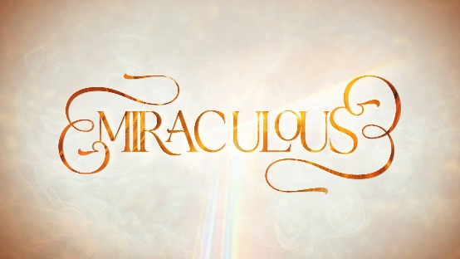

Restoring Power

Quest Book:
Chapter 18

Mark 1:29-39

A. The Presence of Jesus: ____________
- His presence brought ______ to a home.
“As soon as they left the synagogue, they went with James and John to the home of Simon and Andrew. Simon’s mother-in-law was in bed with a fever, and they immediately told Jesus about her.” Mark 1:29-30 (NIV)

- His presence brought _________ to a home.
“So He went to her, took her hand and helped her up. The fever left her…” Mark 1:31a-b (NIV)

- His presence resulted in ______ in the home.
“…and she began to wait on them.” Mark 1:31c (NIV)

- The Presence of Jesus: ______________
- His presence is always _________________.
“That evening after sunset the people brought to Jesus all the sick and demon-possessed.” Mark 1:32 (NIV)

- His presence is always an ______ door.
“The whole town gathered at the door, and Jesus healed many who had various diseases.” Mark 1:33-34a (NIV)

- His presence always ___________ evil.
“He also drove out many demons, but He would not let the demons speak because they knew Who He was.” Mark 1:34b-c (NIV)

- The Presence of Jesus: The Source
- Miracles have a source of power.
“Very early in the morning, while it was still dark, Jesus got up, left the house and went off to a solitary place, where He prayed.” Mark 1:35 (NIV)

- Miracles have a sense of mission.
“Simon and his companions went to look for Him, and when they found Him, they exclaimed: ‘Everyone is looking for You!’” Mark 1:36-37 (NIV)

- Miracles have a sense of direction.
“Jesus replied, ‘Let us go somewhere else—to the nearby villages—so I can preach there also. That is why I have come.’ So He traveled throughout Galilee, preaching in their synagogues and driving out demons.” Mark 1:38-39 (NIV)

But what about when my miracle did not come when I (we) prayed? (Great question!)
- Miracles, by definition, are not the norm.
- Miracles are about God’s glory, not outcomes.
- Miracles are not report cards.
- Miracles do not define God’s character.
- Miracles are not the answer to suffering; God’s presence is.
*Adapted from “When God Doesn’t Give the Miracle You Prayed For,” by Lisa Appelo

Bottom Line:
The greatest miracle will always be
the presence of Jesus.

To begin a relationship with Jesus…
Text: “Jesus” to 570-273-0088

Next Sunday:
Miraculous:
The Signs and Wonders of Jesus Christ

Week 6: A Compassionate Touch
Quest Book: Chapter 19

Milton Campus: Pastor Branden Mestach
Sunbury Campus: Pastor Billy Robel
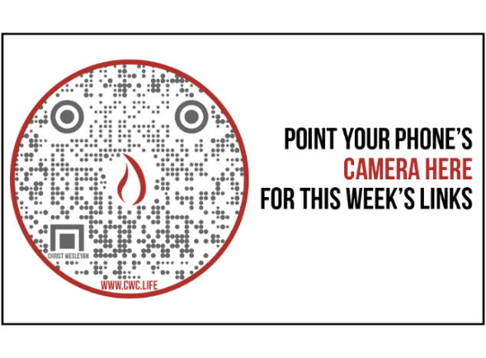

Giving & Attendance Update
Giving last Sunday: 78.1%
Giving year to date: 91.3% of goal
Attendance Last Weekend (Get Out Sunday): 763
Salvations to date: 57 | Baptisms to date: 51

“Reach the One” Campaign Update
157 – Pledges with 383 Total Participants
$2,107,954.30 -Donations Anticipated by Nov. 2027
$1,173,565.14 -Received Donations – 29% of $4M Goal

Want to pledge, donate, or learn more?

Scan:

Upcoming Happenings:

Wednesday, September 3rd – Midweek Launch! 6:30-8p.

Notetakers are History Makers

Looking for your next step at CWC?
Welcome Party – 1st Sunday of Every Month
- If you are new or if you’ve been around a bit and are looking to build friendships with others, our Welcome Party is for you! Get to know others who are newer at CWC as well as our welcome team and our pastors in a relational environment. There will be light refreshments and the opportunity to hear about our small groups, baptism, and your next step of Growth Track. If you’re asking the question, “How can I make friends here,” then this is for you! No registration is required, you can just show up. Look for the signs on the first Sunday of the month.

Growth Track – 3-week class on Sunday Mornings or Wednesday Nights
- Growth Track exists to help you learn about the vision of CWC, the gifts God has given you, and how you can use them in specific opportunities to serve at CWC. You’ll learn amongst others of how to become a vital part of the ministries of the church so that we can share the light of Christ with our communities. If you miss a class, don’t worry! Growth Track runs every month and we even have an online option you can participate in (though we recommend in-person if you can). You can see what classes are available by going to bit.ly/cwcgrowthtrack.

Membership Class – Once a quarter on Sundays after 2nd service
- Membership class is the last step of fully assimilating at CWC. Learn about our denomination, The Wesleyan Church and the bigger movement we are a part of across the world. This 3-hour class with the lead pastor provides you a place to ask important questions about our beliefs as a church and allows you to become eligible for our local board of administration. You also become eligible for denominational events like our district and general conferences. To sign up for our next class, let us know at the Hub or email: loretta.paulhamus@cwc.life

