June 22nd 2025 – Week #6
Milton Campus – Pastor Branden Mestach

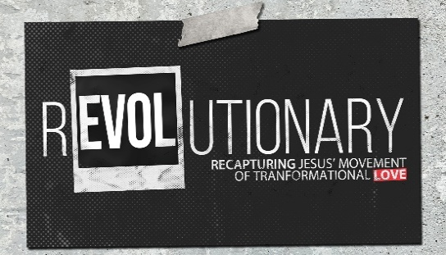
The Love for Our Spiritual Family
Quest Book:
Chapter 10

Mark 3:31-35

A. The Biological ___________ of Jesus…
- …were standing ______________.
“Then Jesus’ mother and brothers arrived. Standing outside, they sent someone in to call Him.” Mark 3:31 (NIV)

- …were wanting to ______ Him.
“A crowd was sitting around Him, and they told Him, ‘Your mother and brothers are outside looking for You.’” Mark 3:32 (NIV)

- …were about to be a _____________ point.
“‘Who are My mother and My brothers?’ He asked.” Mark 3:33 (NIV)

- The ________ Circle of Jesus…
- …were those _____________ around Him.
“Then He looked at those seated in a circle around Him and said, ‘Here are My mother and My brothers!’”
Mark 3:34 (NIV)

- …are those _____________ God’s will.
“‘Whoever does God’s will is My brother and sister and mother.’” Mark 3:35 (NIV)

- …is less about biology and more about ______________.
“He replied, ‘My mother and brothers are those who hear God’s Word and put it into practice.’” Luke 8:21 (NIV)

_______________ (n): The study and practice of faithful obedience to God’s voice, commands, and calling, rooted in Scripture and lived out in every area of life.

- Questions About the Inner Circle
- Am I just in the crowd, or am I in the inner circle of Jesus?
“‘Whoever has My commands and keeps them is the one who loves Me. The one who loves Me will be loved by My Father, and I too will love them and show Myself to them.’” John 14:21 (NIV)

- Am I living in the will of God, or just hearing about it?
“Do not merely listen to the Word, and so deceive yourselves. Do what it says. Anyone who listens to the Word but does not do what it says is like someone who looks at his face in a mirror and, after looking at himself, goes away and immediately forgets what he looks like.” James 1:22-24 (NIV)

- Do I resemble the heart of the Father in my choices, attitudes, and priorities?
“Follow God’s example, therefore, as dearly loved children and walk in the way of love, just as Christ loved us and gave Himself up for us as a fragrant offering and sacrifice to God.” Ephesians 5:1-2 (NIV)

Our choices should reflect His selflessness.
Our attitudes should reflect His love and humility.
Our priorities should mirror Christ’s
love, sacrifice, and obedience to the Father.

Bottom Line:
The door to Jesus’ inner circle
looks like a cross.
The key is in the shape of obedience.

To begin a relationship with Jesus…
Text: “Jesus” to 570-273-0088

Next Sunday: REVOLUTIONARY –
Recapturing Jesus’ Movement
of Transformational Love

Week 7: The Love for the Wrong and the Wronged
Quest Book: Chapter 11

Milton Campus: Pastor Branden Mestach
Sunbury Campus: Pastor Drew Lahr


Giving & Attendance Update
Giving last Sunday: 76.4%
Giving year to date: 103.2% of goal
Attendance Last Weekend: 1,696
Salvations to date: 49 | Baptisms to date: 33

“Reach the One” Campaign Update
156 - Pledges
$2,047,625.19 -Donations Anticipated by Nov. 2027
$1,036,504.37 -Received Donations – 25.5% of $4M Goal

Want to pledge, donate, or learn more?
Scan the QR code below:



Upcoming Happenings:

Sunday, July 6 @3p Freedom Fest! Milton Campus

Saturday, August 9 @1p – Reach the Hole in One Golf
Scramble.
*Sign up your team, or to volunteer, at The HUB!
Notetakers are History Makers

