June 15th 2025 – Week #5
Milton Campus – Pastor Branden Mestach

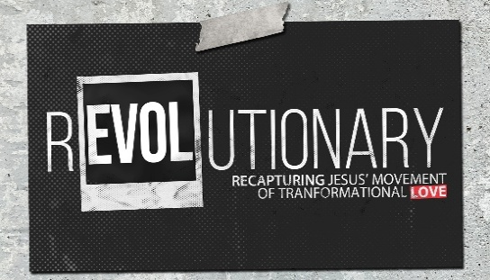
The Love for Reaching Others

Quest Book:
Chapter 9

Luke 5:1-11

A. Jesus met the ____________ where they were at.
- Jesus knew His ______________ well.
“One day as Jesus was standing by the Lake of Gennesaret, the people were crowding around Him and listening to the Word of God. Luke 5:1 (NIV)

- Jesus used resources to __________ the Word.
“He saw at the water’s edge two boats, left there by the fishermen, who were washing their nets. He got into one of the boats, the one belonging to Simon, and asked him to put out a little from shore. Then He sat down and taught the people from the boat.” Luke 5:2-3 (NIV)

- Jesus asked Peter to do something he had done many times ___________.
“When He had finished speaking, He said to Simon, ‘Put out into the deep water, and let down the nets for a catch.’” Luke 5:4 (NIV)

- Jesus demanded Simon Peter to see __________ his limitations.
- Simon had to push past his ________.
“Simon answered, ‘Master, we’ve worked hard all night and haven’t caught anything. But because You said so, I will let down the nets.’” Luke 5:5 (NIV)

- Simon’s reluctant obedience produced unexpected (_____-________) results.
“When they had done so, they caught such a large number of fish that their nets began to break. So they signaled their partners in the other boat to come and help them, and they came and filled both boats so full that they both began to sink.” Luke 5:6-7 (NIV)

- Simon’s unexpected results ___________ in an unexpected call.
“When Simon Peter saw this, he fell at Jesus’ knees and said, ‘Go away from me, Lord; I am a sinful man!’ For he and his companions were astonished at the catch of fish they had taken, and so were James and John, the sons of Zebedee, Simon’s partners. Then Jesus said to Simon, ‘Don’t be afraid; from now on you will fish for people.’ So they pulled their boats up on shore, left everything and followed Him.” Luke 5:8-11 (NIV)

- So, What is God’s Calling on Your Life?
- It begins in your daily grind.
“Stay calm; mind your own business; do your own job. You’ve heard all this from us before, but a reminder never hurts. We want you living in a way that will command the respect of outsiders, not lying around sponging off your friends.” 1 Thessalonians 4:11-12 (MSG)

- It transcends your human logic.
“‘For My thoughts are not your thoughts, neither are your ways My ways,’ declares the Lord. ‘As the heavens are higher than the earth, so are My ways higher than your ways and My thoughts than your thoughts.’” Isaiah 55:8-9 (NIV)

- It transforms your identity.
“Those who live according to the flesh have their minds set on what the flesh desires; but those who live in accordance with the Spirit have their minds set on what the Spirit desires. The mind governed by the flesh is death, but the mind governed by the Spirit is life and peace.” Romans 8:5-6 (NIV)

Bottom Line:

God’s calling on your life is not a
destination, but a transformation.

To begin a relationship with Jesus…
Text: “Jesus” to 570-273-0088

Next Sunday: REVOLUTIONARY –
Recapturing Jesus’ Movement
of Transformational Love

Week 6: The Love For Our Spiritual Family
Quest Book: Chapter 10

Milton Campus: Pastor Branden Mestach
Sunbury Campus: Pastor Billy Robel


Giving & Attendance Update
Giving last Sunday: 91.6%
Giving year to date: 105.9% of goal
Attendance Last Weekend: 1,857
Salvations to date: 52 | Baptisms to date: 33

“Reach the One” Campaign Update
155 - Pledges
$1,889,289.67 - Donations Anticipated by Nov. 2027
$978,087.22 - Received Donations – 24% of $4M Goal

Want to pledge, donate, or learn more?
Scan the QR code below:



Upcoming Happenings:

Tuesday-Friday, June 17-20 @ 9:00a: CWC Kidz Camp
Milton Campus

Sunday, July 6 @3p Freedom Fest! Milton Campus

Saturday, August 9 @1p – Reach the Hole in One Golf
Scramble.
*Sign up your team, or to volunteer, at The HUB!
Notetakers are History Makers

