June 1st 2025 – Week #3
Milton Campus – Pastor Branden Mestach

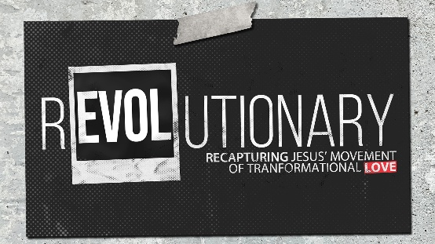
The Love for Those Who Wrong Us

Quest Book:
Chapter 7

Luke 19:1-10

- Zacchaeus put himself into _________.
- Zacchaeus’ position in life did not ________ him from getting into position.
“Jesus entered Jericho and was passing through. A man was there by the name of Zacchaeus; he was a chief tax collector and was wealthy.” Luke 19:1-2 (NIV)

- Zacchaeus felt an internal ____________.
“He wanted to see Who Jesus was, but because he was short he could not see over the crowd.” Luke 19:3 (NIV)

- Zacchaeus showed __________________ that money could not buy.
“So he ran ahead and climbed a sycamore-fig tree to see Him, since Jesus was coming that way.” Luke 19:4 (NIV)

- Jesus _____ the position of Zacchaeus.
- Jesus’ love led to an ___________ response.
“When Jesus reached the spot, He looked up and said to him, ‘Zacchaeus, come down immediately. I must stay at your house today. So he came down at once and welcomed Him gladly.’” Luke 19:5 (NIV)

- Jesus’ love for the unloved remained ____________________.
“All the people saw this and began to mutter, ‘He has gone to be the guest of a sinner.’” Luke 19:7 (NIV)

- Life-change led to an ___________ change.
“But Zacchaeus stood up and said to the Lord, ‘Look, Lord! Here and now I give half of my possessions to the poor, and if I have cheated anybody out of anything, I will pay back four times the amount.’ Jesus said to him, ‘Today salvation has come to this house, because this man, too, is a son of Abraham.’” Luke 19:8-9 (NIV)

- Jesus’ mission of love reveals His purpose for coming to earth.
- Jesus’ love drove His mission. What drives your mission?
“For the Son of Man came to seek and to save the lost.” Luke 19:10 (NIV)

- Surrender leads to life-changing discipleship.
“When the young man heard this, he went away sad, because he had great wealth.” Matthew 19:22 (NIV)

- Are we known by Christ’s love?
“A new command I give you: Love one another. As I have loved you, so you must love one another. By this everyone will know that you are My disciples, if you love one another.” John 13:34-35 (NIV)

Bottom Line:
Love is a part of discipleship,
not an option of discipleship.

To begin a relationship with Jesus…
Text: “Jesus” to 570-273-0088

Next Sunday: REVOLUTIONARY –
Recapturing Jesus’ Movement
of Transformational Love

Week 4: The Love For the Church
Quest Book: Chapter 8

Milton Campus: Pastor Branden Mestach
Sunbury Campus: Pastor Billy Robel


Giving & Attendance Update
Giving last Sunday: 66.5%
Giving year to date: 109.3% of goal (Praise God!)
Attendance Last Weekend: 1,677
Salvations to date: 48 | Baptisms to date: 6

“Reach the One” Campaign Update
155 - Pledges
$1,880,800.01 - Donations Anticipated by Nov. 2027
$940,556.44 - Received Donations – 23.5% of $4M Goal

Want to pledge, donate, or learn more?
Scan the QR code below:



Upcoming Happenings:

Thursday, Friday, Saturday, June 12-14 @ 7p: The Play That Goes Wrong – Milton Auditorium.

Tuesday-Friday, June 17-20 @ 9:00a: CWC Kidz Camp
Milton Campus

Sunday, July 6 @3p Freedom Fest! Milton Campus
Notetakers are History Makers

