May 25th 2025 – Week #2
Milton Campus – Pastor Ken Paulhamus
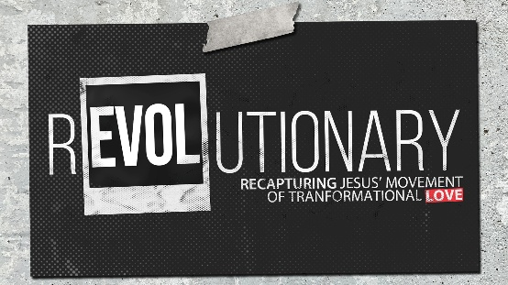
The Love for His Father (Part 2)

Quest Book:
Chapter 6

Matthew 3:13-4:11

- Jesus’ Revolutionary _________
- The Holy Spirit _______ John to prepare the way.
“I baptize you with water for repentance. But after me will come one who is more powerful than I, whose sandals I am not fit to carry.” Matthew 3:11 (NIV)

- Jesus humbly __________ to the will of God the Father at both the beginning and the end of His earthly ministry.
“Let it be so now; it is proper for us to do this to fulfill all righteousness.” Matthew 3:13 (NIV)

- Through baptism, Jesus identified with the sacrificial role He would play in the _____________ of humanity.
“My Father, if it is possible, may this cup be taken from Me. Yet not as I will, but as You will.” Matthew 26:39 (NIV)

- God the Father’s ________ to Jesus’ humble submission.
“This is My Son, whom I love, with Him I am well pleased.” Matthew 3:17 (NIV)

- Jesus’ Revolutionary ______________
- The Holy Spirit ___________ Jesus into the desert to be tempted by Satan.
“Then Jesus was led by the Spirit into the desert to be tempted by the devil. After fasting forty days and forty nights, He was hungry.” Matthew 4:1-2 (NIV)

- Jesus triumphed over ______ temptation.
“For we do not have a high priest who is unable to sympathize with our weaknesses, but we have one who has been tempted in every way, just as we are – yet was without sin.” Hebrews 4:15 (NIV)

- Jesus utilized Scripture to stand up to temptation and He demonstrated His ___________ over the evil one.
“Jesus said to him, ‘Away from Me, Satan. For it is written: Worship the Lord your God and serve Him only.’ Then the devil left Him and angels came and attended Him.” Matthew 4:10-11 (NIV)

- Jesus’ Submission to God the Father
- Jesus was truly God and truly human at the same time but humbled Himself and was obedient to the Father.
“Do nothing out of selfish ambition or vain conceit, but in humility consider others better than yourselves… Your attitude should be the same as that of Christ Jesus: Who, being in the very nature God, did not consider equality with God something to be grasped, but made Himself nothing, taking the very nature of a servant, being made in human likeness. And being found in appearance as a man, He humbled Himself and became obedient to death – even death on a cross.” Philippians 2:3, 5-8 (NIV)

- Humility is a hallmark of someone who follows Jesus.
“Therefore, as God’s chosen people, holy and dearly loved, clothe yourselves with compassion, kindness, humility, gentleness and patience.” Colossians 3:12 (NIV)

- What does Jesus’ submission to the Father teach us?
- We are to submit to one another.
“Submit to one another out of reverence for Christ.” Ephesians 5:21 (NIV)
- We are to submit to those who have authority over us.
“Submit yourselves, for the Lord’s sake to every authority instituted among men: whether to the king…or to governors...” 1 Peter 2:13 (NIV)
- We are to submit to God following Jesus’ example.
“Submit yourselves, then, to God. Resist the devil, and he will flee from you.” “Humble yourselves before the Lord, and He will lift you up.” James 4:7 & 10 (NIV)

Bottom Line:
Submission to the will of God the Father
is a choice.

To begin a relationship with Jesus…
Text: “Jesus” to 570-273-0088

Next Sunday: REVOLUTIONARY –
Recapturing Jesus’ Movement
of Transformational Love

Week 3: The Love For Those Who Wrong Us
Quest Book: Chapter 7

Milton Campus: Pastor Branden Mestach
Sunbury Campus: Drew Lahr


Giving & Attendance Update
Giving last Sunday: 67% of goal
Giving year to date: 115.4% of goal
Attendance Last Weekend: 1,869
Salvations to date: 47 | Baptisms to date: 6

“Reach the One” Campaign Update
155 - Pledges
$1,880,800.01 - Donations Anticipated by Nov. 2027
$935,924.47 - Received Donations – 23% of $4M Goal

Want to pledge, donate, or learn more?
Scan the QR code below:



Upcoming Happenings:

Thursday, Friday, Saturday, June 12-14 @ 7p: The Play That Goes Wrong – Milton Auditorium.

Saturday, June 14 @ 8a: Men’s Breakfast – Milton Campus

Tuesday-Friday, June 17-20 @ 9:00a: CWC Kidz Camp
Milton Campus

Sunday, June 22 @10:45a: Baptism Class, Room 118
Notetakers are History Makers

