May 11th 2025 – Week #3
Milton Campus – Pastor Branden Mestach
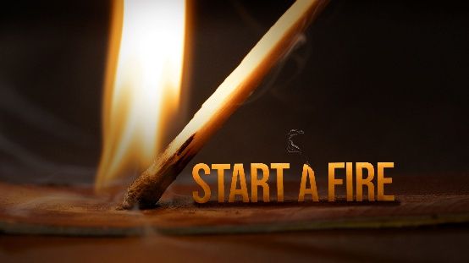
Burning Bright

Quest Book:
Chapter 52

Revelation 1:12-18

- Jesus Is the _______.
- John heard a _________.
“I turned around to see the voice that was speaking to me. Revelation 1:12a (NIV)

- John saw the _____________.
“And when I turned I saw seven golden lampstands,” Revelation 1:12b (NIV)

- John saw ________.
“and among the lampstand was someone like a son of man.” Revelation 1:13a (NIV)

Unless Jesus stands amid the church,
the church cannot burn bright.

- Jesus’ Symbolic ________
- Jesus’ priestly robe and _______.
“dressed in a robe reaching down to His feet and with a golden sash around His chest.” Revelation 1:13b-c (NIV)

- Jesus’ _________ hair and conquering eyes.
“The hair on His head was white like wool, as white as snow, and His eyes were blazing like fire.” Revelation 1:14 (NIV)

- Jesus’ Good News of _______ and Rebuke
“His feet were like bronze glowing in a furnace, and His voice was like the sound of rushing waters.”
Revelation 1:15 (NIV)

- Jesus’ Skillful Hand and _____________ Presence
“In His right hand He held seven stars, and coming out of His mouth was a sharp, double-edged sword. His face was like the sun shining in all its brilliance.” Revelation 1:16 (NIV)

Unless Jesus shines out from the church,
the church cannot burn bright.

- Jesus: Our Trusted Messiah.
- He is the One we are to bow to.
“When I saw Him, I fell at His feet as though dead.” Revelation 1:17a (NIV)

- He is the One Who gives peace and comfort.
“Then He placed His right hand on me and said: ‘Do not be afraid. I am the First and the Last.’”
Revelation 1:17b-c (NIV)

- He is the One Who reigns forever with all authority.
“I am the Living One; I was dead, and now look, I am alive for ever and ever! And I hold the keys of death and Hades.” Revelation 1:18 (NIV)

Bottom Line:
You’re not enough, but Jesus is.
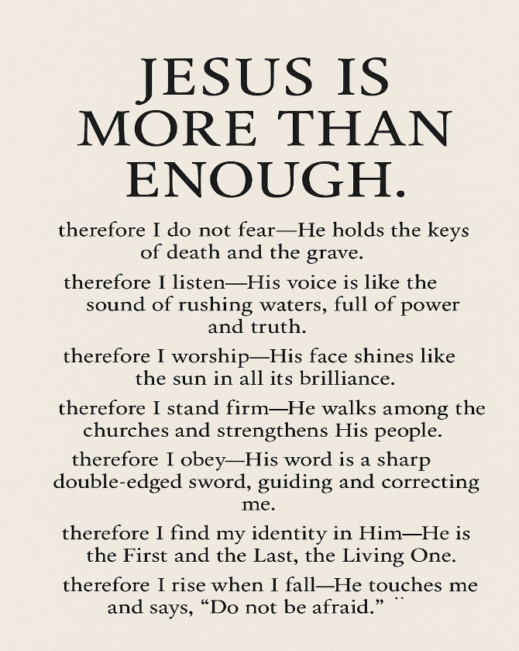

To begin a relationship with Jesus…
Text: “Jesus” to 570-273-0088

Next Sunday: A new series: REVOLUTIONARY – Recapturing Jesus’ Movement
of Transformational Love

Week 1: The Love For His Father
Quest Book: Chapter 5
Milton Campus: Pastor Branden Mestach
Sunbury Campus: Pastor Billy Robel


Giving & Attendance Update
Giving last Sunday: 88.1% of goal
Giving year to date: 125.2% of goal
Attendance Last Weekend: 1,879
Salvations to date: 47 | Baptisms to date: 6

“Reach the One” Campaign Update
155 - Pledges
$1,873,669.19 - Donations Anticipated by Nov. 2027
$916,420.08 - Received Donations – 23% of $4M Goal

Want to pledge, donate, or learn more?
Scan the QR code below:



Upcoming Happenings:

Friday, May 16 @ 6:30p: Soul Sister’s (Women’s Ministry)
Milton Campus Youth Center

Sunday, May 18 @ 10:45a: Stephen Ministry Training
Open House – Milton Campus Cafeteria

Thursday, Friday, Saturday, June 12-14 @ 7p: The Play That Goes Wrong – Milton Auditorium.

Tuesday-Friday, June 17-20 @ 9:00a: CWC Kidz Camp
Milton Campus
Notetakers are History Makers

