May 4th, 2025 – Week #2
Milton & Sunbury Campuses- Pastor Branden Mestach
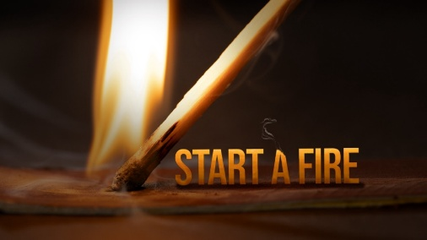
Fanning the Flame

Acts 1:8

”But you will receive power when the Holy Spirit comes on you; and you will be My witnesses in Jerusalem, and in all Judea and Samaria, and to the ends of the earth.”
Mission Statement:
Sharing the Light of Jesus Christ with Our World.
Notes:__________________________________________________________________________________________________________________________________________________________________________________________________________________________________________________________________________________________________________________________________________________________________________________________________________________________________________________________________________________________________________________________________________________________________________________________________________________________________________________________________________________________________________________________________________ To begin a relationship with Jesus…
Text: “Jesus” to 570-273-0088

Next Sunday: Set A Fire
Week 3: Trial By Fire
Quest Book: Chapter 52
Milton Campus: Pastor Branden Mestach
Sunbury Campus: Pastor Billy Robel
May 4th, 2025 – Week #2
Milton & Sunbury Campuses- Pastor Branden Mestach
Fanning the Flame

Acts 1:8

”But you will receive power when the Holy Spirit comes on you; and you will be My witnesses in Jerusalem, and in all Judea and Samaria, and to the ends of the earth.”
Mission Statement:
Sharing the Light of Jesus Christ with Our World.
Notes:__________________________________________________________________________________________________________________________________________________________________________________________________________________________________________________________________________________________________________________________________________________________________________________________________________________________________________________________________________________________________________________________________________________________________________________________________________________________________________________________________________________________________________________________________________ To begin a relationship with Jesus…
Text: “Jesus” to 570-273-0088

Next Sunday: Set A Fire
Week 3: Trial By Fire
Quest Book: Chapter 52
Milton Campus: Pastor Branden Mestach
Sunbury Campus: Pastor Billy Robel
May 4th, 2025 – Week #2
Milton & Sunbury Campuses- Pastor Branden Mestach
Fanning the Flame

Acts 1:8

”But you will receive power when the Holy Spirit comes on you; and you will be My witnesses in Jerusalem, and in all Judea and Samaria, and to the ends of the earth.”
Mission Statement:
Sharing the Light of Jesus Christ with Our World.
Notes:__________________________________________________________________________________________________________________________________________________________________________________________________________________________________________________________________________________________________________________________________________________________________________________________________________________________________________________________________________________________________________________________________________________________________________________________________________________________________________________________________________________________________________________________________________ To begin a relationship with Jesus…
Text: “Jesus” to 570-273-0088

Next Sunday: Set A Fire
Week 3: Trial By Fire
Quest Book: Chapter 52
Milton Campus: Pastor Branden Mestach
Sunbury Campus: Pastor Billy Robel


Giving & Attendance Update
Giving last Sunday: 258.4%
Giving year to date: 134.5% of goal
Attendance Last Weekend: 2037
Salvations to date: 47 | Baptisms to date: 6

“Reach the One” Campaign Update
154 - Pledges
$1,864,121.49 - Donations Anticipated by Nov. 2027
$903,063.63- Received Donations – 22.5% of $4M Goal

Want to pledge, donate, or learn more?
Scan the QR code below:

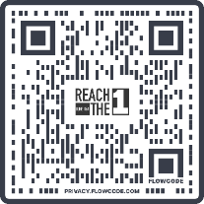

Upcoming Happenings:
Sunday, May 4 @ 3p-5p: Family Flower Funday
Sunday, May 4 @ 6:00p: Local Church Conference
The Well Coffee House
Wednesday, May 7 @ 6:30p: Worship Onboarding
Milton Campus Auditorium
Sunday, May 18 @ 10:45a: Stephen Ministry Training
Open House – Milton Campus Cafeteria

Giving & Attendance Update
Giving last Sunday: 258.4%
Giving year to date: 134.5% of goal
Attendance Last Weekend: 2037
Salvations to date: 47 | Baptisms to date: 6

“Reach the One” Campaign Update
154 - Pledges
$1,864,121.49 - Donations Anticipated by Nov. 2027
$903,063.63- Received Donations – 22.5% of $4M Goal

Want to pledge, donate, or learn more?
Scan the QR code below:

Upcoming Happenings:
Sunday, May 4 @ 3p-5p: Family Flower Funday
Sunday, May 4 @ 6:00p: Local Church Conference
The Well Coffee House
Wednesday, May 7 @ 6:30p: Worship Onboarding
Milton Campus Auditorium
Sunday, May 18 @ 10:45a: Stephen Ministry Training
Open House – Milton Campus Cafeteria

Giving & Attendance Update
Giving last Sunday: 258.4%
Giving year to date: 134.5% of goal
Attendance Last Weekend: 2037
Salvations to date: 47 | Baptisms to date: 6

“Reach the One” Campaign Update
154 - Pledges
$1,864,121.49 - Donations Anticipated by Nov. 2027
$903,063.63- Received Donations – 22.5% of $4M Goal

Want to pledge, donate, or learn more?
Scan the QR code below:

Upcoming Happenings:
Sunday, May 4 @ 3p-5p: Family Flower Funday
Sunday, May 4 @ 6:00p: Local Church Conference
The Well Coffee House
Wednesday, May 7 @ 6:30p: Worship Onboarding
Milton Campus Auditorium
Sunday, May 18 @ 10:45a: Stephen Ministry Training
Open House – Milton Campus Cafeteria

