February 16th 2025 – Week #1
Milton Campus – Pastor Branden Mestach
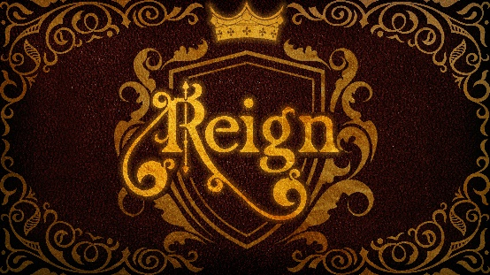

A Welcome Fit For the King
Chapter 40

Luke 19:29-44

- The King’s Humble _____________
- The King’s ___________.
“As He approached Bethpage and Bethany at the hill called the Mount of Olives, He sent two of His disciples, saying to them, ‘Go to the village ahead of you, and as you enter it, you will find a colt tied there, which no one has ever ridden. Untie it and bring it here. If anyone asks you, ‘Why are you untying it?’ say, ‘The Lord needs it.’” Luke 19:29-31 (NIV)

- The King’s ___________________.
“They brought it to Jesus, threw their cloaks on the colt and put Jesus on it. As He went along, people spread their cloaks on the road. When He came near the place where the road goes down to the Mount of Olives, the whole crowd of disciples began joyfully to praise God in loud voices for all the miracles they had seen: ‘Blessed is the king Who comes in the name of the Lord! Peace in heaven and glory in the highest!’” Luke 19:35-38 (NIV)

- The King’s ____________.
“Some of the Pharisees in the crowd said to Jesus, ‘Teacher, rebuke Your disciples!’ ‘I tell you,’ He replied, ‘if they keep quiet, the stones will cry out.’” Luke 19:39-40 (NIV)

- The King’s Weeping _______
- The King wept because of wrong ________.
“As He approached Jerusalem and saw the city, He wept over it and said, ‘If you, even you, had only known on this day what would bring you peace—but now it is hidden from your eyes.’” Luke 19:41-42 (NIV)

- The King wept because of a _______ people.
“‘The days will come upon you when your enemies will build an embankment against you and encircle you and hem you in on every side. They will dash you to the ground, you and the children within your walls.’” Luke 19:43-44a (NIV)

- The King wept because of blind ______.
“‘They will not leave one stone on another, because you did not recognize the time of God’s coming to you.’” Luke 19:44b-c (NIV)

- Why Is the Triumphal Entry so Important?
- It fulfilled prophesy and revealed Jesus’ Identity.
“Rejoice greatly, Daughter Zion! Shout, Daughter Jerusalem! See, your King comes to you, righteous and victorious, lowly and riding on a donkey, on a colt, the foal of a donkey.” Zechariah 9:9 (NIV)

- It revealed people’s hearts towards God.
“He came to that which was His own, but His own did not receive Him.” John 1:11 (NIV)

“If you openly declare that Jesus is Lord and believe in your heart that God raised Him from the dead, you will be saved.” Romans 10:9 (NLT)

- It revealed that people change, but God does not.
“And I will cause hostility between you and the woman,
and between your offspring and her offspring. He will strike your head, and you will strike His heel.” Genesis 3:15 (NIV)

Bottom Line:
Jesus came to reign in hearts,
not to reign on earth.

To begin a relationship with Jesus…
Text: “Jesus” to 570-273-0088

Next Sunday: Reign
Week 2: The Faith of the King
Quest Book: Chapter 41
Milton Campus: Pastor Erik Ireland
Sunbury Campus: Pastor Billy Robel



Giving & Attendance Update
Giving last Sunday: 84.1% of goal
Giving year to date: 78.1% of goal
Attendance Last Weekend: 1,680
Salvations to date: 211 | Baptisms to date: 61

“Reach the One” Campaign Update
147 - Pledges
$1,716,057.80 - Donations Anticipated by Nov. 2027
$742,575.68 - Received Donations – 18.6% of $4M Goal

Want to pledge, donate, or learn more?
Scan the QR code below:



Upcoming Happenings:

TODAY! Sunday, February 16: CWC Potluck - Well Fit Gym.

Saturday, February 22: Ladies Tea - The Well Coffee House. 2-4p

Sunday, March 2: Connections Breakfast. Sign up at The Hub. Come hear about who CWC is and what your next steps could be.

Tuesday, March 11: 40 Days of Prayer and Fasting begins.

Attention:
*CWC Members*: You should have received by email or mail a letter of interest in leader positions at the church. (CWC Board and District Conference Delegates)
If you would like to be considered for a leadership position, please submit your form.
Voting will take place in April.
Extra copies will be at The Hub for the next few weeks.

Notetakers are History Makers

