February 25, 2024 – Week #3
Milton Campus – Pastor Branden Mestach
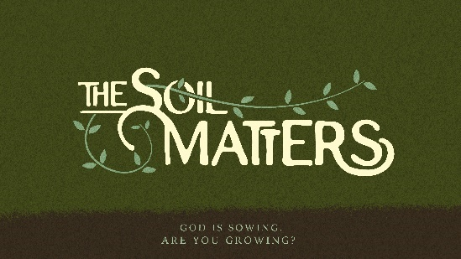
The Seed in the Thorny Places

Matt. 13:7, 22

- Condition #3: __________ Soil

      - The _______________ dirt.
“Other seed fell among thorns,” Matthew 13:7a (NIV)

      - The _____________ seed.
“Which grew up and choked the plants.” Matthew 13:7b (NIV)

- Condition #3: The _________ Heart
“The seed falling among the thorns refers to someone who hears the word, but the worries of this life and the deceitfulness of wealth choke the word, making it unfruitful.” Matthew 13:22 (NIV)

1. The thorns represent the _____ of this world.
“No one serving as a soldier gets entangled in civilian affairs, but rather tries to please his commanding officer.” 2 Timothy 2:4 (NIV)

2. The thorns represent the _____________ of riches.
a. Wealth can make someone too ______________.

b. Wealth can make someone ____________.

c. Wealth can become a _________ center piece.

d. Wealth can cause a misinterpretation of God’s __________.

- Avoiding the Choked-Out Soil

      - Acquire wealth, but don’t desire wealth.
“But those who want to get rich fall into temptation and a snare and many foolish and harmful desires which plunge men into ruin and destruction.” 1 Timothy 6:9 (NASB)

      - Set your mind on the things above, not on things below.
“ Set your mind on things above, not on things on the earth. For you died, and your life is hidden with Christ in God.” Colossians 3:2-3 (NKJV)

      - Let Christ be the Gatorade of your life.
“However, you are not in the flesh but in the Spirit, if indeed the Spirit of God dwells in you. But if anyone does not have the Spirit of Christ, he does not belong to Him. If Christ is in you, though the body is dead because of sin, yet the spirit is alive because of righteousness. But if the Spirit of Him who raised Jesus from the dead dwells in you, He who raised Christ Jesus from the dead will also give life to your mortal bodies through His Spirit who dwells in you.” Romans 8:9-11 (NASB)

Bottom Line:
God’s greatest blessings are
spiritual, not material.

To begin a relationship with Jesus…
Text: IChooseJesus (all one word) to 570-273-0088

Next Sunday:
Milton Campus: Pastor Billy Robel
Sunbury Campus: Pastor Mike Sweigard

Week 4: The Seed on the Good Soil
The Soil Matters: God is sowing. Are you growing?
A deep dive look at The Parable of the Sower.

Giving & Attendance Update
Giving last Sunday: 82.9% of goal
Giving year to date: 83% of goal
Attendance last Sunday: 2,057
Salvations to date: 103 | Baptisms to date: 110

Upcoming Happenings:
February 20-March 30 – 40 Days of Prayer and Fasting begins.

March 3 – Connections breakfast
March 8 – Family Movie Night! 6p / White Deer Elem. School

March 31 – Easter Weekend:

Milton Campus
March 29 – Good Friday Service 7p
March 30 – Saturday Night Easter Service 6:00p
March 31 – Easter Sunday 6:30a, 9a and 10:45a

Sunbury Campus:
March 31 – Easter Sunday 9a and 11a

April 7 – Baptism Sunday!
April 7 – Membership Class 12:30p

Notetakers are History Makers

