February 11, 2024 – Week #1
Milton Campus – Pastor Branden Mestach
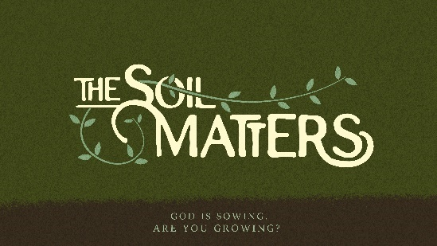
The Seed on the Path

Matthew 13:3-4, 18-19

- The ______________ Characters

      - The Sower/Farmer is Jesus Christ and His ____________.

      - The _____ is God’s Word.

      - The _______ is our heart.

- Condition #1: The ____________ Soil

_______________: existing or occurring at or on the surface or appearing to be true or real only until examined more closely.

1. The superficial soil is ______________.
“‘As he was scattering the seed, some fell along the path, and the birds came and ate it up.’” Matthew 13:4 (NIV)

2. The superficial heart is __________ because:
“‘When anyone hears the message about the kingdom and does not understand it, the evil one comes and snatches it away that was sown in their heart. This is the seed sown along the path.’” Matthew 13:18-19 (NIV)

a. It plays the ________ game.
“A person’s own folly leads to their ruin, yet their heart rages against the LORD.” Proverbs 19:3 (NIV)

b. It is unalert in _____________.
“The Lord said to Gideon, ‘With the three hundred men that lapped I will save you and give the Midianites into your hands. Let all the others go home.’” Judges 7:7 (NIV)

c. It has an “__________ gospel” mentality.
“I have told you these things, so that in me you may have peace. In this world you will have trouble. But take heart! I have overcome the world.” John 16:33 (NIV)

d. It has an ______________ spirit.
“Do you see a man [who is unteachable and] wise in his own eyes and full of self-conceit? There is more hope for a fool than for him.” Proverbs 26:12 (AMP)

e. It has an __________ character.
“No one who lives in Him keeps on sinning. No one who continues to sin has either seen Him or known Him.” 1 John 3:6 (NIV)
d. It is ___________ by the deceiver.
John 8:33-47 (NIV)

- Avoiding the Superficial Soil

      - Read God’s Word

      - Push past feelings.

      - Get some rest.

      - Do not over-personalize failure and success.

      - Decide to trust—again.

      - Fight isolation.

Bottom Line:
The Word of God cannot transform
what it cannot infiltrate.

To begin a relationship with Jesus…
Text: IChooseJesus (all one word) to 570-273-0088

Next Sunday:
Milton Campus: Pastor Mike Sweigard
Sunbury Campus: Pastor Branden Mestach

Week 2: The Seed on the Rocky Places
The Soil Matters: God is sowing. Are you growing?
A deep dive look at The Parable of the Sower.

Giving & Attendance Update
Giving last Sunday: 82.8% of goal
Giving year to date: 82.9% of goal
Attendance last Sunday: 2,151
Salvations to date: 98 | Baptisms to date: 111

Upcoming Happenings:
March 31 – Easter Sunday!
April 7 – Baptism Sunday!
April 7 – Membership Class 12:30p

Notetakers are History Makers

