December 22, 2024 – Week #4
Milton Campus – Pastor Branden Mestach
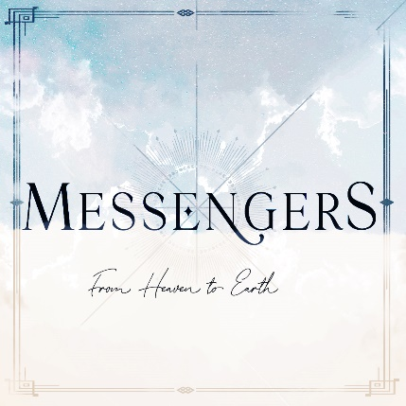

The Shepherds

Luke 2:8-20

- The ___________ of the Good News
- The recipients were _____________.
“And there were shepherds living out in the fields nearby, keeping watch over their flocks at night.” Luke 2:8 (NIV)

- The recipients were _____________.
“An angel of the Lord appeared to them, and the glory of the Lord shone around them, and they were terrified.” Luke 2:9 (NIV)

- The recipients were given _________.
“But the angel said to them, ‘Do not be afraid. I bring you good news that will cause great joy for all the people.’” Luke 2:10 (NIV)

- The _________ About the Good News
- The message was about the _____________.
“‘Today in the town of David a Savior has been born to you; He is the Messiah, the Lord.’” Luke 2:11 (NIV)

- The message was ___________.
“‘This will be a sign to you: You will find a baby wrapped in cloths and lying in a manger.’” Luke 2:12 (NIV)

- The message was _____________.
“Suddenly a great company of the heavenly host appeared with the angel, praising God and saying, ‘Glory to God in the highest heaven, and on earth peace to those on whom His favor rests.’” Luke 2:13-14 (NIV)

- The Response to the Good News
- The response was confident faith.
“When the angels had left them and gone into heaven, the shepherds said to one another, ‘Let’s go to Bethlehem and see this thing that has happened, which the Lord has told us about.’” Luke 2:15 (NIV)

- The response was urgent.
“So they hurried off and found Mary and Joseph, and the baby, who was lying in the manger. When they had seen Him, they spread the word concerning what had been told them about this child, and all who heard it were amazed at what the shepherds said to them.” Luke 2:16-18 (NIV)

- The response was praise and worship.
“But Mary treasured up all these things and pondered them in her heart. The shepherds returned, glorifying and praising God for all the things they had heard and seen, which were just as they had been told.” Luke 2:19-20 (NIV)

Bottom Line:
God’s Good News is for everyone!

To begin a relationship with Jesus…
Text: “Jesus” to 570-273-0088

Next Sunday:
Culture Wars: How Do We Engage?
Milton Campus: Ruslan KD with Q and A
Sunbury Campus: Ruslan KD streamed


Giving & Attendance Update
Giving last Sunday: 59.5% of goal
Giving year to date: 79.6% of goal
Attendance Last Weekend: 1,914
Salvations to date: 189 | Baptisms to date: 61

“Reach the One” Campaign Update
136 - Pledges
$1,554,756.74 - Donations Anticipated by November 2027
$578,585.25 - Received Donations – 14.5% of $4M Goal

Want to pledge, donate, or learn more?
Scan the QR code below:



Upcoming Happenings:

Christmas @ Christ Wesleyan!
December 24: Christmas Eve: Candle Lighting service
Milton Campus: 3p, 4:30p, 6p
Sunbury Campus: 3p and 4:30p

December 29: “Culture Wars: How Do We Engage?”
LIVE Morning Guest Speaker: Ruslan KD
(YouTube Influencer.)

Notetakers are History Makers

