December 15, 2024 – Week #3
Milton Campus – Pastor Caleb Swartz
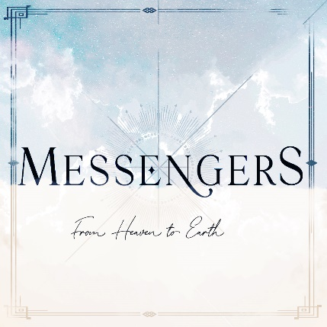

Joseph

Matthew 1:18-25

- _____________ of Life
“¹⁸ This is how the birth of Jesus the Messiah came about: His mother Mary was pledged to be married to Joseph, but before they came together, she was found to be pregnant through the Holy Spirit. ¹⁹ Because Joseph her husband was faithful to the law, and yet did not want to expose her to public disgrace, he had in mind to divorce her quietly.”

- Joseph’s decision to divorce was _________ and ________.
- Remember that the _____________ was the basis for righteous living in the Old Covenant.

- The ____________ of Joseph
“20 But after he had considered this, an angel of the Lord appeared to him in a dream and said, ‘Joseph son of David, do not be afraid to take Mary home as your wife, because what is conceived in her is from the Holy Spirit. 21 She will give birth to a son, and you are to give him the name Jesus, because he will save his people from their sins.’”
- Joseph was not ______ of the angel.
  - Joseph was ______ to hear from God.
“22 All this took place to fulfill what the Lord had said through the prophet: 23 ‘The virgin will conceive and give birth to a son, and they will call him Immanuel’ (which means ‘God with us’).”
- Reference to the ___________
- This is from _________
  - God had planned to call His people back to him and he gave Ahaz a _______.
  - Joseph would _________________ of the kings after their own hearts, he would ______________________.

“24 When Joseph woke up, he did what the angel of the Lord had commanded him and took Mary home as his wife.”
- This verse depicts what I would call ___________________________ obedience.
“25 But he did not consummate their marriage until she gave birth to a son. And he gave him the name Jesus.”
- Joseph ________ the immaculate conception and wanted to be ________________.
- By tradition, and cultural expectation, Joseph had the ______ to name the child.
- Instruction is not going to transform your life. Action is not going to transform your life. It’s remaining _____________ that transforms your life!

- Consider ______ Life
- What decisions are you being led through? Are you facing a crossroad?
  - Consult Scripture
  - Seek godly council
  - Pray intensely
Trust Him, Obey Him, Commit to Him

Next Sunday:
Week 4: Messengers: From Heaven to Earth
Milton Campus: Pastor Branden Mestach
Sunbury Campus: Pastor Billy Robel


Giving & Attendance Update
Giving last Sunday: 91.8% of goal
Giving year to date: 80.1% of goal
Attendance Last Weekend: 1,935
Salvations to date: 189 | Baptisms to date: 61

“Reach the One” Campaign Update
134 - Pledges
$1,513,105.84 - Donations Anticipated by November 2027
$446,637.67 - Received Donations - 11% of $4M Goal

Want to pledge, donate, or learn more?
Scan the QR code below:



Upcoming Happenings:

Christmas @ Christ Wesleyan!
December 24: Christmas Eve: Candle Lighting service
Milton Campus: 3p, 4:30p, 6p
Sunbury Campus: 3p and 4:30p

December 29: “Culture Wars: A Morning with Ruslan”
LIVE Morning Guest Speaker: Ruslan KD
(YouTube Influencer.)

Notetakers are History Makers

