December 8, 2024 – Week #2
Milton Campus – Pastor Branden Mestach
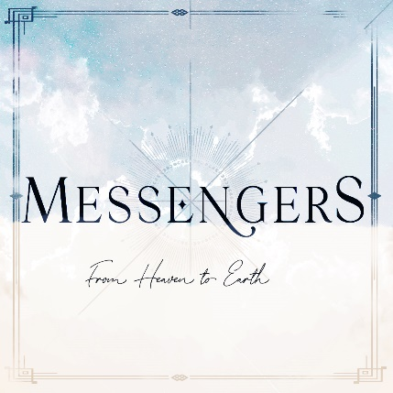

Mary

Luke 1:26-38

- ______ to When, Where, and Who?
- When and Where: First Century _________
“In the sixth month of Elizabeth’s pregnancy, God sent the angel Gabriel to Nazareth, a town in Galilee…” Luke 1:26 (NIV)

- Who: ________________________
“…to a virgin pledged to be married to a man named Joseph, a descendent of David.” Luke 1:27a-b (NIV)

- Who: ________
“The virgin’s name was Mary.” Luke 1:27c (NIV)

“I would like to ask Him (Jesus) if He was indeed virgin born, because the answer to that question would define history.” Larry King (Talk Show Host and self-proclaimed atheist in 2015)

- To _________ the Way for Salvation.
- ___________ gave hope right away.
“The angel went to her and said, ‘Greetings, you who are highly favored! The Lord is with you.” Luke 1:28 (NIV)

- Mary was a bit ____________.
“Mary was greatly troubled at his words and wondered what kind of greeting this might be. But the angel said to her, ‘Do not be afraid, Mary; you have found favor with God.” Luke 1:29-30 (NIV)

- Gabriel gave ___________ context.
“‘You will conceive and give birth to a son, and you are to call Him Jesus. He will be great and will be called the Son of the Most High. The Lord God will give Him the throne of His father David, and He will reign over Jacob’s descendants forever; His kingdom will never end.’” Luke 1:31-33 (NIV)
- Mary wanted more __________.
“‘How will this be,’ Mary asked the angel, ‘since I am a virgin?’ The angel answered, ‘The Holy Spirit will come on you, and the power of the Most High will overshadow you. So the Holy One to be born will be called the Son of God.” Luke 1:34-35
- Gabirel’s last words were ___________.
“‘Even Elizabeth your relative is going to have a child in her old age, and she who said to be unable to conceive is in her sixth month. For no word from God will ever fail.’” Luke 1:36-37 (NIV)

- Questions of Application
- What Nazareth moments are in your life—places or people you’ve overlooked—but God wants to use for His glory?
“‘For My thoughts are not your thoughts, and My ways are not your ways,’ says the Lord. ‘For as the heavens are higher than the earth, so are My ways higher than your ways, and My thoughts than your thoughts.’” Isaiah 55:8-9 (NLV)

- Faith does not mean we have complete understanding. What clarification do you need from God?
“For God is not the author of confusion but of peace, as in all the churches of the saints.” 1 Corinthians 14:33 (NKJV)

- Is there room in your heart/life for Jesus?
“‘I am the Lord’s servant,’ Mary answered. ‘May your word to me be fulfilled.’ Then the angel left her.” Luke 1:38 (NIV)

Bottom Line:
God transcends our elevated value systems.

To begin a relationship with Jesus…
Text: “Jesus” to 570-273-0088

Next Sunday:
Week 3: Messengers: From Heaven to Earth
Milton Campus: Pastor Caleb Swartz
Sunbury Campus: Pastor Branden Mestach


Giving & Attendance Update
Giving last Sunday: 64.2% of goal
Giving year to date: 79.8% of goal
Attendance Last Weekend: 1,794
Salvations to date: 188 | Baptisms to date: 61

“Reach the One” Campaign Update:
$1,424,531 pledged with 131 pledges received.
$413,796.58 total received YTD

Want to pledge, donate, or learn more?
Scan the QR code below:



Upcoming Happenings:

Christmas @ Christ Wesleyan!
December 14: Christmas Encounter 6p
December 24: Christmas Eve: Candle Lighting service
Milton Campus: 3p, 4:30p, 6p
Sunbury Campus: 3p and 4:30p
December 29: “Culture Wars: A Morning with Ruslan”
LIVE Morning Guest Speaker: Ruslan KD
(YouTube Influencer.)

Notetakers are History Makers

