December 1, 2024 – Week #1
Milton Campus – Rev. Dr. Erik Ireland

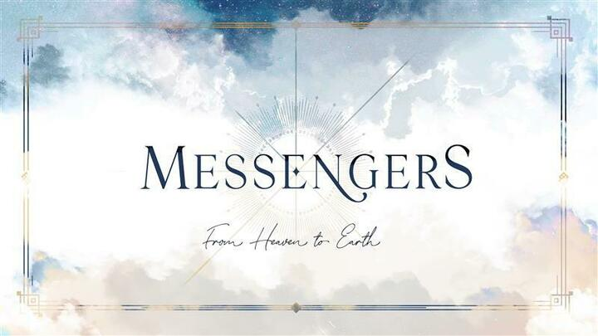
Pr Zechariah
and
Elizabeth

Luke 1:5-25

Notes:__________________________________________________________________________________________________________________________________________________________________________________________________________________________________________________________________________________________________________________________________________________________________________________________________________________________________________________________________________________________________________________________________________________________________________________________________________________________________________________________________________________________________________________________________________ To begin a relationship with Jesus…
Text: “Jesus” to 570-273-0088

Next Sunday:
Week 2: Messengers: The Promise Revealed
Milton Campus: Pastor Branden Mestach
Sunbury Campus: Pastor Billy Robel

December 1, 2024 – Week #1
Milton Campus – Rev. Dr. Erik Ireland

P Zechariah and
Elizabeth

Luke 1:5-25

Notes:__________________________________________________________________________________________________________________________________________________________________________________________________________________________________________________________________________________________________________________________________________________________________________________________________________________________________________________________________________________________________________________________________________________________________________________________________________________________________________________________________________________________________________________________________________ To begin a relationship with Jesus…
Text: “Jesus” to 570-273-0088

Next Sunday:
Week 2: Messengers: The Promise Revealed
Milton Campus: Pastor Branden Mestach
Sunbury Campus: Pastor Billy Robel
December 1, 2024 – Week #1
Milton Campus – Rev. Dr. Erik Ireland

P Zechariah
and
Elizabeth

Luke 1:5-25

Notes:__________________________________________________________________________________________________________________________________________________________________________________________________________________________________________________________________________________________________________________________________________________________________________________________________________________________________________________________________________________________________________________________________________________________________________________________________________________________________________________________________________________________________________________________________________ To begin a relationship with Jesus…
Text: “Jesus” to 570-273-0088

Next Sunday:
Week 2: Messengers: The Promise Revealed
Milton Campus: Pastor Branden Mestach
Sunbury Campus: Pastor Billy Robel

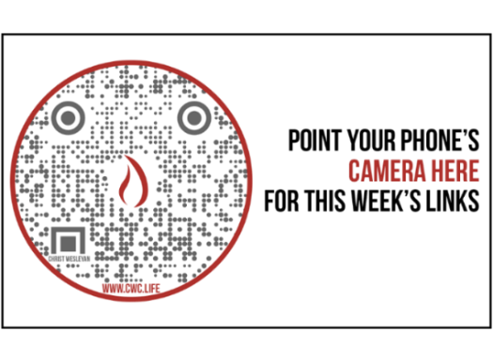

Giving & Attendance Update
Giving last Sunday: 48.3% of goal
Giving year to date: 80.2% of goal
Attendance Last Weekend: 1,962
Salvations to date: 188 | Baptisms to date: 61

“Reach the One” Campaign Update:
$1,363,631 pledged with 128 pledges received.
$401,410 total received YTD (pledged and non-pledged)

Want to pledge, donate, or learn more?
Scan the QR code below:



Upcoming Happenings:

Christmas @ Christ Wesleyan!
December 6: Christmas at the Well 6:30p
December 14: Christmas Encounter 6p
December 24: Christmas Eve: Candle Lighting service
Milton Campus: 3p, 4:30p, 6p
Sunbury Campus: 3p and 4:30p
December 29: “Culture Wars: A Morning with Ruslan”
LIVE Morning Guest Speaker: Ruslan KD
(YouTube Influencer.)

Giving & Attendance Update
Giving last Sunday: 48.3% of goal
Giving year to date: 80.2% of goal
Attendance Last Weekend: 1,962
Salvations to date: 188 | Baptisms to date: 61

“Reach the One” Campaign Update:
$1,363,631 pledged with 128 pledges received.
$401,410 total received YTD (pledged and non-pledged)

Want to pledge, donate, or learn more?
Scan the QR code below:

Upcoming Happenings:

Christmas @ Christ Wesleyan!
December 6: Christmas at the Well 6:30p
December 14: Christmas Encounter 6p
December 24: Christmas Eve: Candle Lighting service
Milton Campus: 3p, 4:30p, 6p
Sunbury Campus: 3p and 4:30p
December 29: “Culture Wars: A Morning with Ruslan”
LIVE Morning Guest Speaker: Ruslan KD
(YouTube Influencer.)

Giving & Attendance Update
Giving last Sunday: 48.3% of goal
Giving year to date: 80.2% of goal
Attendance Last Weekend: 1,962
Salvations to date: 188 | Baptisms to date: 61

“Reach the One” Campaign Update:
$1,363,631 pledged with 128 pledges received.
$401,410 total received YTD (pledged and non-pledged)

Want to pledge, donate, or learn more?
Scan the QR code below:

Upcoming Happenings:

Christmas @ Christ Wesleyan!
December 6: Christmas at the Well 6:30p
December 14: Christmas Encounter 6p
December 24: Christmas Eve: Candle Lighting service
Milton Campus: 3p, 4:30p, 6p
Sunbury Campus: 3p and 4:30p
December 29: “Culture Wars: A Morning with Ruslan”
LIVE Morning Guest Speaker: Ruslan KD
(YouTube Influencer.)

