November 3, 2024 – Week #1
Milton Campus – Rev. Dr. Erik Ireland

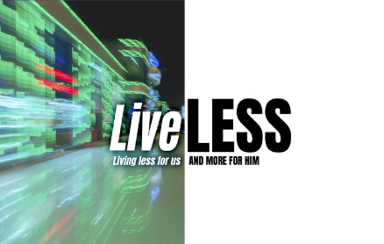
“God’s “Detours” are better than Google Maps.”

Philippians 1:12-30

Notes:__________________________________________________________________________________________________________________________________________________________________________________________________________________________________________________________________________________________________________________________________________________________________________________________________________________________________________ To begin a relationship with Jesus…
Text: “Jesus” to 570-273-0088

Next Sunday: LiveLESS
Week 2: A Life Like Jesus
Milton Campus: Pastor Branden Mestach
Sunbury Campus: Pastor Billy Robel
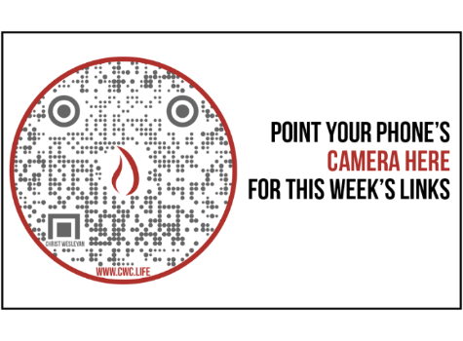

November 3, 2024 – Week #1
Milton Campus – Rev. Dr. Erik Ireland

“God’s “Detours” are better than Google Maps.”

Philippians
1:12-30

Notes:__________________________________________________________________________________________________________________________________________________________________________________________________________________________________________________________________________________________________________________________________________________________________________________________________________________________________________ To begin a relationship with Jesus…
Text: “Jesus” to 570-273-0088

Next Sunday: LiveLESS
Week 2: A Life Like Jesus
Milton Campus: Pastor Branden Mestach
Sunbury Campus: Pastor Billy Robel

November 3, 2024 – Week #1
Milton Campus – Rev. Dr. Erik Ireland

“God’s “Detours” are better than Google Maps.”

Philippians
1:12-30

Notes:__________________________________________________________________________________________________________________________________________________________________________________________________________________________________________________________________________________________________________________________________________________________________________________________________________________________________________ To begin a relationship with Jesus…
Text: “Jesus” to 570-273-0088

Next Sunday: LiveLESS
Week 2: A Life Like Jesus
Milton Campus: Pastor Branden Mestach
Sunbury Campus: Pastor Billy Robel

Giving & Attendance Update
Giving last Sunday: 68.6%
Giving year to date: 81.7%
Attendance Last Weekend: 1,852
Salvations to date: 183 | Baptisms to date: 61

Reach The One Update
$959,220 pledged with 56 pledges received
$146,775 received
Scan the QR code below for more information
on Reach The One


Upcoming Happenings:
November 8: Soul Sisters Friendsgiving 6-8pm

November 9: Enchanted Evening! 6pm

December 14: Christmas Encounter Worship 6pm

December 24: A Christ Wesleyan Christmas Eve
Milton Campus: 3pm, 4:30pm, & 6pm
Sunbury Campus: 3pm & 4:30pm

December 29: “Culture Wars: A Morning with Ruslan” LIVE morning guest speaker: Ruslan
(YouTube Influencer)

Giving & Attendance Update
Giving last Sunday: 68.6%
Giving year to date: 81.7%
Attendance Last Weekend: 1,852
Salvations to date: 183 | Baptisms to date: 61

Reach The One Update
$959,220 pledged with 56 pledges received
$146,775 received
Scan the QR code below for more information
on Reach The One

Upcoming Happenings:
November 8: Soul Sisters Friendsgiving 6-8pm

November 9: Enchanted Evening! 6pm

December 14: Christmas Encounter Worship 6pm

December 24: A Christ Wesleyan Christmas Eve
Milton Campus: 3pm, 4:30pm, & 6pm
Sunbury Campus: 3pm & 4:30pm

December 29: “Culture Wars: A Morning with Ruslan” LIVE morning guest speaker: Ruslan
(YouTube Influencer)

Giving & Attendance Update
Giving last Sunday: 68.6%
Giving year to date: 81.7%
Attendance Last Weekend: 1,852
Salvations to date: 183 | Baptisms to date: 61

Reach The One Update
$959,220 pledged with 56 pledges received
$146,775 received
Scan the QR code below for more information
on Reach The One

Upcoming Happenings:
November 8: Soul Sisters Friendsgiving 6-8pm

November 9: Enchanted Evening! 6pm

December 14: Christmas Encounter Worship 6pm

December 24: A Christ Wesleyan Christmas Eve
Milton Campus: 3pm, 4:30pm, & 6pm
Sunbury Campus: 3pm & 4:30pm

December 29: “Culture Wars: A Morning with Ruslan” LIVE morning guest speaker: Ruslan
(YouTube Influencer)

