August 18, 2024 – Week #1
Milton Campus – Pastor Branden Mestach
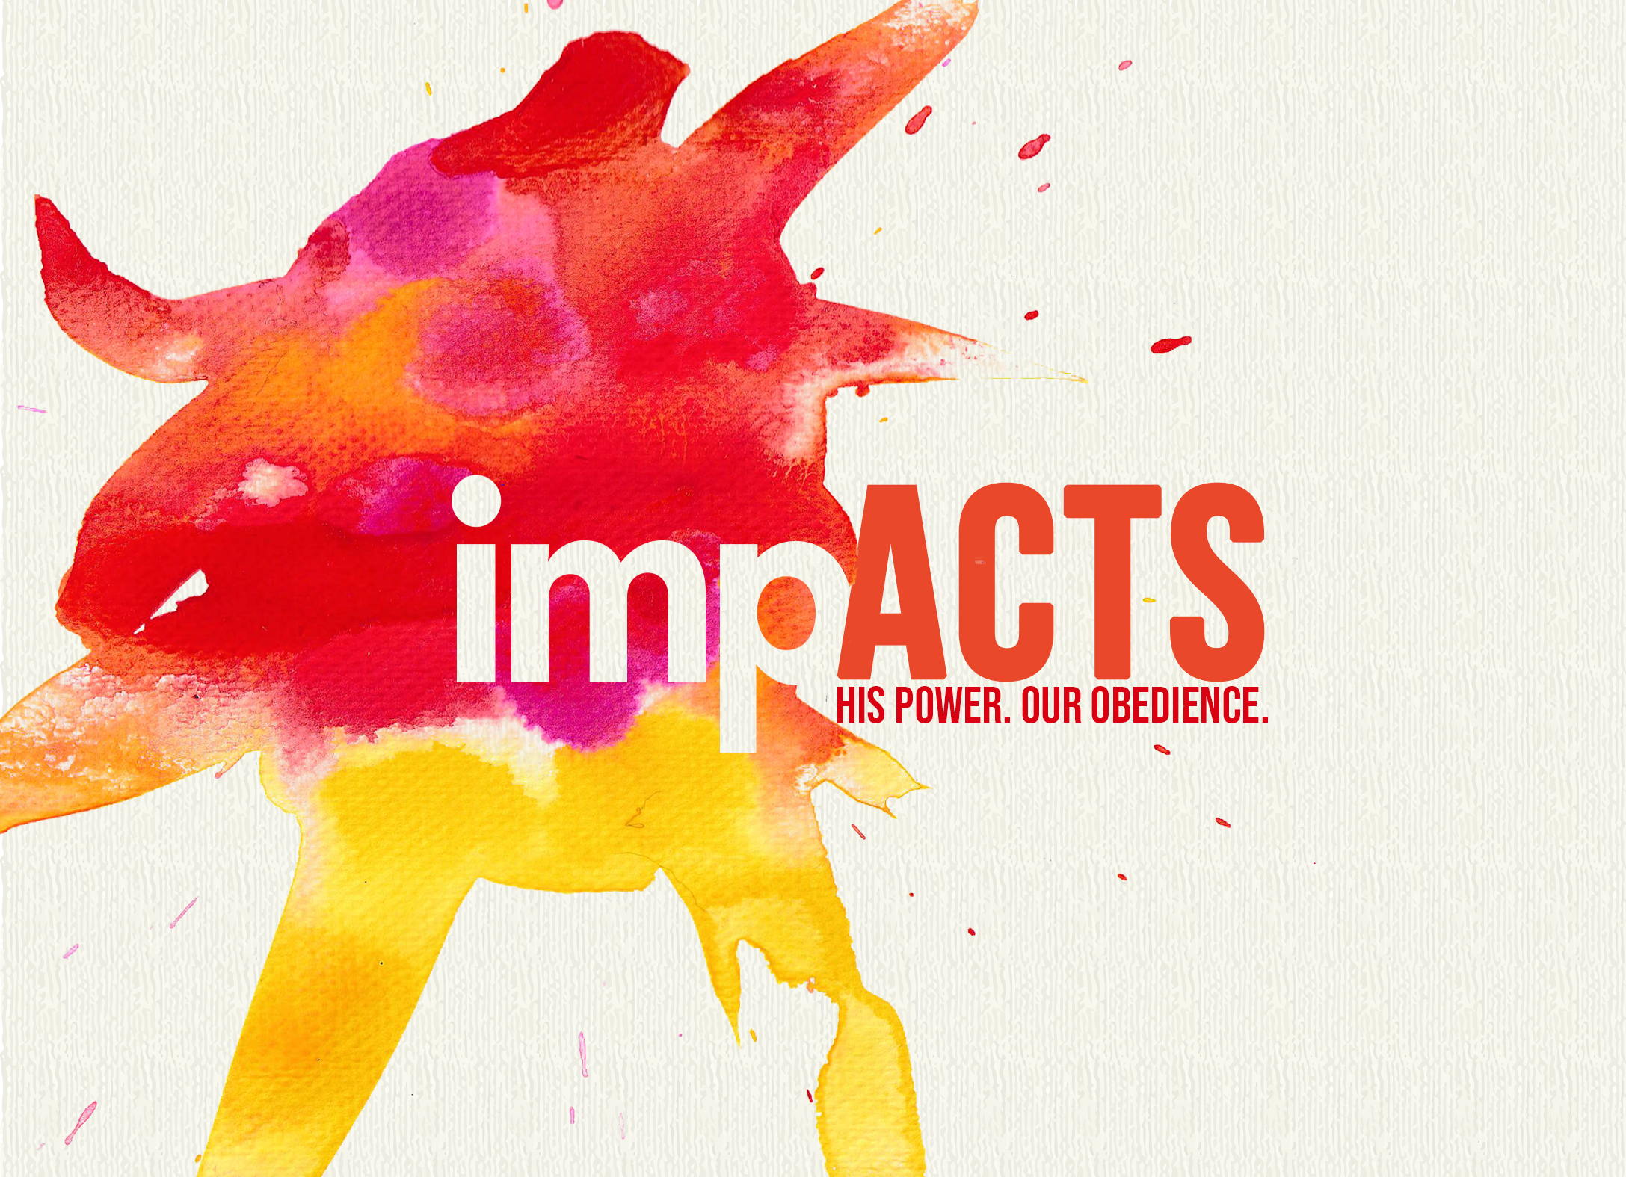

A Shaken Place

Acts 2

- The ________ of the Holy Spirit
1. There was a promised _________.
“Suddenly a sound like blowing of a violent wind came from heaven and filled the whole house where they were sitting.” Acts 2:2 (NIV)
2. There was a promised ______________.
“They saw what seemed to be tongues of fire that separated and came to rest on each of them. All of them were filled with the Holy Spirit and began to speak in other tongues as the Spirit enabled them.” Acts 2:3-4 (NIV)
3. There was a promised _________.
“Amazed and perplexed, they asked one another, ‘What does this mean?’” Acts 2:12 (NIV)

B. The __________ of Peter’s Sermon
1. Peter preached ________________.
“’Fellow Jews and all of you who live in Jerusalem, let me explain this to you; listen carefully to what I have to say. These people are not drunk, as you suppose. It’s only nine in the morning.’” Acts 2:14 (NIV)
2. Peter preached Scriptural _____________.
“No, this is what was spoken by the prophet Joel: ‘In the last days, God says, I will pour out my spirit on all people.’” Acts 2:16-17a (NIV)
3. Peter preached the _________ of Jesus.
“This Man was handed over to you by God’s deliberate plan and foreknowledge; and you, with the help of wicked men, put Him to death by nailing Him to the cross. But God raised Him from the dead, freeing Him from the agony of death because it was impossible for death to keep its hold on Him.” Acts 2:23-24 (NIV)

C. The Response of the Crowd
1. There was conviction and repentance.
“When the people heard this, they were cut to the heart and said to Peter and other apostles, ‘Brothers, what shall we do?’ Peter replied, ‘repent…’” Acts 2:37-38a (NIV)
2. There was baptism and forgiveness.
“‘…and be baptized, every one of you, in the name of Jesus Christ for the forgiveness of your sins. And you will receive the gift of the Holy Spirit.’” Acts 2:38b-c (NIV)
3. There was growth.
“Those who accepted his message were baptized, and about three thousand were added to their number that day.” Acts 2:41 (NIV)
4. What is your response to the Holy Spirit?
“‘I’ll give you a new heart, put a new spirit in you. I’ll remove the stone heart from your body and replace it with a heart that’s God-willed, not self-willed. I’ll put my Spirit in you and make it possible for you to do what I tell you and live by My commands. You’ll once again live in the land I gave your ancestors. You’ll be My people! I’ll be your God!’” Ezekiel 36:26-28 (MSG)

Bottom Line:
“With great power comes great responsibility.” Uncle Ben
To begin a relationship with Jesus…
Text: “Jesus” to 570-273-0088

Next Sunday: “impACTS”
Week 2: Judea-Samaria
Milton Campus: Pastor Branden Mestach

Sunbury Campus: Pastor Billy Robel

Giving & Attendance Update
Giving last Sunday: 81%
Giving year to date: 85.7%
Attendance Last Weekend (Get Out Sunday): 763
Salvations to date: 40 | Baptisms to date: 35

Upcoming Happenings:
September 8 – Classics Fall Kickoff Dinner – 12:30pm
September 11 – Mid-Week Groups/Youth/Kidz – 6:30pm
Notetakers are History Makers

