June 30, 2024 – Week #3
Milton Campus – Pastor Branden Mestach


The Wall Boundaries

Genesis 2:16-17

- God: The _________ of Boundaries.
“It was You who set all the boundaries of the earth;
You made both summer and winter.” Psalm 74:17 (NIV)
- Boundaries were ________ from the very beginning.
“And God said, ‘Let there be light,’ and there was light. God saw that the light was good, and He separated the light from the darkness. Genesis 1:3-4 (NIV)

- Boundaries were given to the _______ man.
“And the Lord God commanded the man, ‘You are free to eat from any tree in the garden; but you must not eat from the tree of the knowledge of good and evil, for when you eat from it you will certainly die.’” Genesis 2:16-17 (NIV)

3. Boundaries were given to the ___________.
“And God spoke all these words: ‘I am the Lord your God, who brought you out of Egypt, out of the land of slavery. You shall have no other gods before Me.
You shall not make for yourself an image in the form of anything in heaven above or on the earth beneath or in the waters below. You shall not bow down to them or worship them; for I, the Lord your God, am a jealous God, punishing the children for the sin of the parents to the third and fourth generation of those who hate Me, but showing love to a thousand generations of those who love Me and keep My commandments. You shall not misuse the name of the Lord your God, for the Lord will not hold anyone guiltless who misuses His name. Remember the Sabbath day by keeping it holy. Six days you shall labor and do all your work, but the seventh day is a sabbath to the Lord your God. On it you shall not do any work, neither you, nor your son or daughter, nor your male or female servant, nor your animals, nor any foreigner residing in your towns. For in six days the Lord made the heavens and the earth, the sea, and all that is in them, but He rested on the seventh day. Therefore the Lord blessed the Sabbath day and made it holy. Honor your father and your mother, so that you may live long in the land the Lord your God is giving you. You shall not murder. You shall not commit adultery. You shall not steal. You shall not give false testimony against your neighbor. You shall not covet your neighbor’s house. You shall not covet your neighbor’s wife, or his male or female servant, his ox or donkey, or anything that belongs to your neighbor.”
Exodus 20:1-17 (NIV)

4. Boundaries were _______ out by Jesus.
“But Jesus often withdrew to lonely places and prayed.” Luke 5:16 (NIV)

B. God: The ________ for Boundaries.
1. Unhealthy boundaries hinder the church.
“For I am afraid that when I come I may not find you as I want you to be, and you may not find me as you want me to be. I fear that there may be discord, jealousy, fits of rage, selfish ambition, slander, gossip, arrogance and disorder.” 2 Corinthians 12:20 (NIV)

2. Unhealthy ________ boundaries keep us from God’s peace.
“Finally, brothers and sisters, whatever is true, whatever is noble, whatever is right, whatever is pure, whatever is lovely, whatever is admirable—if anything is excellent or praiseworthy—think about such things. Whatever you have learned or received or heard from Me, or seen in Me—put it into practice. And the God of peace will be with you. Philippians 4:8-9 (NIV)

3. Unhealthy boundaries ______ our protection.
“Have you eaten from the tree that I commanded you not to eat from? The man said, ‘The woman You put here with me—she gave me some fruit from the tree, and I ate it.’” Genesis 3:11b-12 (NIV)

4. Unhealthy boundaries cause us to _______ from our identity in God.
“But the Lord said to Samuel, ‘Do not consider his appearance or his height, for I have rejected him. The Lord does not look at the things people look at. People look at the outward appearance, but the Lord looks at the heart.’”
1 Samuel 16:7 NIV

C. Build Healthy Relationships by
Building Healthy Boundaries.
1. Healthy boundaries are a part of
sanctification.
“Those who live according to the flesh have their minds set on what the flesh desires; but those who live in accordance with the Spirit have their minds set on what the Spirit desires. ⁶ The mind governed by the flesh is death, but the mind governed by the Spirit is life and peace.” Romans 8:5-6(NIV)

2. Healthy boundaries develop, “If you, I will,
if you continue” language.

3. Healthy boundaries are a process of growth
and knowledge.
“I have learned the secret of being content in any and every situation, whether well fed or hungry, whether living in plenty or in want.” Philippians 4:12b (NIV)

4. Healthy boundaries may need extra power.
“I can do all this through Him who gives me strength.” Philippians 4:13 (NIV)

Bottom Line:
Without healthy boundaries,
healthy relationships cease to exist.
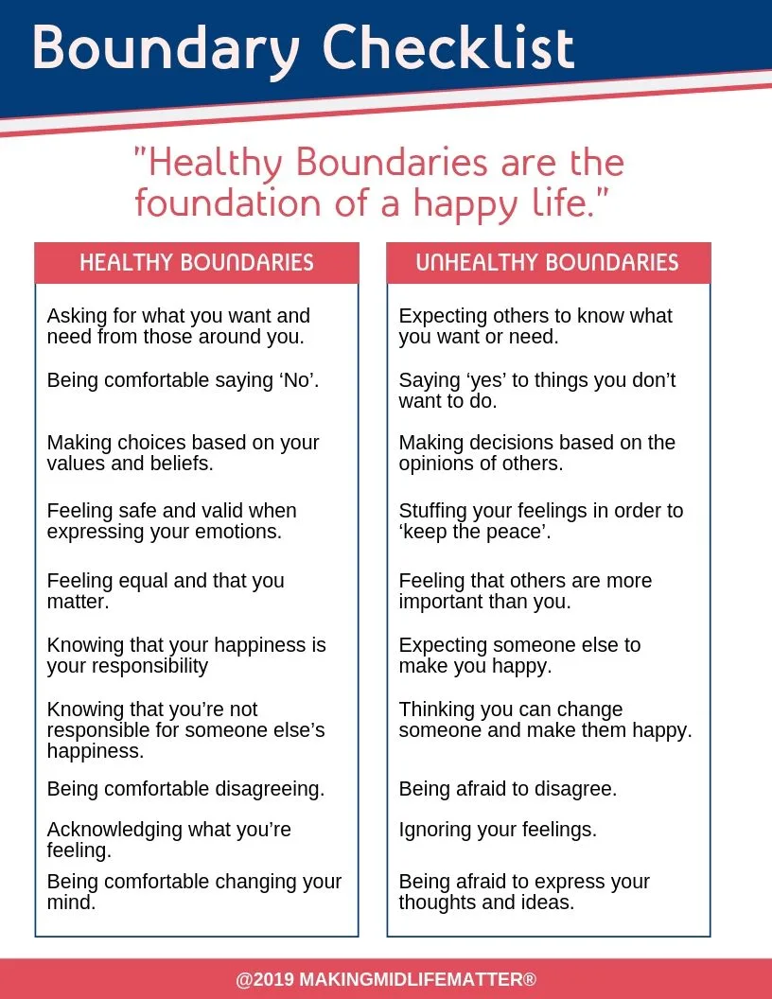
To begin a relationship with Jesus…
Text: “Jesus” to 570-273-0088

Next Sunday: “by Design”
Week 4: The Protective Finishings
Milton Campus: Pastor Branden Mestach

Sunbury Campus: Pastor Billy Robel

Giving & Attendance Update
Giving last Sunday: 65.3% of goal
Giving year to date: 89.8% of goal
Attendance Last Weekend: 1,775
Salvations to date: 10 | Baptisms to date: 18

Upcoming Happenings:
July 7 – FREEDOM FEST!
Regular morning services at both campuses.
Outdoor Baptism Service 3p
Kids Inflatables, Tailgating, & Activities at 4.
Fireworks at dusk.
Want to volunteer for Freedom Fest? Go to: cwclife.churchcenter.com

August 11 – Get Out Sunday!
We will meet outdoors in our local communities!
We will worship and hear the Word together.
We will go out and pray for our schools, teachers, and
students and administrations.
Notetakers are History Makers

