May 26, 2024 – Week #3
Milton Campus – Pastor Ken Paulhamus
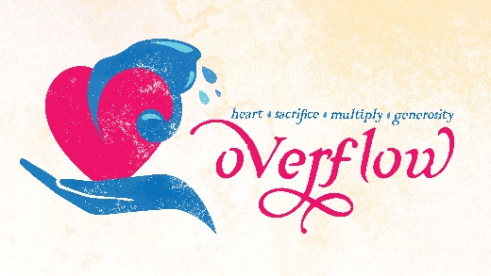
The Principles of Multiplication

Luke 9:10-17

- The Miracle of _______________

“Late in the afternoon the Twelve came to Him and said, ‘Send the crowd away so they can go to the surrounding villages and countryside and find food and lodging, because we are in a remote place here.’ Luke 9:12 (NIV)
1. Jesus said, “____ give them something to eat".
He replied, “You give them something to eat.” Luke 9:13a

2. The disciple’s response – “We don’t have __________.”
“They answered, “We have only five loaves of bread and two fish—unless we go and buy food for all this crowd.” Luke 9:13b

3. About ______ men were there, so there were likely 15,000 to 20,000 people total.
“The number of those who ate was about five thousand men, besides women and children” Matthew 14:21

“Taking the five loaves and the two fish and looking up to heaven, He gave thanks and broke them. Then He gave them to the disciples to distribute to the people.”
Luke 9:16

4. Jesus broke ____ and gave ____ to the disciples.

5. The small amount of food multiplied, only after Jesus ________ it and only after His disciples started ________ it away.
“They all ate and were satisfied, and the disciples picked up twelve basketfuls of broken pieces that were left over.” Luke 9:17

B. The ___________ of Multiplication

1. We give to the Lord first, so that what we give can be __________.

“Will a mere mortal rob God? Yet you rob Me.” But you ask, ‘How are we robbing You?’ “In tithes and offerings. You are under a curse—your whole nation—because you are robbing Me. Bring the whole tithe into the storehouse, that there may be food in My house. Test Me in this,” says the Lord Almighty, “and see if I will not throw open the floodgates of heaven and pour out so much blessing that there will not be room enough to store it.” Malachi 3:8-10

2. We share what is given, because only what is shared can be _____________.

“The whole earth is Mine.” Exodus 19:5b
“To the LORD your God belong the heavens, even the highest heavens, the earth and everything in it.” Deuteronomy 10:14
“The earth is the LORD's, and everything in it, the world, and all who live in it.” Psalm 24:1

“Stewardship is managing God’s treasures in God’s way, for God’s purposes, and always for God’s glory. We begin life with our hands wide open and nothing in them. As we mature, by the grace of God, He allows certain things to be placed into our possession, none of them under our ownership. Remember, He owns everything in heaven and earth. It’s all His.” Chuck Swindoll, Insight for Living Article: God Owns It All, November 10, 2010

C. The Blessed Life is not how much you get _____ – it’s how much you _____.

1. Benevolence – the 0.5% from tithes and the offerings beyond that allowed us to give over $90,000 to 112 needy families last year.

2. Food Pantry – the 0.5% from tithes and the offerings beyond that allowed us to purchase nearly $61,000 worth of food and give it to 200 families per month last year.

3. Missions/Outreach – the 9% from tithes and the offerings beyond that totaled $722,000 for use to share the Light of Jesus Christ with our World last year.

The 90-Day Tithe Challenge

Your part is to commit to bring back to God the tithe, the first 10% for 90 days. Our commitment to you is that at the end of 90 days, if you have not experienced or recognized God’s faithful care of you, nurturing you in your journey of faith, then we commit to giving back every penny you’ve given to CWC during the 90 days, no questions asked.

Bottom Line:
It is intentional on our part, that your giving has to be intentional on your part.

To begin a relationship with Jesus…
Text: “Jesus” to 570-273-0088

Next Sunday: Overflow
Week 4: The Principle of Generosity

Milton Campus: Pastor Branden Mestach
Sunbury Campus: Pastor Billy Robel


Giving & Attendance Update
Giving last Sunday: 67.9% of goal
Giving year to date: 87.1% of goal
Attendance Last Weekend: 2,125
Salvations to date: 6 | Baptisms to date: 18

Upcoming Happenings:
June 2 – Graduation Recognition Sunday
June 25-28 – CWC Kidz Camp
July 7 – Freedom Fest

Notes

