May 19, 2024 – Week #2
Milton Campus – Pastor Mike Sweigard
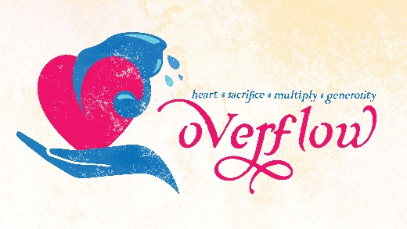

First Thing’s First
For where your treasure is, there your heart will be also.
Matthew 6:21 (NIV)

Your treasure’s __________ reveals your heart’s ______.

What did Jesus say?
“You’re hopeless, you religion scholars and Pharisees! Frauds! You keep meticulous account books, tithing on every nickel and dime you get, but on the meat of God’s Law, things like fairness and compassion and commitment—the absolute basics!—you carelessly take it or leave it. Careful bookkeeping is commendable, but the basics are required. Do you have any idea how silly you look, writing a life story that’s wrong from start to finish, nitpicking over commas and semicolons? – Matt 23:23-24 (The Message)

The First _________________________
Jesus replied: “‘Love the Lord your God with all your heart and with all your soul and with all your mind.’ – Matthew 22:37 (NIV)
Notes:_______________________________________________________________________________________________________________________________________________________________________

The Principle of the __________: Sacrificed or Redeemed
“Consecrate to Me every firstborn male. The first offspring of every womb among the Israelites belongs to Me, whether human or animal.” – Exodus 13:2 (NIV)
Notes:_______________________________________________________________________________________________________________________________________________________________________

“the firstborn was either to be sacrificed or redeemed…to summarize, the clean firstborn had to be sacrificed and the unclean firstborn had to be redeemed.” – (Morris, The Blessed Life, p.31).

The Principle of the ________________

Cain & Abel
In the course of time Cain brought some of the fruits of the soil as an offering to the Lord. ⁴ And Abel also brought an offering—fat portions from some of the firstborn of his flock. The Lord looked with favor on Abel and his offering, ⁵ but on Cain and his offering he did not look with favor. So Cain was very angry, and his face was downcast. – Genesis 4:3-5 (NIV)

The Practice of Giving ________
Tithe vs. ______________
Tithing is the ________ 10%
Tithing is about the ________
Notes:_______________________________________________________________________________________________________________________________________________________________________

“A checkbook is a theological document; it will tell you who and what you worship.” -- Billy Graham
My Response to Jesus:
______________________________________________________________________________________________________________________________________________________________________________

Do you want to begin a relationship with Jesus?…
Text: IChooseJesus (all one word) to 570-273-0088
Statistics on Tithing in Local Churches:
- Only 5% tithe, and 80% of Americans only give 2% of their income.
- Christians are giving at 2.5% of income; during the Great Depression it was 3.3%.
- Only 3-5% of Americans who give to their local church do so through regular tithing.
- When surveyed, 17% of Americans state that they regularly tithe.

The 90-Day Tithe Challenge
“‘Bring the whole tithe into the storehouse, so that there may be food in My house, and put Me to the test now in this,’ says the Lord of armies, ‘if I do not open for you the windows of heaven and pour out for you a blessing until it overflows.’” Malachi 3:10 (NASB)
Our part is to commit to bring back to God the tithe, the first 10% for 90 days. At the end of 90 days, if you have not experienced, recognized, God’s faithful care of you, nurturing you in your journey of faith, then we commit to giving back every penny you’ve given to CWC during the 90 days, no questions asked.
Next Sunday: The Principle of Multiplication
Milton: Pastor Ken Paulhamus
9:00am | 10:45am
Sunbury: Pastor Billy Robel
10:00am
Online:
9:00am | 10:45am | 7:00pm

Have a question? Want to take the message further? E-mail mike.sweigard@cwc.life with a question to be included on the Dive Deep Podcast


Giving & Attendance Update
Giving last Sunday: 88.1%
Giving year to date: 89.8%
Weekend Attendance: 2,158
Salvations to date: 6 | Baptisms to date: 18

Upcoming Happenings
May 19 – Annual Church Celebration! 2:30p
May 25 – Community Service Day! 9-11a
June 25-28 – CWC Kidz Camp!

Morris, Robert. “Sacrificed or Redeemed.” The Blessed Life, Regal Books, Ventura, CA, 2002, pp. 31–31.
https://nonprofitssource.com/online-giving-statistics/#:~:text=Only%205%25%20tithe%2C%20and%2080,state%20that%20they%20regularly%20tithe.

