March 30-31, 2024 – Week #4
Milton Campus – Pastor Branden Mestach
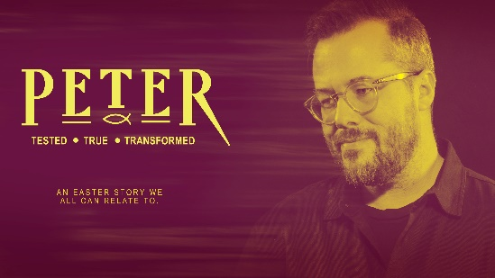
The Reinstatement

John 21:15-23

- The Context of the _____________

      - Peter had ____ off an ear, as he was ill-prepared.
“Then Simon Peter, who had a sword, drew it and struck the high priest’s servant, cutting off his right ear. (The servant’s name was Malchus.) Jesus commanded Peter, ‘Put your sword away! Shall I not drink the cup the Father has given Me?’” John 18:10-11 (NIV)

      - Peter had denied Christ _______ times, as he was filled with fear.
“One of the high priest’s servants, a relative of the man whose ear Peter had cut off, challenged him, ‘Didn’t I see you with Him in the garden?’ Again Peter denied it, and at that moment a rooster began to crow.” John 18:26-27 (NIV)

3. Jesus had ____ and _____ from the grave, as
He was filled with love.
“Later, knowing that everything had now been finished, and so that Scripture would be fulfilled, Jesus said, “I am thirsty.” A jar of wine vinegar was there, so they soaked a sponge in it, put the sponge on a stalk of the hyssop plant, and lifted it to Jesus’ lips. ³⁰ When He had received the drink, Jesus said, “It is finished.” With that, He bowed His head and gave up His spirit.” John 19:28-30 (NIV)

“On the evening of that first day of the week, when the disciples were together, with the doors locked for fear of the Jewish leaders, Jesus came and stood among them and said, ‘Peace be with you!’ After He said this, He showed them His hands and side. The disciples were overjoyed when they saw the Lord.” John 20:19-20 (NIV)

4. Jesus and seven of His disciples had
________, as they all were filled with hope.
“When they had finished eating,” John 21:15a (NIV)

- Peter’s Calling by Jesus Was ________

1. Jesus said to Peter, “______ Me.”
“Simon son of John, do you love Me more than these?” John 21:15b (NIV)
“Again Jesus said, ‘Simon son of John, do you love Me?” John 21:16a (NIV)
“The third time He said to him, ‘Simon son of John, do you love Me?” John 21:17a (NIV)

2. Jesus tasked Peter to “_____ My sheep.”
“Jesus said, ‘Feed My lambs.’” John 21:15c (NIV)
“Jesus said, ‘Take care of My sheep.’” John 21:16c (NIV)
“Jesus said, ‘Feed My sheep.’” John 21:17c (NIV)

3. Jesus predicted Peter would “____ for Me.”
“‘Very truly I tell you, when you were younger you dressed yourself and went where you wanted; but when you are old you will stretch out your hands, and someone else will dress you and lead you where you do not want to go.’ Jesus said this to indicate the kind of death by which Peter would glorify God.” John 21:18-19b-c (NIV)

4. Jesus went back to the beginning and said, “________ Me.”
“Then He said to him, ‘Follow Me.’ Peter turned and saw that the disciple whom Jesus loved was following them. When Peter saw him, he asked, ‘Lord, what about him?’ Jesus answered, ‘If I want him to remain alive until I return, what is that to you? You must follow Me.’” John 21:19c-20a; 21-22 (NIV)

- As Disciples, Our Calling is Similar

1. Jesus wants us to follow Him, despite our failures.
“There is therefore now no condemnation for those who are in Christ Jesus. For the law of the life-giving Spirit in Christ Jesus has set you free from the law of sin and death.” Romans 8:1-2 (NET)

2. Jesus wants us to love Him with all of our heart.
“Jesus replied: ‘Love the Lord your God with all your heart and with all your soul and with all your mind.’” Matthew 22:37 (NIV)

3. Jesus wants us to care for His sheep.
“Care for the flock that God has entrusted to you. Watch over it willingly, not grudgingly—not for what you will get out of it, but because you are eager to serve God. Don’t lord it over the people assigned to your care but lead them by your own good example. And when the Great Shepherd appears, you will receive a crown of never-ending glory and honor.” 1 Peter 5:2-4 (NLT)

4. Jesus asks us to give up everything to follow Him.
“Then Jesus went to work on His disciples. ‘Anyone who intends to come with Me has to let Me lead. You’re not in the driver’s seat; I am. Don’t run from suffering; embrace it. Follow Me and I’ll show you how. Self-help is no help at all. Self-sacrifice is the way, My way, to finding yourself, your true self. What kind of deal is it to get everything you want but lose yourself? What could you ever trade your soul for?’” Matthew 16:24-26 (MSG)

Bottom Line:
The resurrected Christ wants more than just breakfast, He wants the whole day.
To begin a relationship with Jesus…
Text: IChooseJesus (all one word) to 570-273-0088

Next Sunday: A New Sermon Series!
Church: Who Needs It?

Milton Campus: Pastor Branden Mestach
Sunbury Campus: Pastor Billy Robel


Giving & Attendance Update
Giving last Sunday: 52.7% of goal
Giving year to date: 82% of goal
Attendance last Sunday: 2,176
Salvations to date: 205 | Baptisms to date: 110

Upcoming Happenings:
April 7 – Membership Class 12:30p
Classics Dinner 12:30p
April 11-13 – MCS Presents: Seussical the Musical!

Notetakers are History Makers

