March 10, 2024 – Week #1
Milton Campus – Pastor Branden Mestach
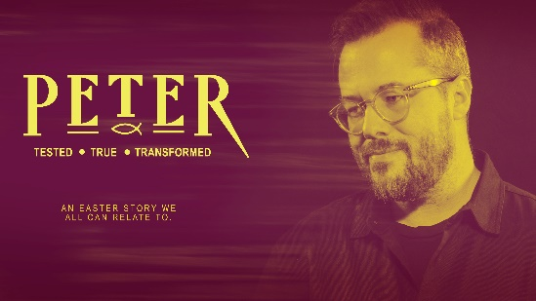
The Garden Failure

John 18:10-11

- Peter’s _____________ Behavior
“Then Simon Peter, who had a sword, drew it and struck the high priest’s servant, cutting off his ear. (The servant’s name was Malchus.)” John 18:10 (NIV)

      - Peter knew the Who, but not the ______.
“Simon Peter replied, ‘You are the Messiah, the Son of the living God.’” Matthew 16:16 (NIV)

      - Peter did not wait on the Lord’s _________.
“When Jesus’ followers saw what was going to happen, they said, ‘Lord, should we strike with our swords?’ And one of them struck the servant of the high priest, cutting off his right ear.” Luke 22:49-50 (NIV)

3. Peter fell asleep, therefore was not _______.
“Then He returned to His disciples and found them sleeping. ‘Simon,’ He said to Peter, ‘are you asleep? Couldn’t you keep watch for one hour? Watch and pray so that you will not fall into temptation. The spirit is willing, but the flesh is weak.’” Mark 14:37-38 (NIV)

- Jesus’ ______________ Behavior

1. Jesus wanted ________, not the sword.
“‘Put your sword back in its place,’ Jesus said to him, ‘for all who draw the sword will die by the sword. Do you think I cannot call on My Father, and He will at once put at My disposal more than twelve legions of angels? But how then would the Scriptures be fulfilled that say it must happen in this way?’” Matthew 26:52-54 (NIV)

2. Jesus submitted to His Father’s __________.
“Jesus commanded Peter, ‘Put your sword away! Shall I not drink the cup the Father has given Me?” John 18:11 (NIV)
a. The cup was God’s ______.
“Awake, awake! Rise up, Jerusalem, you who have drunk from the hand of the Lord the cup of His wrath, you who have drained to its dregs the goblet that makes people stagger.” Isaiah 51:17 (NIV)

b. The cup of wrath became our _________.
“I will lift up the cup of salvation and call on the name of the Lord.” Isaiah 116:13 (NIV)

3. Jesus _________, therefore was prepared.
“Going a little further, He fell to the ground and prayed that if possible the hour might pass from Him. ‘Abba, Father,’ He said, ‘everything is possible for you. Take this cup from Me. Yet not what I will, but what You will.’” Mark 14:35-36 (NIV)

“But Jesus answered, ‘No more of this!’ And He touched the man’s ear and healed him.” Luke 22:51 (NIV)

- Do you have committable behavior?

1. What does your life say about Who Jesus is?
“Jesus said to him, ‘I am the [only] Way [to God] and the [real] Truth and the [real] Life; no one comes to the Father but through Me. If you had [really] known Me, you would also have known My Father. From now on you know Him, and have seen Him.’” John 14:6-7 (AMP)

2. Are you prepared to be a drink offering?
“But even if I am being poured out like a drink offering on the sacrifice and service coming from your faith, I am glad and rejoice with all of you. So, you too should be glad and rejoice with me.” Philippians 2:17 (NIV)

3. Are your weapons carnal or spiritual?
“For though we live in the world, we do not wage war as the world does. The weapons we fight with are not weapons of the world. On the contrary, they have divine power to demolish strongholds.” 2 Corinthians 10:3-4 (NIV)

“For our struggle is not against flesh and blood, but against the rulers, against the authorities, against the powers of this dark world and against the spiritual forces of evil in the heavenly realms.” Ephesians 6:12 (NIV)

Bottom Line:
Success or failure is determined
in the preparation, not in the battle.

To begin a relationship with Jesus…
Text: IChooseJesus (all one word) to 570-273-0088

Next Sunday:
Milton Campus: Pastor Branden Mestach
Sunbury Campus: Pastor Billy Robel

Week 2: The Denials
Peter: Tested. True. Transformed.
A deep dive look at the life of St. Peter.

Giving & Attendance Update
Giving last Sunday: 82.5% of goal
Giving year to date: 82.9% of goal
Attendance last Sunday: 2,058
Salvations to date: 104 | Baptisms to date: 110

Upcoming Happenings:
February 20-March 30 – 40 Days of Prayer and Fasting begins.

March 29-31 – Easter Weekend:

Milton Campus
March 29 – Good Friday Service 7p
March 30 – Saturday Night Easter Service 6:00p
March 31 – Easter Sunday 6:30a, 9a and 10:45a

Sunbury Campus:
March 31 – Easter Sunday 9a and 11a

April 7 – Baptism Sunday!
April 7 – Membership Class 12:30p

Notetakers are History Makers

