December 17, 2023 – Week #3
Milton Campus – Pastor Branden Mestach
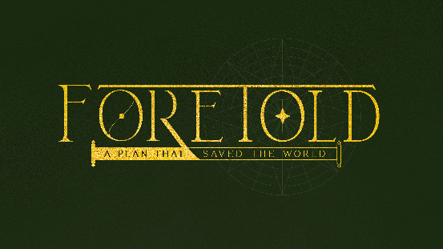
God’s Plan for Love
Isaiah 7:14
John 3:16
1 John 3:16
Ephesians 2:4-5

- The __________ of Love
“Therefore, the Lord Himself will give you a sign: The virgin will conceive and give birth to a son and will call Him Immanuel.” Isaiah 7:14 (NIV)

      - The unbelief of man will not make the ___________ of God of no effect.

      - The prophesy of love is _____________.

      - The prophesy of love is ________.

- The _____________ of Love
“For God so loved the world that He gave His one and only Son, that whoever believes in Him shall not perish but have eternal life.” John 3:16 (NIV)

      - This love has no _______ to be missed.
“The Lord said to Moses, ‘Make a snake and put it up on a pole; anyone who is bitten can look at it and live.’ So Moses made a bronze snake and put it up on a pole. Then when anyone was bitten by a snake and looked at the bronze snake, they lived.” Numbers 21:8-9 (NIV)

- Like the bronze snake, Christ ______ bright.
“His feet were like bronze glowing in a furnace, and His voice was like the sound of rushing waters.” Revelation 1:15 (NIV)

- Like the bronze snake, Christ was made a _______.
“Christ redeemed us from the curse of the law by becoming a curse for us, for it is written: ‘Cursed is everyone who is hung on a pole.’” Galatians 3:13 (NIV)

- Like the bronze snake, Christ was ______ up.
“‘And I, when I am lifted up from the earth, will draw all people to Myself.’ He said this to show the kind of death He was going to die.” John 12:32-33 (NIV)

      - Christ was lifted up so we can lay _______.
“This is how we know what love is: Jesus Christ laid down His life for us. And we ought to lay down our lives for our brothers and sisters.” 1 John 3:16 (NIV)

- The ________________ of Joy
“But because of His great love for us, God, Who is rich in mercy, made us alive with Christ even when we were dead in transgressions—it is by grace you have been saved.” Ephesians 2:4-5 (NIV)

      - We, who were dead, are given life.

      - We, who were buried, are resurrected.

      - We, who were lost, are given light.
“You are the light of the world. A town built on a hill cannot be hidden. Neither do people light a lamp and put it under a bowl. Instead, they put it on its stand, and it gives light to everyone in the house. In the same way, let your light shine before others, that they may see your good deeds and glorify your Father in heaven.” Matthew 5:14-16 (NIV)

Bottom Line:
There is a Love that makes no sense.

To begin a relationship with Jesus…
Text: IChooseJesus (all one word) to 570-273-0088

Want to take it deeper? Send in a question for the Dive Deep Podcast to our Online Campus Pastor: mike.sweigard@cwc.life

Next Sunday:
Foretold: A Plan That Saved the World
Week 4: God’s Plan for Christ

Milton Campus: Pastor Branden Mestach
Sunbury Campus: Pastor Billy Robel
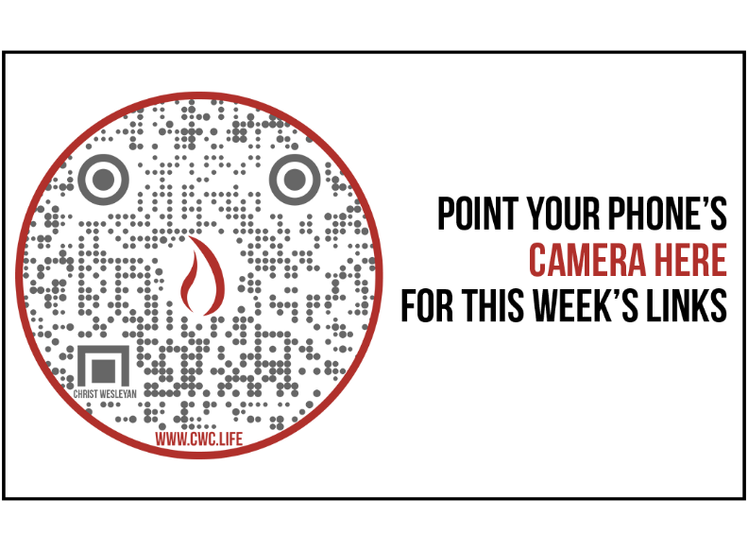

Giving & Attendance Update
Giving last Sunday: 92.3% of goal
Giving year to date: 82.4% of goal
Attendance last Sunday: 2,070
Salvations to date: 80 | Baptisms to date: 76

Upcoming Happenings:
Christmas @ Christ Wesleyan:
Christmas Eve Candlelight Services:
Milton Campus: 9:00a, 10:45a, and 5p
Sunbury Campus: 9:00a, 11:00a, and 5p

Notetakers are History Makers

