October 22, 2023
Milton Campus, Pastor Ryan Brosious

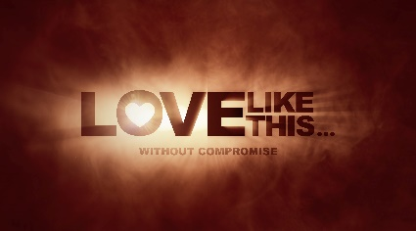
Week 2:
“To Love or Not To Love?”
1 John 2

Holy Spirit, if it’s of You, we want it. Come how You want; come when You want. Just so long as You come. In Jesus’ name, Amen.

- Love Made a ______

“My dear children, I write this to you so that you will not sin. But if anybody does sin, we have an advocate with the Father – Jesus Christ, the Righteous One. He is the atoning sacrifice for our sins, and not only for ours but also for the sins of the whole world.”
– 1 John 2:1-2

- Sin is not God’s plan for our life, but He wanted a relationship with us so much that the made a way.

- We cannot for our own sin.

- There is no that Christ didn’t die for.

- Do I Love?

“We know that we have come to know Him if we keep His commands. Whoever says, ‘I know Him,’ but does not do what He commands is a liar, and the truth is not in that person. But if anyone obeys His word, love for God is truly made complete in them. This is how we know we are in Him: Whoever claims to live in Him must live as Jesus did.”
– 1 John 2:3-6

- We cannot our love for God from our obedience to Him.

- Our with God grows through obedience and suffers through disobedience.

- can take many forms: one is saying we know God but then neglect to walk in His ways.

- The best and most complete way to love God is to
like Jesus.

- To ______

“Dear friends, I am not writing you a new command but an old one, which you have had since the beginning. This old command is the message you have heard. Yet I am writing you a new command; its truth is seen in Him and in you, because the darkness is passing and the true light is already shining. Anyone who claims to be in the light but hates a brother or sister is still in the darkness. Anyone who loves their brother and sister lives in the light, and there is nothing in them to make them stumble. But anyone who hates a brother or sister is in the darkness and walks around in the darkness. They do not know where they are going, because the darkness has blinded them.”
– 1 John 2:7-11

- The command to love each other is not . (Leviticus 19:18)

- Darkness and light shines when we love like Jesus.

- Hate for others our Kingdom vision and mission.
- To Love

“Do not love the world or anything in the world. If anyone loves the world, love for the Father is not in them. For everything in the world – the lust of the flesh, the lust of the eyes, and the pride of life – comes not from the Father but from the world. The world and its desires pass away, but whoever does the will of God lives forever.”
– 1 John 2:15-17

- A command to love: that which is _________ (God/His Word/people)

- A command not to love: that which is ________

- There are good temporary things that we can
, and there are bad temporary things that will us. Neither is intended to have our hearts.

- If lust and pride destroy us, then for God and heal us.

- : Our Ultimate Declaration

“Who is the liar? It is whoever denies that Jesus is the Christ. Such a person is the antichrist – denying the Father and the Son. No one who denies the Son has the Father; whoever acknowledges the Son has the Father also. As for you, see that what you have heard from the beginning remains in you. If it does, you also will remain in the Son and in the Father. And this is what He promised us – eternal life.”
– 1 John 2:22-25

- To deny Jesus is to deny the , to deny heaven.

- To be anti-Christ is to be an .

- To acknowledge Jesus gives us the Father with power from the Holy Spirit. Jesus gives us
access.

- We are prone to wander; in Him.

What has your love? What doesn’t have your love?

“And now, dear children, continue in Him, so that when He appears we may be confident and unashamed before Him at His coming. If you know that He is righteous, you know that everyone who does what is right has been born of Him.”
– 1 John 2:28-29

For further encouragement: Read 1 John 2:12-14
No matter your age/stage… the message is for you!

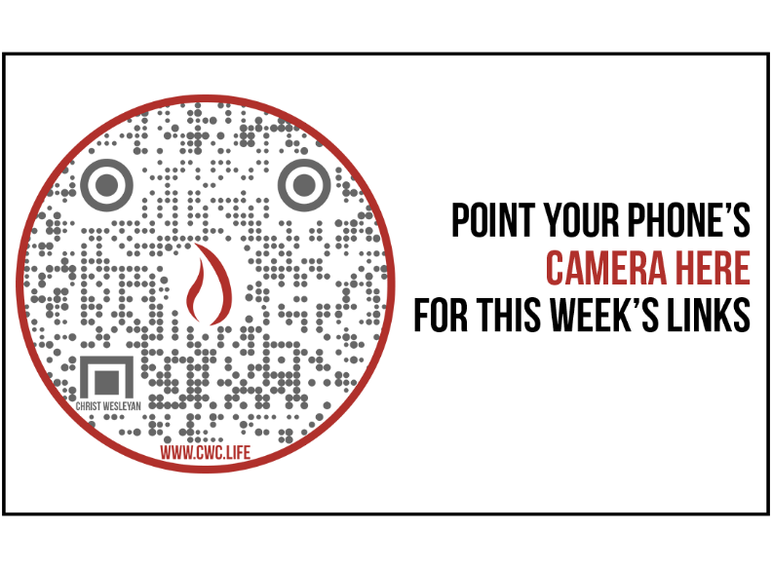

Stewardship Update
Giving Last Weekend: 56.6%
Giving YTD: 82.9%
Attendance Last Weekend: 2,110
Salvations to date: 70 | Baptisms to date: 62

Upcoming Happenings:
October 24: Sunbury Prayer Night
October 27: Trunk or Treat (Milton)
October 28: Trunk or Treat (Sunbury)
November 9-12: The Sound of Music Performances
December 3: Membership Class (Milton)

