October 15, 2023 – Week #1
Milton Campus – Pastor Branden Mestach

Be Light…
1 John 1

- A ________________ Commission
      - Jesus Christ was witnessed as the Son of God.
“That which was from the beginning, which we have heard, which we have seen with our own eyes, which we have looked at and our hands have touched—this we proclaim about the Word of Life.” 1 John 1:1 (NIV)

      - Jesus Christ is _________ life.
“The life appeared; we have seen it and testify to it, and we proclaim to you the eternal life, which was with the Father and has appeared to us.” 1 John 1:2 (NIV)

3. Proper fellowship with _____ leads to
proper fellowship with other ____________.
“We proclaim to you what we have seen and heard, so that you also may have fellowship with us. And our fellowship is with the Father and with His Son, Jesus Christ. We write this to make our joy complete.” 1 John 1:3-4 (NIV)

- A Light and _____ Story
- Dark: Without Christ: ____
“This is the message we have heard from Him and declare to you: God is light; in Him there is no darkness at all. If we claim to have fellowship with Him and yet walk in darkness, we lie and do not live out the Truth.” 1 John 1:5-6 (NIV)

  - Darkness is _______ to the Light.
  - Darkness _______ the Light.
  - Darkness represents the __________.
  - Darkness focuses on ______.
  - Darkness leads to __________________.
  - Darkness is the place of eternal ______________.

- Light: With Christ: ________________
“But if we walk in the Light, as He is in the Light, we have fellowship with one another, and the blood of Jesus, His Son, purifies us from all sin.” 1 John 1:7 (NIV)

- For all have sinned and ____ short.
“If we claim to be without sin, we deceive ourselves and the truth is not in us. If we confess our sins, He is faithful and just and will forgive our sins and purify us from all unrighteousness. If we claim we have not sinned, we make Him out to be a liar and His Word is not in us.” 1 John 1:8-10 (NIV)

- What is and will be your story?
      - A life/story lived in darkness is obvious.
“The acts of the flesh are obvious: Sexual immorality, impurity and debauchery; idolatry and witchcraft; hatred, discord, jealousy, fits of rage, selfish ambition, dissensions, factions and envy; drunkenness, orgies, and the like. I warn you, as I did before, that those who live like this will not inherit the kingdom of Heaven.” Galatians 5:19-21 (NIV)

      - A life/story lived in the Light is obvious.
“But the fruit of the Spirit is love, joy, peace, forbearance, kindness, goodness, faithfulness, gentleness and self-control. Against such things there is not law. Those who belong to Christ Jesus have crucified the flesh with its passions and desires.” Galatians 5:22-24 (NIV)
      - Want to walk in the Light or teach others how to find the Light?

Follow the Roman Road…

“For all have sinned and fall short of the glory of God.” Romans 3:23 (NIV)

“But God demonstrates His own love for us in this: While we were still sinners, Christ died for us.” Romans 5:8 (NIV)

“For the wages of sin is death, but the gift of God is eternal life in Christ Jesus our Lord.” Romans 6:23 (NIV)

“Therefore, there is now no condemnation for those who are in Christ Jesus.” Romans 8:1 (NIV)

“If you declare with your mouth, ‘Jesus is Lord,’ and believe in your heart that God raised Him from the dead, you will be saved.” Romans 10:9 (NIV)

Bottom Line:
Our joy is complete when
we walk in the Light.

To begin a relationship with Jesus…
Text: IChooseJesus (all one word) to 570-273-0088

Want to take it deeper? Send in a question for the Dive Deep Podcast to our Online Campus Pastor: mike.sweigard@cwc.life

Next Sunday:
“Love Like This: Without Compromise”
Week 2: 1 John 2: Command the Love

Milton Campus: Pastor Ryan Brosious
Sunbury Campus: Pastor Branden Mestach
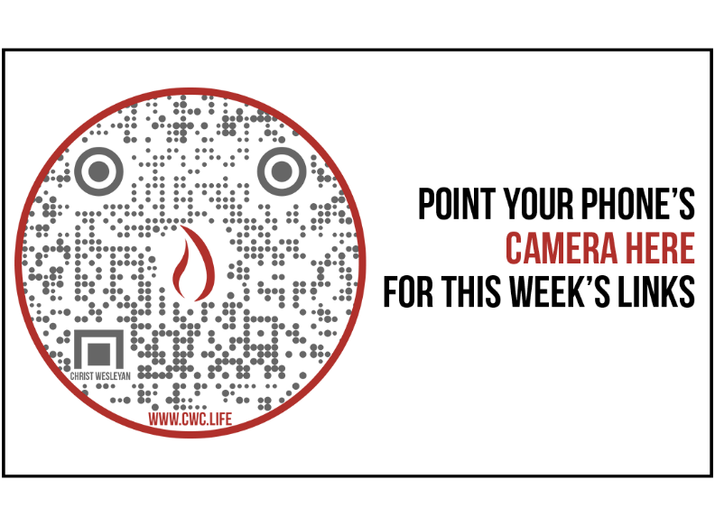
Giving & Attendance Update
Giving last Sunday: 118.9% of goal
Giving year to date: 84% of goal
Attendance last Sunday: 2,158
Salvations to date: 69 | Baptisms to date: 62

Upcoming Happenings:
40 Days of Prayer & Fasting (Happening Now) – Join in personal and corporate worship through prayer and fasting. Together as a church we will seek God’s heart with concerted effort from 9/26-11/5.
October 15: Baptism Class
October 29: Baptism Service
October 27: Trunk or Treat
Milton Campus – 6:30-8:30p
October 28: Trunk or Treat
Sunbury Campus – 4:00-6:00p
November 9-12: The Sound of Music
Membership Class: December 3—12:30p (Milton Campus)

Notetakers are History Makers

