October 8, 2023 – Week #4
Milton Campus – Pastor Branden Mestach
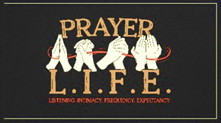
LISTENING INTIMACY FREQUENCY EXPECTANCY

Expectancy in Prayer…
Matthew 6:5-15

- In Prayer, God __________ Us…
      - To pray with __________
“And when you pray, do not be like the hypocrites, for they love to pray standing in the synagogues and on the street corners to be seen by others. Truly I tell you, they have received their reward in full. But when you pray, go to your room, close the door and pray to your Father, Who is unseen. Then your Father, Who sees what is done in secret, will reward you.” Matthew 6:5-6 (NIV)

      - To pray with a desire for _______________
“And when you pray, do not keep on babbling like pagans, for they think they will be heard because of their many words. Do not be like them, for your Father knows what you need before you ask Him.” Matthew 6:7-8 (NIV)

      - To pray with ______-_____ faith
“He called a little child to Him, and placed the child among them. And He said, ‘Truly I tell you, unless you change and become like little children, you will never enter the kingdom of Heaven. Therefore, whoever takes the lowly position of this child is the greatest in the kingdom of Heaven. And whoever welcomes one such child in My name welcomes Me.’” Matthew 18:2-5 (NIV)
- In Prayer, We Can _________ God…
- To be _____________ over all
“This, then, is how you should pray: Our Father in Heaven, hallowed be Your name,” Matthew 6:9 (NIV)

- To ________________ His will according to His purpose
“You Kingdom come, Your will be done, on earth as it is in Heaven.” Matthew 6:10 (NIV)

- To _______ our needs
“Give us today our daily bread.” Matthew 6:11 (NIV)

- To ___________ our sins, as we forgive sins
“And forgive us our debts, as we also have forgiven our debtors.” Matthew 6:12 (NIV)

“For if you forgive other people when they sin against you, your Heavenly Father will also forgive you. But if you do not forgive others their sins, your Father will not forgive your sins.” Matthew 6:14-15 (NIV)

- To ________ us deliverance
“And lead us not into temptation, but deliver us from the evil one.” Matthew 6:13 (NIV)

- What Do You Expect From Prayer?
      - Do you expect more of God and less of you?
“He must increase, but I must decrease.” John 3:30 (NIV)

      - Do you expect more from God and less from you?
“Come to Me, all you who are weary and burdened, and I will give you rest. Take My yoke upon you and learn from Me, for I am gentle and Humble in heart, and you will find rest for your souls. For My yoke is easy and My burden is light.” Matthew 11:28-30 (NIV)

      - Do you trust God’s will over yours?
“You Kingdom come, Your will be done, on earth as it is in Heaven.” Matthew 6:10 (NIV)

Bottom Line:
A proper posture of expectant prayer is impossible without humility.

To begin a relationship with Jesus…
Text: IChooseJesus (all one word) to 570-273-0088

Want to take it deeper? Send in a question for the Dive Deep Podcast to our Online Campus Pastor: mike.sweigard@cwc.life

Next Sunday:
“Love Like This: Without Compromise”
Week 1: 1 John 1: Be the Light

Milton Campus: Pastor Branden Mestach
Sunbury Campus: Pastor Ryan Brosious
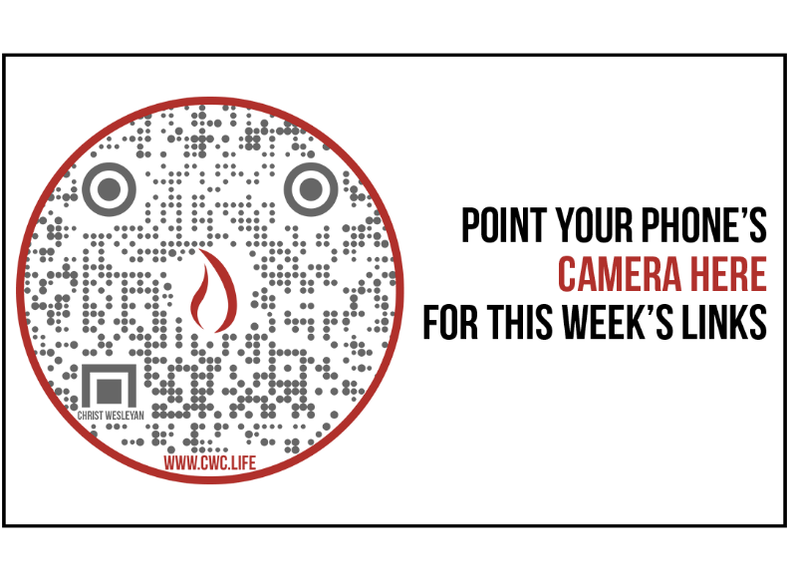
Giving & Attendance Update
Giving last Sunday: 71.7% of goal
Giving year to date: 82.8% of goal
Attendance last Sunday: 2,033
Salvations to date: 65 | Baptisms to date: 35

Upcoming Happenings:
40 Days of Prayer & Fasting (Happening Now) – Join in personal and corporate worship through prayer and fasting. Together as a church we will seek God’s heart with concerted effort from 9/26-11/5.
October 15: Baptism Class
October 29: Baptism Service
October 27: Trunk or Treat
Milton Campus – 6:30-8:30p
October 28: Trunk or Treat
Sunbury Campus – 4:00-6:00p
November 9-12: The Sound of Music
Membership Class: December 3—12:30p (Milton Campus)

Notetakers are History Makers

