September 11, 2022 – Pastor Ryan Brosious

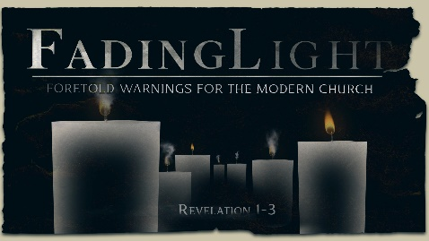
Week 6:
The Church in Sardis

Revelation 3:1-6

Notes:

What It _______ Like –

What It _____ –

What To _____ –

What If I _______? –

What If I _____? –

September 11, 2022 – Pastor Ryan Brosious

Week 6:
The Church in Sardis

Revelation 3:1-6

Notes:

What It _______ Like –

What It _____ –

What To _____ –

What If I _______? –

What If I _____? –

To begin a relationship with Jesus…
Text: IChooseJesus (all one word) to 570-273-0088
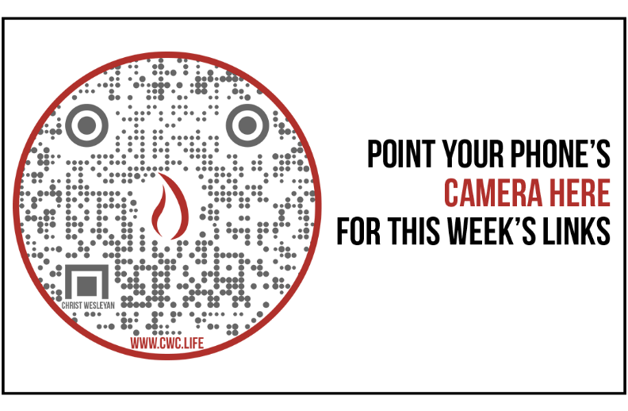

Giving & Attendance Update
Giving last Sunday: 104.3% of goal
Giving year to date: 94.1% of goal
Attendance last Sunday: 1,813
Salvations to date: 96 | Baptisms to date: 21

Upcoming Happenings:
September 18 | Connection Breakfast (Milton Campus)
September 24 | Priscilla Shirer Simulcast
September 30 | The Isaacs & The Martins Concert
October 28 | Trunk or Treat

To begin a relationship with Jesus…
Text: IChooseJesus (all one word) to 570-273-0088

Giving & Attendance Update
Giving last Sunday: 104.3% of goal
Giving year to date: 94.1% of goal
Attendance last Sunday: 1,813
Salvations to date: 96 | Baptisms to date: 21

Upcoming Happenings:
September 18 | Connection Breakfast (Milton Campus)
September 24 | Priscilla Shirer Simulcast
September 30 | The Isaacs & The Martins Concert
October 28 | Trunk or Treat

