August 28, 2022 Fading Light – Week 4

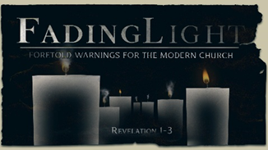
Week 4:

To the Church in Pergamum…

Revelation 2:12-17 (NIV)

- Jesus to us…
“To the angel of the church in Pergamum write:
These are the words of him who has the sharp, double-edged sword.”
Revelation 2:12 (NIV)

  - Why a sword??
^{“12} For the word of God is alive and active. Sharper than any double-edged sword, it penetrates even to dividing soul and spirit, joints and marrow; it judges the thoughts and attitudes of the heart.” Hebrews 4:12 (NIV)

“Take the helmet of salvation and the sword of the Spirit, which is the word of God.”
Ephesians 6:17 (NIV)

  - Are you ?...

      - When was the last time you stopped to listen to The Holy Spirit’s leading/still small voice?
__________________________
  - Before we move on…list five things about your week-to-week or day-to-day environment, season of life, work, family, etc.

- Jesus our situation…
“I know where you live—where Satan has his throne.” Revelation 2:13 (NIV)

In Smyrna, the “synagogue of Satan” was ; in Pergamum, the “throne of Satan” was .

“Yet you remain true to My name. You did not renounce your faith in Me, not even in the days of Antipas, My faithful witness, who was put to death in your city—where Satan lives.”
Revelation 2:13 (NIV)

  - What does He ?

- Jesus us.

^{“14} Nevertheless, I have a few things against you:…”

  - The LORD those He loves. Proverbs 3:12 | Hebrews 12:6 (NIV)

“There are some among you who hold to the teaching of Balaam, who taught Balak to entice the Israelites to sin so that they ate food sacrificed to idols and committed sexual immorality. ¹⁵ Likewise, you also have those who hold to the teaching of the Nicolaitans.”
Revelation 2:14-15 (NIV)

  - How is His Word guiding and correcting you?
  - Have you been living by the “It’s just…/It’s only…” mentality?

- Jesus us closer.

^{“16} Repent therefore! Otherwise, I will soon come to you and will fight against them with the sword of My mouth.
¹⁷ Whoever has ears, let them hear what the Spirit says to the churches. To the one who is victorious, I will give some of the hidden manna. I will also give that person a white stone with a new name written on it, known only to the one who receives it.” Revelation 2:16-17 (NIV)

  - Jesus speaks…are you ?
  - Jesus knows your situation…what does He ?
  - Jesus disciplines us…how is His Word _______ you?
  - Jesus calls you closer…which are you moving?

To begin a relationship with Jesus…
Text: IChooseJesus to 570-273-0088

Next Sunday: Pastor Branden Mestach
Fading Light:
A Foretold Warning for the Modern Church
Week 5: Revelation 2:18-29
The Church in Thyatira
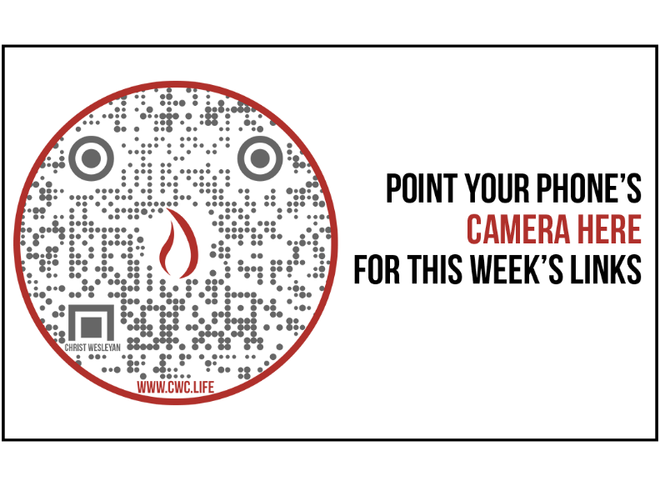

Giving and Attendance Update
Giving last Sunday: 59.3%
Giving year to date: 94.2%
Last Sunday weekend attendance: 2,005
Salvations to date: 83 | Baptisms to date: 2

Upcoming Happenings:

Aug. 31st |  | Mid-Week Open House 6:30p
Sept. 7th |  | Mid-Week Kickoff
Sept. 11 |  | Classics Kickoff Dinner
Sept. 24 |  | Priscilla Shirer Simulcast
Sept. 30 |  | The Isaacs & The Martins Concert

Kendell H. Easley, Revelation, vol. 12, Holman New Testament Commentary (Nashville, TN: Broadman & Holman Publishers, 1998), 38.

