August 21st, 2022

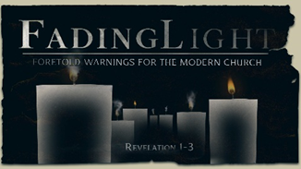
Week 3:

The Church in Smyrna

Revelation 2:8-11 (NIV)

- The City of _________
- Derived from the word “_______”
“These are the words of Him Who is the First and the Last, Who died and came to life again.” Revelation 2:8b (NIV)

- Like Ephesus, Smyrna was on the influential ________ ______.

- Smyrna’s Bishop _________ was burned alive because of his faith in Jesus.
“To the angel of the church in Smyrna write…” Revelation 2:8a (NIV)

“Thou threatenest me with the fire that burns for an hour and in a little time is extinguished; for thou knowest not the fire of the future judgment, and of the eternal punishment that is reserved for the ungodly.” (Polycarp, upon being burned to death)

- The ___________ Christian
“I know your afflictions and your poverty—yet you are rich! I know about the slander of those who say they are Jews and are not, but are a synagogue of Satan.” Revelation 2:9 (NIV)
- Commended by Christ even though ____________ by culture, friends, and neighbors.

- Commended by Christ even though afflicted by the __________ people.

- Commended by Christ because of their faithful witness in a __________ world.
“Do not be afraid for what you are about to suffer. I tell you, the devil will put some of you in prison to test you, and you will suffer persecution for ten days. Be faithful, even to the point of death, and I will give you life as your victor’s crown.” Revelation 2:10 (NIV)

- The Modern ____________ Church
“Whoever has ears, let them hear what the Spirit says to the churches. The one who is victorious will not be hurt at all by the second death.” Revelation 2:11 (NIV)

- To the Christian church in the U.S.A.: persecution _____ come.

- To the Christian church in the U.S.A.: know the Spirit’s _________ more than the cultural pressures (counter-cultural living).

- To the individual Christian believer in the U.S.A.: ________________ will lead to surviving the second death.

“Anyone whose name was not found written in the book of life was thrown into the lake of fire.” Revelation 20:15 (NIV)

- In the meantime, how do we continue to live in a post-Christian culture?

- Develop our Christian communities-we need each other.
Example: Support Christian-owned businesses.

- Do not neglect working to influence the larger society.
Remember, those who DO evil are not the SOURCE of evil. (v. 10)
Example: Encourage Christians to work in mainstream media, political arenas, and the secular art/educational communities.

- When trials come: pray, trust the Lord, and walk in faith.

- Pray for the current persecuted Christians and the future persecution of the U.S. Christian community.

- Listen to the Spirit of God and press in.

Bottom Line:
Fear is not consistent with God’s good and redemptive plan for you.

To begin a relationship with Jesus…
Text: IChooseJesus to 570-273-0088

Notetakers are history makers.
Next Sunday: Pastor Mike Sweigard
Fading Light: A Foretold Warning for the Modern Church
Week 4: Revelation 2:12-14
The Church in Pergamum
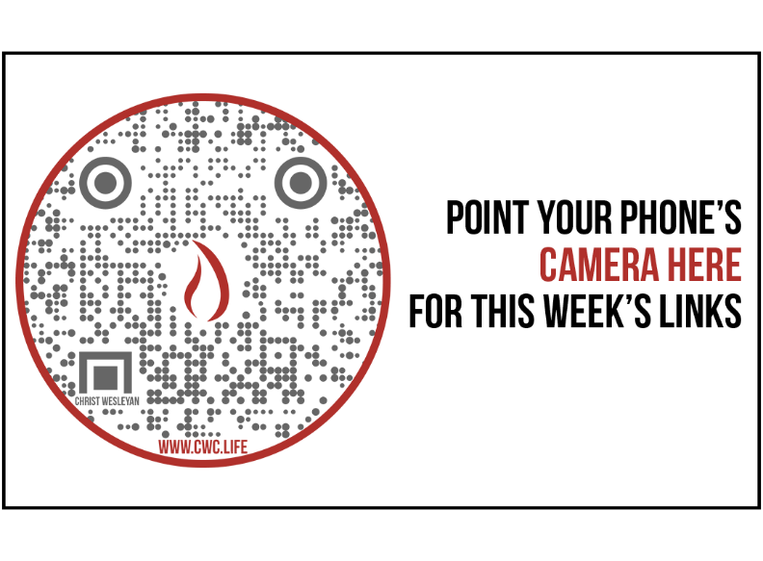

Giving and Attendance Update
Giving last Sunday: 83.6%
Giving year to date: 96%
Last Sunday weekend attendance: 1,852
Salvations to date: 83 | Baptisms to date: 21

Upcoming Happenings:

Aug. 31st  Sept. 7th |  | Mid-Week Open House 6:30p  Mid-Week Kickoff

Facts on Worldwide, Christian Persecution

Where It’s Hardest to Follow Jesus:
1. North Korea
2. Afghanistan
3. Somalia
4. Libya
5. Pakistan
6. Eritrea
7. Yemen
8. Iran
9. Nigeria
10. India

The listed nations (Top 50) contain 309 million Christians living in places with very high or extreme levels of persecution, up from 260 million in last year’s list.

Worldwide registered martyrdoms rose to 4,761 in the 2021 report, up 60 percent from the 2,983 tallied the year before and surpassing the 4,305 deaths noted in the 2019 report.

The latest Pew Research Center analysis of governmental and societal hostilities toward religion found that Christians were harassed in 145 countries in 2018, more than any other religious group. Muslims were harassed in 139 countries, followed by Jews in 88 countries.

Sources: Christianity Today/Open Doors 2021 World Watch List

