August 14, 2022
Rev. Ken Paulhamus

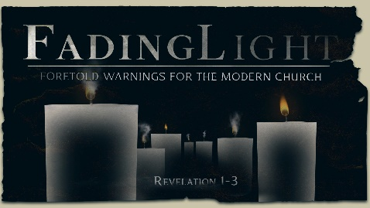
Week 2:
The Church in Ephesus

Revelation 2:1-7

“You have forsaken your first love. Remember the height from which you have fallen! Repent and do the things you did at first.” Revelation 2:4-5

Symbolism Key
Angel of the church (Star) = Messenger/Pastor
Lampstand = Church

- Commendation
“I know your deeds, your hard work and your perseverance. I know that you cannot tolerate wicked people, that you have tested those who claim to be apostles but are not, and have found them false. You have persevered and have endured hardships for my name, and have not grown weary.”
“But you have this in your favor: You hate the practices of the Nicolaitans, which I also hate.” Rev. 2:2-3, & 6 (NIV)

- Good _______ (works)

- Hard _______ (labor)

- _______________ (patient endurance)

- Intolerance of _____

- Testing for sound __________

- Suffering for _________

- _________ the practice of the Nicolaitans

- Condemnation
“Yet I hold this against you: You have forsaken the love you had at first.” Rev. 2:4 (NIV)

- Counsel
“Consider how far you have fallen! Repent and do the things you did at first.” Rev. 2:5a (NIV)

- Remember

- Repent

- Return

- Consequence
“If you do not repent, I will come to you and remove your lampstand from its place.” Rev. 2:5b (NIV)

- Challenge – Persevere and overcome
“Whoever has ears, let them hear what the Spirit says to the churches. To the one who is victorious, I will give the right to eat from the tree of life, which is in the paradise of God.”
Rev. 2:7 (NIV)

If I need to return – what are the basics I need to focus on?

- _______ God’s Word – everyday.

- _______ – both speaking and listening – everyday.

- _________ with other disciples – often.

- ________ your faith with others.

To begin a relationship with Jesus…
Text: IChooseJesus to 570-273-0088

Next Sunday: Pastor Branden Mestach
The Church in Smyrna
Week 3: Revelation 2:8-11
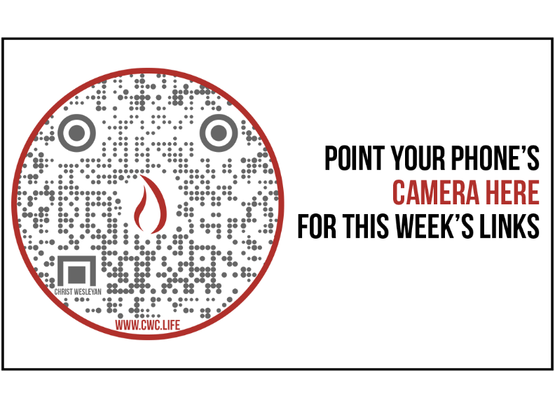

Giving and Attendance Update
Giving last Sunday: 98.7%
Giving year to date: 96.6%
Last Sunday weekend attendance: 1,881
Salvations to date: 83 | Baptisms to date: 21

Upcoming Happenings:
August 26 | Soul Sisters Worship Night
August 31 | Midweek Open House

