August 7, 2022

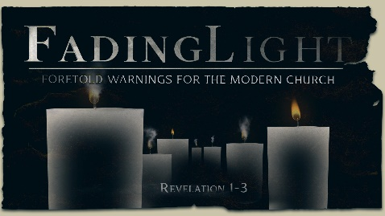
Week 1:
The Vision

Revelation 1

Notes:

Prologue –

Greetings and Doxology –

The Vision –

You and Me –

To begin a relationship with Jesus…
Text: IChooseJesus (all one word) to 570-273-0088
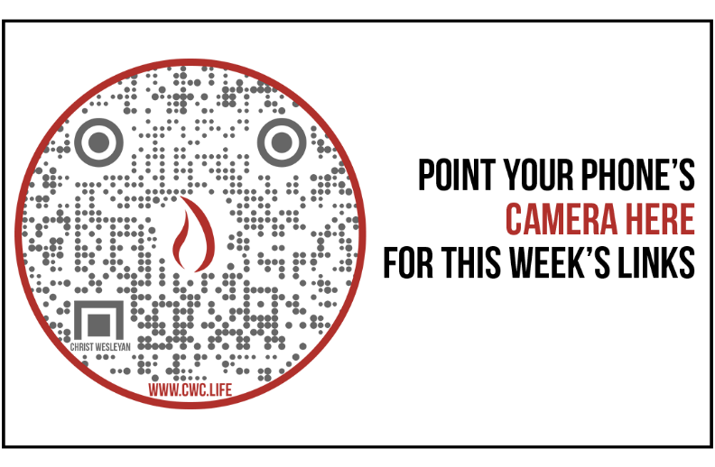

Giving & Attendance Update
Giving last Sunday: 92.2% of goal
Giving year to date: 96.5% of goal
Attendance last Sunday: 1,723
Salvations to date: 81 | Baptisms to date: 21

Upcoming Happenings:
August 26 | Soul Sisters Worship Night
August 31 | Midweek Open House

