July 10th, 2022
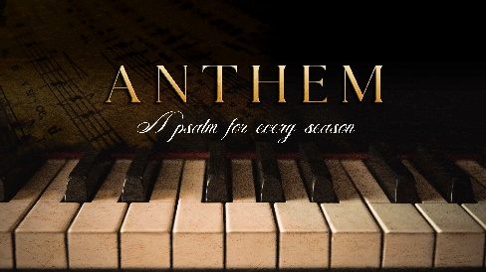
Week 6:

The Transitional Season

Psalm 23:1-6

- Transitional Season _______

- Transition is the _________ or a period of changing from one state or condition to another. (Dictionary.com)

- Transitions happen either by choice, circumstances, the ________, or God.

- Times of transition _______ our character.

- Change is situational, while transition is ________.

- David’s _________ to the World

- The Lord is the ___________.
“The Lord is my shepherd, I lack nothing.” Psalms 23:1 (NIV)

- The Lord is the __________.
“He makes me lie down in green pastures, He leads me beside quiet waters, He refreshes my soul.” Psalms 23:2-3a (NIV)

- The Lord gets ____ the glory.
“He guides me along the right paths for His name’s sake.” Psalms 23:3b-c (NIV)

- David’s _____________ with God

- When David did not know what was coming, he knew the Shepherd would be ______.
“Even though I walk through the darkest valley, I will fear no evil, for You are with me; Your rod and Your staff, they comfort me.” Psalms 23:4 (NIV)

- The darkness of transition led David to incredible ___________.
“You prepare a table before me in the presence of my enemies. You anoint my head with oil; my cup overflows.” Psalms 23:5 (NIV)

- David’s final transition was of an _________ nature.
“Surely Your goodness and love will follow me all the days of my life, and I will dwell in the house of the Lord forever.” Psalms 23:6 (NIV)

- Making it Through Transition

- On the lit paths, David spoke about God; in the dark valleys, David spoke to God.

- Maintain a soft heart while in transition.
“Be patient, then, brothers and sisters, until the Lord’s coming. See how the farmer waits for the land to yield its valuable crop, patiently waiting for the autumn and spring rains. You too, be patient and stand firm, because the Lord’s coming is near. Don’t grumble against one another, brothers and sisters, or you will be judged. The Judge is standing at the door!” James 5:7-9 (NIV)

- Your thoughts and words are key to making it through transition.
“For the mouth speaks what the heart is full of.” Luke 6:45c (NIV)

- Do not get scared, get bold.
“For the Spirit God gave us does not make us timid, but gives us power, love and self-discipline.” 2 Timothy 1:7 (NIV)

To begin a relationship with Jesus…
Text: IChooseJesus to 570-273-0088

Notetakers are history makers.

Next Sunday: Pastor Branden
Anthem: A Psalm for Every Season
Week 7: The Busy Season

Giving and Attendance Update
Giving last Sunday: 86%
Giving year to date: 97.1%
Last Sunday weekend attendance: 1,709
Salvations to date: 76 | Baptisms to date: 7

Upcoming Happenings:

July 25-29  August 7 |  | CWC Youth Camp  Membership Class (12:30p) Room 102

Get all the info & register: cwc.life/events

