June 5th, 2022
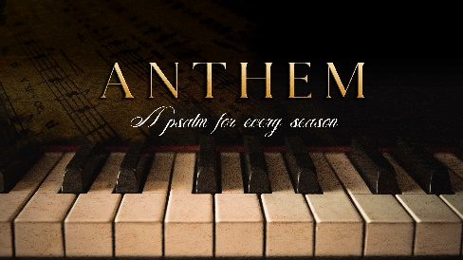
Week 1:
A Statement on Human Existence

Psalms 1:1-6

- The on Psalms
- The of the book:
- (Tehillim) means, “Psalms of praise.”
- Psalms were meant to be with joy.
- Psalms were a collection of and
that can be described as, “an abstract of both testaments.”

- The of the book:
- The Holy __________
- Shepherd/King _______
- Various others (Asaph, )

- The of the book:
- To in the exercise of faith
- To the excellence of God
- To bring a on what human existence looks like

- The of the Righteous
- The righteous will be .
“Blessed is the one who does not walk in step with the wicked or stand in the way that sinners take or sit in the company of mockers.” Psalms 1:1 (NIV)
- The righteous find in God’s Word.
“…but whose delight is in the law of the Lord, and who meditates on His Law day and night.” Psalms 1:2 (NIV)

- The righteous will bear .
“That person is like a tree planted by streams of water, which yields its fruit in season…whatever they do prospers.” Psalms 1:3 (NIV)

- The of the Ungodly
- The ungodly will not be .
“Not so with the wicked!” Psalms 1:4a (NIV)

- The ungodly find delight in the .
“They are like chaff that the wind blows away.” Psalms 1:4b (NIV)

- The ungodly will not .
“Therefore, the wicked will not stand in the judgment, nor sinners in the assembly of the righteous.” Psalms 1:5 (NIV)

- The Choice of Every Human
- Who/What are my influences?
- What do I delight in?
- Where does my nourishment come from?
- What path am I on?

Bottom Line: God has designed a world where the right decisions are the best decisions.

To begin a relationship with Jesus…
Text: IChooseJesus to 570-273-0088

Next Sunday:
Anthem: A Psalm for Every Season
Week 2: A Psalm for the battle season.

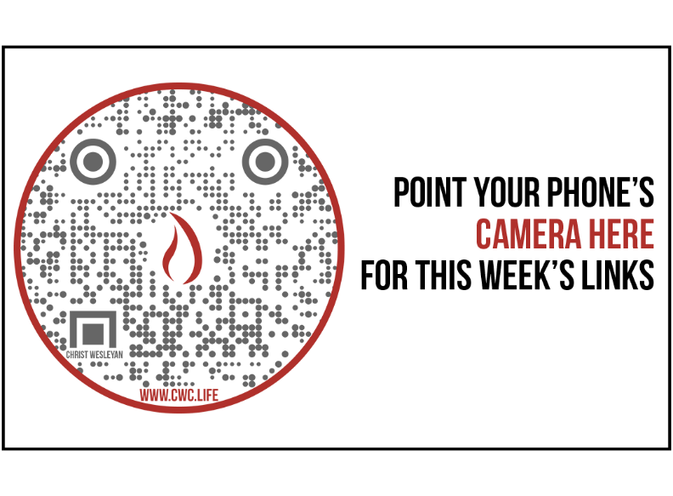

Giving and Attendance Update
Giving last Sunday: 93%
Giving year to date: 94.7%
Last Sunday weekend attendance: 1,755
Salvations to date: 14 | Baptisms to date: 7

Upcoming Happenings:

June 16-18 |  | Agatha Christie’s Murder on the Orient Express Performances
June 21-24  July 9  July 10  July 25-29 |  | Kidz Camp  Valley Fest  Outdoor Service/Baptisms  CWC Youth Camp

Get all the info & register: cwc.life/events

