May 8, 2022
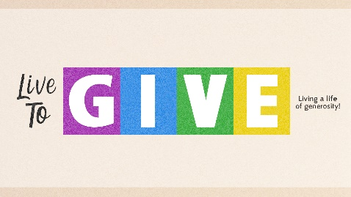
Week 3:
The Motherload of Generosity

- Hannah’s First Prayer

1 Samuel 1:9-28

1. Hannah it her all.

“Hannah was in deep anguish, crying bitterly as she prayed to the Lord. 1 Samuel 1:10

2. Hannah had .

Her husband Elkanah would say to her, “Hannah, why are you weeping? Why don’t you eat? Why are you downhearted? Don’t I mean more to you than ten sons?” 1 Samuel 1:8

3. Hannah was .

And she made this vow: “O Lord of Heaven’s Armies, if You will look upon my sorrow and answer my prayer and give me a son... 1 Samuel 1:11

4. Hannah a promise.

And she made this vow: “O Lord of Heaven’s Armies, if You will look upon my sorrow and answer my prayer and give me a son, then I will give him back to You. He will be Yours for his entire lifetime, and as a sign that he has been dedicated to the Lord, his hair will never be cut.
1 Samuel 1:11

5. Hannah (and Elkanah) her promise.

She told her husband, “Wait until the boy is weaned. Then I will take him to the Tabernacle and leave him there with the Lord permanently.” 1 Samuel 1:22

B. Hannah’s Second Prayer/Poem 1 Samuel 2:1-11

1. Hannah God.

“My heart rejoices in the Lord! 1 Samuel 2:1

2. Hannah God.

“I rejoice because You rescued me”1 Samuel 2:1

2. Hannah reminds us of God’s .

“The childless woman now has seven children,
and the woman with many children wastes away”
1 Samuel 2:5

3. Hannah’s prayer was .

He gives power to his king;
He increases the strength of His anointed one.”
1 Samuel 2:10

C. We’ve Got Issues...God’s Got Answers!

- We have issues.
- We rely on too much.
- We think .
- We don’t .

Bottom Line- When we give our all to God, God’s plans unfold!

To begin a relationship th Jesus…
Text: I Choose Jesus to 570-273-0088
Next Sunday:
Annual Report – Pastor Branden

Giving and Attendance Update
Giving last Sunday: 79.7%
Giving year to date: 92.7%
Last Sunday’s attendance: 1,967
Salvations to date: 14 | Baptisms to date: 0

Upcoming Happenings:

May 15 | 5:00pm: Annual Church Celebration – Milton Campus  (Pre-register TODAY!)
May 29 | 5th Family Sunday  with teen baptisms
June 5 | Graduate Sunday
June 16-18 | Agatha Christie’s Murder on the Orient Express Performances
June 21-24 | Kidz Camp
Get all the info & register: cwc.life/events

