April 16th & 17th, 2022

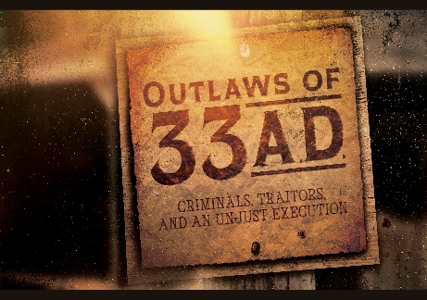
Week 7:
The Resurrected Jesus:
The Proof of Eternal Life

Luke 24:1-8

- “____

- Jesus: The ___________
“The Lord your God will raise up for you a Prophet like me from among you, from your fellow Israelites. You must listen to Him.” Deuteronomy 18:15 (NIV)

“Jesus answered them, ‘Destroy this temple, and I will raise it again in three days.’” John 2:19 (NIV)

- Jesus: The _________
“Such a High Priest truly meets our need—One Who is holy, blameless, pure, set apart from sinners, exalted above the heavens.” Hebrews 7:26 (NIV)

- Jesus: The _______
“Jesus said, ‘My kingdom is not of this world. If it were, My servants would fight to prevent My arrest by the Jewish leaders. But now My kingdom is from another place.’ ‘You are a king, then!’ said Pilate. Jesus answered, ‘You say that I am a king. In fact, the reason I was born and came into the world is to testify to the truth. Everyone on the side of truth listens to Me.’” John 18:36-37 (NIV)

- ____
“While they were still talking about this, Jesus Himself stood among them and said to them, ‘Peace be with you.’” Luke 24:36 (NIV)

- Jesus is _______ risen. (God’s final Word)
“But about the Son He says, ‘Your throne, O God, will last for ever and ever; a scepter of justice will be the scepter of Your Kingdom.’” Hebrews 1:8 (NIV)

- Jesus was seen by more than _____ people.
“After that, He appeared to more than five hundred of the brothers and sisters at the same time, most of whom are still living, though some have fallen asleep.” 1 Corinthians 15:6 (NIV)

- The placement of the ________ clothes
“Then Simon Peter came along behind him and went straight into the tomb. He saw the strips of linen lying there, as well as the cloth that had been wrapped around Jesus’ head. The cloth was still lying in its place, separate from the linen. Finally, the other disciple, who had reached the tomb first, also went inside. He saw and believed.” John 20:6-8 (NIV)

- _________.”
“Why do you look for the living among the dead? He is not here; He has risen!” Luke 24:5c-6a (NIV)

- Risen means ________.

- Because Jesus is _______ from the dead:
- We are never without ______.
- Jesus is ___________.
- There is a man Who sits upon the _______.
- He will make all things ______.
- We have the _______ of the Holy Spirit.

- If _____ had not been raised from the dead:
- Christian _________ on Heaven is a lie.
- Christians are not _________ but are still dead in sin and separated from God.
- Eternal life is a ___________, and we are to be pitied, not ____________.
- Christian belief is ________ and invalid.

- You can be too.
- There is more evidence not to doubt than to doubt.
“Jesus’ resurrection has more eyewitness evidence to support it than any other event in ancient times—more evidence than the military victories of Julius Caesar or the first Olympic games or the death of Alexander the Great, enough evidence to convince thousands of skeptics over the centuries and millions of seekers. Jesus died as the result of a brutal execution on the cross, but death could not hold Him. He rose alive and stands alive in heaven today—our conquering King.”

- Jesus is the absolute leader for our spirit, soul, and body.

- Belief in the resurrected Jesus changes everything—even sinners like us.
“Now if we are children, then we are heirs—heirs of God and co-heirs with Christ, if indeed we share in His sufferings in order that we may also share in His glory.” Romans 8:17 (NIV)

Bottom Line: He is forever risen, so we can be too. (The proof of eternal life.)

To begin a relationship with Jesus…
Text: I Choose Jesus to 570-273-0088

Next Sunday:
A New Series: Live to Give (Living a LIFE of Generosity)

Giving and Attendance Update
Giving last Sunday: 98.3%
Giving year to date: 88.5%
Last Sunday’s attendance: 2,119
Salvations to date: 204/ Baptisms to date: 43

Upcoming Happenings:

April 24 | Connection Breakfast  Milton Campus
May 1 | Local Church Conference  (Annual Reporting)  The Well Coffee House
May 7  May 29 | Mother Daughter Brunch  Well Fit Gym  5th Family Sunday  with teen baptisms
Get all the info & register: cwc.life/events

Douglas Connelly and Martin Manser, What Christians Believe: Moving Your Faith—Or Flock—To the Next Level (Manser and Connelly, 2020), 144.

